Deep Azure Final Project

Azure Batch

Prepared by: Joel Keith

Table of Contents

Problem Statement 4

Data Sets 6

US Postal Zip Codes with Latitude and Longitude 6

FDA Drug files 6

EDI Purchase Order Acknowledgment files 7

Account Demographic data 8

Description of Hardware 10

Development 10

Azure Batch 10

Description of Software 11

Development Software 11

Runtime Software 11

Installation and Configuration 12

Application code 66

Maven pom.xml 68

Java classes 70

com.mckesson.mpts.azure.batch.OpioidOrderingRecorder.java 70

com.mckesson.mpts.azure.batch.OpioidOrderingWorker.java 72

com.mckesson.mpts.azure.tasks.MergeDrugInfoTask.MergeDrugInfoTask.java 83

com.mckesson.mpts.azure.tasks.model.OrderedDrug.java 92

com.mckesson.mpts.azure.tasks.model.OrderedDrugs.java 95

com.mckesson.mpts.azure.tasks.poackparser.EDI855ParseTask.java 95

com.mckesson.mpts.azure.tasks.poackparser.EDIX12ParseHelper.java 101

com.mckesson.mpts.azure.tasks.poackparser.EDIX12TransactionData.java 103

com.mckesson.mpts.azure.tasks.poackparser.EDIX12TransactionLine.java 112

com.mckesson.mpts.azure.tasks.RecordOrderingHistoryTask.RecordOrderingHistoryTask.java 117

com.mckesson.mpts.azure.tasks.TaskInfo.java 123

Summary 125

References 127

# Problem Statement

The opioid crisis is a nation-wide issue with far reaching impact across all spectrums of society. There are many approaches being taken to try to deal with this epidemic and to identify bad actors whose actions contribute greatly to the problem. One area where fraud and abuse can happen is within pharmacies where opioid drugs may be diverted or over-ordered. Unless the companies that own the pharmacies are watching for such activity, it can be missed. While pharmaceutical distributors can also watch for excessive ordering, many pharma customers use multiple suppliers and so any one Supplier may not catch illicit activity. What is needed is a way to track ordering activity across all sources for a customer.

Other worthwhile solutions for identifying opiod issues include tracking “dispensing” information from pharmacies. This can identify over utilization of opiods and excessive prescribing activities, which is extremely useful. However, if a bad actor within a pharmacy is diverting opioids for illicit use, this will not be identifiable through dispensing and prescribing activity alone. It would require tracking excessive ordering of opioids as well. And again, given any one Supplier will only be able to track ordering from their business, a more holistic solution is needed to allow better identification of illicit ordering situations.

The EnterpriseRx Pharmacy Management System operated by McKesson’s MPTS business unit provides EDI services for all customers using this software. These services include receipt of EDI 855 Purchase Order Acknowledgment documents from all Suppliers and sources of drugs for a customer. These documents represent the vast majority of a customer’s ordering activity and therefore are prime sources of information for tracking opioid ordering trends and activity. If these document can be analyzed in a timely manner, this could provide a missing piece in the opioid crisis solution. However, there are routinely 10s of thousands of these documents that are processed on a daily basis and there is no way to identify the “opioid” drugs within those orders except by extracting the drug data from the order and matching it up against drug databases and then tracking the historical ordering activity. Such processing could require a large investment in hardware and software, which is where Azure Batch comes in…

My project uses Azure Batch’s highly scalable compute environment to capture drug ordering data from all sources for a customer and provide that data to an analytic environment where aggregated data across all Suppliers can be used to identify potential opioid fraud and abuse. The dynamic scaling features of Azure Batch, as well as its ease and simplicity in configuring additional resources, make it a great fit for providing a platform for this activity. Additionally, since this analysis of ordering activity is not required to be “real time”, having an on-demand solution that can adjust capacity over time makes it much easier to implement this on a large-scale basis.

Having said that, the example solution provided here should NOT be taken as anything close to “production ready”. It really is no more than a proof of concept and would need to have much more work put into it to be a production quality solution. But it does demonstrate some of the capabilities and potential of Azure Batch for aiding in implementation of a full-blown solution.

# Data Sets

## US Postal Zip Codes with Latitude and Longitude

**Purpose**: Latitude and Longitude are required by the plot.ly mapping library in order to produce a bubble chart superimposed on a map of the United States. The Zip Code and State data is needed to match to the location of customers placing orders, so ordering data can be aggregated.

**File Name(s)**: us_postal_codes.csv

**Manipulation required**: The only manipulation required of this data is to left-pad the Zip Code with zeroes to make them all 5 digits long.

**URL**: <https://www.aggdata.com/node/86>

## FDA Drug files

**Purpose**: The only drug data obtained from EDI 855 Purchase Order Acknowledgment documents are identifiers assigned either by the FDA (the National Drug Code or NDC) or assigned by the Supplier of the drug. In order to know whether a drug is classified as an “opiod”, more detailed drug classification information is required. The FDA makes such data publicly available for use by software applications and the like.

**File Name(s)**:

The data consists of two files:

**product.xls** - Base drug information regardless of how it is packaged. This is where the pharmaceutical classification data is found, which identifies a drug as an “opioid” (at least for the purposes of this application)

**package.xls** – Packaging-specific drug information, including the full National Drug Code (non-normalized to 11 digits)

These files can be “joined” through a unique Drug Identifier assigned by the FDA (uses a UUID), but there will routinely be multiple rows in the package.xls file for each Drug Identifier, since drugs are routinely packaged in different sizes, forms, and routes of administration.

**Manipulation Required**:

The primary manipulation required is within the “package.xls” file as the National Drug Code (called NDCPACKAGECODE in the file) assigned here is 10 digits long. However, all drug Suppliers use a “rationalized” version of the NDC that fixes it at 11 digits. The NDC consists of 3 sets of numbers :

Manufacturer code – up to 5 digits long

Product code – up to 4 digits long

Package code – up to 2 digits long

The algorithm essentially is to left-pad with zeroes each of these 3 fields, to their max length, and then concatenate the numbers together (with no dashes) to form an 11 digit number. This should match the 11-digit values used by drug Suppliers.

For example:

|  |  |
| --- | --- |
| NDC Package Code | 11-digit NDC |
| 0268-6180-10 | 00268-6180-10 |
| 16708-002-01 | 16708-0002-01 |
| 68788-9818-5 | 68788-9818-05 |

Not all of the columns in these spreadsheets was relevant to this problem space so only those columns that were needed were loaded to the application. Additionally, Opioid drugs are always “scheduled” drugs by the FDA (meaning they have a propensity for addiction and abuse) so the list was further narrowed down to only those drugs with a value in the “DEASCHEDULE” column within the “product.xls” file.

**URL**: <https://www.accessdata.fda.gov/cder/ndctext.zip>

## EDI Purchase Order Acknowledgment files

**Purpose**: These are the primary “source” files for drug ordering information and are the core of this application. These files represent one Purchase Order placed by a pharmaceutical customer for one or more drugs and the intended shipment of said order from the Supplier. Included in these files is an identifier for the location (pharmacy) placing the order, and a set of 2 lines for each drug that was ordered, including the NDC and quantity. These are standard X12 documents and are fairly easily parsed to find this information.

Example File contents:

ISA*00* *00* *ZZ*987654321 *ZZ*CUSTABCD *180207*0642*U*00401*000014550*0*P*>~

GS*PR*987654321*CUSTABCD*20180207*0642*14550*X*004010~

ST*855*145500001~

BAK*06*AC*6151470*20180206~

N1*ST**91*0043438118~

N1*SE**91*987654321~

PO1*1*1*UN*66.8**VN*2987121*N4*96705000343~

ACK*IA*1*UN****VN*2987121*N4*96705000343~

PO1*2*1*UN*20.64**VN*5418355*N4*00000032911~

ACK*IA*1*UN****VN*5418355*N4*00000032911~

CTT*2~

SE*10*145500001~

GE*1*14550~

IEA*1*000014550~

X12 documents consist of “segments” and “fields”. Segments start with a specified character string that identifies the Segment type (e.g. – ISA, ST, BAK, PO1, etc). Fields within a segment are delimited by a common character (* in the example above), and Segments are terminated by a common character as well (~ in the example above). The ISA Segment is ALWAYS the first segment found in an X12 document and is fixed length. Therefore, it is trivial to find the field delimiter (first character after “ISA”) and the segment delimiter (located at character 106). From there it is simple to identify segments and the fields they contain.

In the above example, the highlighted fields typically contain customer and supplier identifiers and so were masked using the jEdit editor’s capability for replacing strings within all files within a directory. The fields marked in Green are ones that were retained as they provide the needed information to identify the drugs ordered, quantity, and to match to a geographic area for aggregation purposes.

**Manipulation Required**:

Due to the sensitive nature of this information, these files were heavily de-identified to remove any effective means of identifying the customer or supplier, without having direct access to a Supplier’s internal systems. This included the following:

* Masking the “header” identifiers for the Supplier and Customer within the X12 ISA and GS segments. This was performed using the jEdit editing tool.
* Changing the file names to be completely generic. This was performed using the “Advanced Renamer” software.
* Re-assigning Account Numbers to different geographic locations when loading Account data into the MySQL database.

**URL**: N/A (obtained from the EnterpriseRx pharmacy management system)

## Account Demographic data

**Purpose**: In order to be able to assign ordering history to a geographic location, there had to be a way to cross-reference data from an EDI document with actual zip code information. I chose to extract data from the EnterpriseRx Pharmacy Management System for 3 larger customers who span larger geographic regions, in order to provide a more realistic visualization of data. The “real” Account Numbers are used in this example, since those have to match up with the account number contained in each EDI document, but the actual demographic data assigned to the account is not “real”.

**Manipulation Required**:

The data extracted included the EDI Account Number, State, and Zip code for each pharmacy for these customers. However, before this data was loaded into the example application database, it was “mixed” so that each Account, while assigned to some “real” Zip code, was not assigned to their “real” Zip Code. This was done to further “de-identify” the data and caused no issues with the application.

# Description of Hardware

## Development

All solution development was conducted using a Hewlett-Packard 64-bit laptop running Windows 7

## Azure Batch

The hardware used in the Azure Batch environment included:

Azure D2sV3 VM for the MySQL service

2 Standard D2 V2 VMs for the Azure Batch Pool

# Description of Software

## Development Software

|  |  |
| --- | --- |
| Name | Download location |
| Intellij IDEA 2017.3.4 Community Edition | https://www.jetbrains.com/idea/ |
| Maven 3.5 | https://maven.apache.org/download.cgi |
| Java 1.8 SDK (Windows) | http://www.oracle.com/technetwork/java/javase/downloads/jre8-downloads-2133155.html |
| Azure Batch Java SDK | Maven download: http://search.maven.org/#search%7Cga%7C1%7Ca%3A%22azure-batch%22 |
| Azure Batch Java samples | <https://github.com/Azure/azure-batch-samples/tree/master/Java> |
| MySQL Community Server | https://dev.mysql.com/downloads/mysql/ |
| MySQL Workbench | https://dev.mysql.com/downloads/workbench/ |
| MySQL Connector/J JDBC driver | https://dev.mysql.com/downloads/connector/j/ |
| Jupyter Notebook | http://jupyter.org/ |
| Plot.ly Python plotting library | <https://plot.ly/python/> |
| Advanced Renamer (for de-identifying EDI documents) | <https://www.advancedrenamer.com/download> |
| jEdit (for de-identifying EDI documents) | http://www.jedit.org/ |

## Runtime Software

|  |  |
| --- | --- |
| Name | Download location |
| Java 1.8 SDK (Ubuntu) | Downloaded through apt-get |
| MySQL Community Server | Downloaded through apt-get |
| MySQL Workbench | https://dev.mysql.com/downloads/workbench/ |
| MySQL Connector/J JDBC driver | https://dev.mysql.com/downloads/connector/j/ |
| Jupyter Notebook | http://jupyter.org/ |
| Plot.ly Python plotting library | https://plot.ly/python/ |

# Installation and Configuration

Follow these steps to install the Opioid Ordering Tracking application and get it running within Azure:

1. Download the Opioid Ordering Tracking application from GitHub
   1. GitHub URL: <https://github.com/jmkeith1303/DeepAzureFinalProject.git>
   2. Create a directory in a local environment to house the application development directory and run-time environment

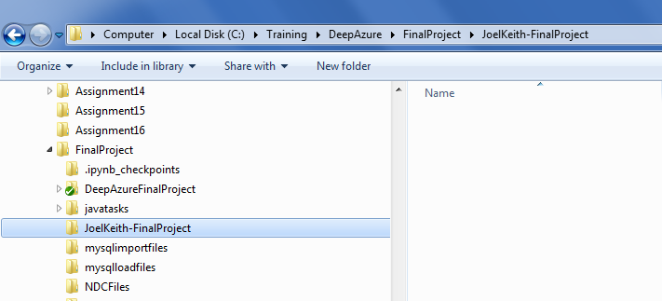

* 1. Open a command window (assumes git is installed) and use the git “clone” command to clone the github repository to your local file system. There are a number of jar files included so this may take a few minutes…

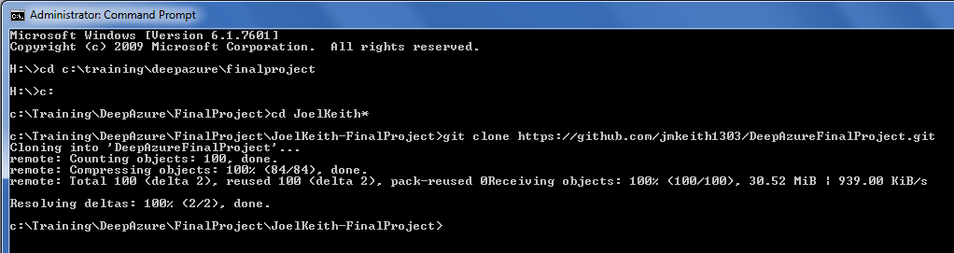

* 1. There is a root directory (DeepAzureFinalProject) and then two sub-directories
     1. AzureBatchJava – the Java Maven project and all Java code
     2. OpioidOrderingTracking – the runtime environment for executing the OpioidOrderingTracking application

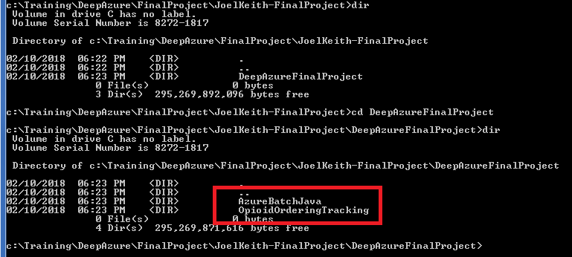

* 1. The steps to configure the runtime application are documented later as that requires Azure data which is created in the next set of steps

1. Set up a VM and install MySQL server
   1. Create a minimal VM in Azure Portal

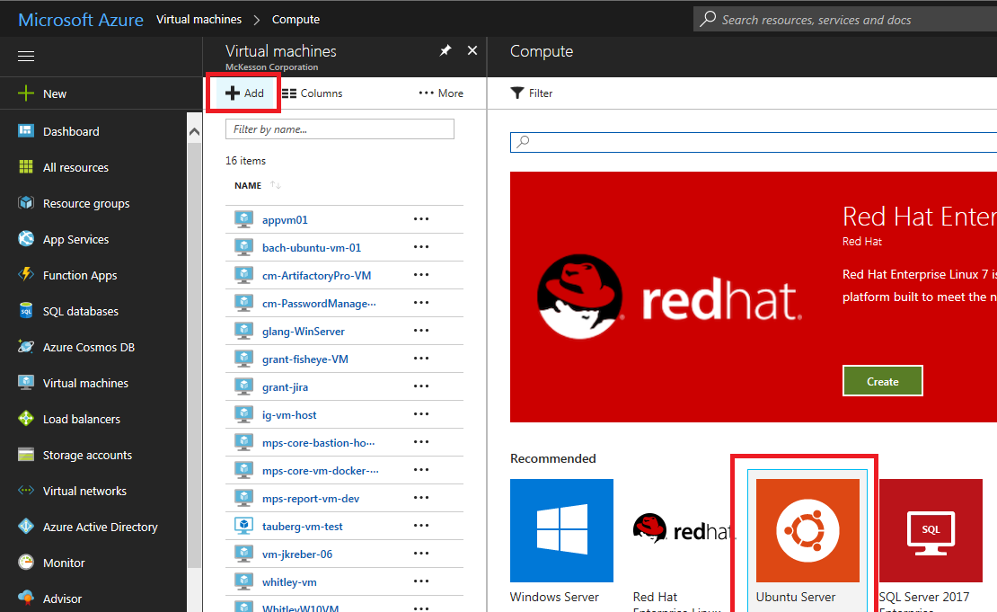

I Selected Ubuntu 16.4:

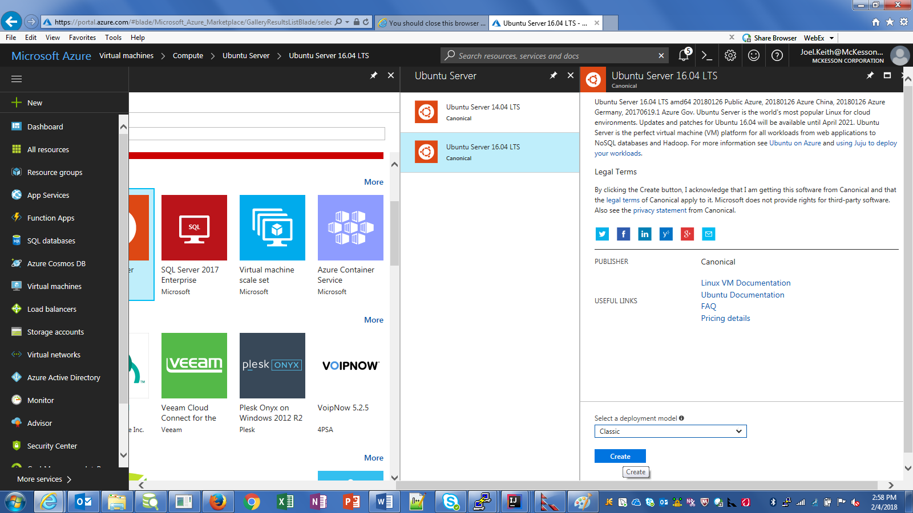

I set it up for user-based authentication to simplify interaction, and created a new Resource Group:

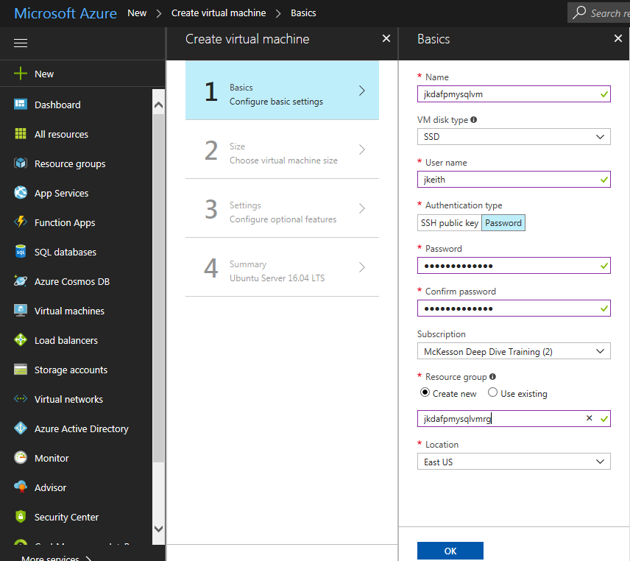

I chose a minimal sizing for the purposes of the demonstration:

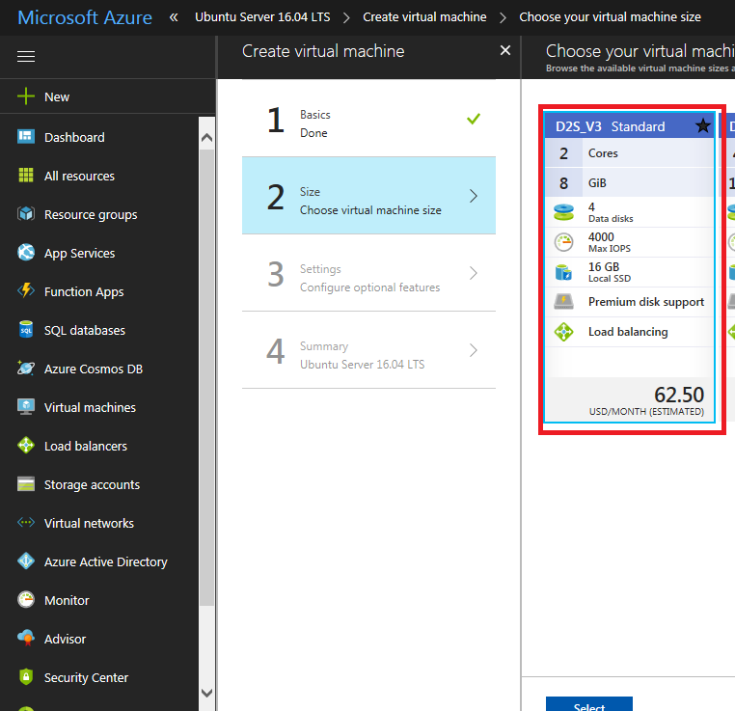

You must add a firewall rule for port 3306 to allow access to MySQL:

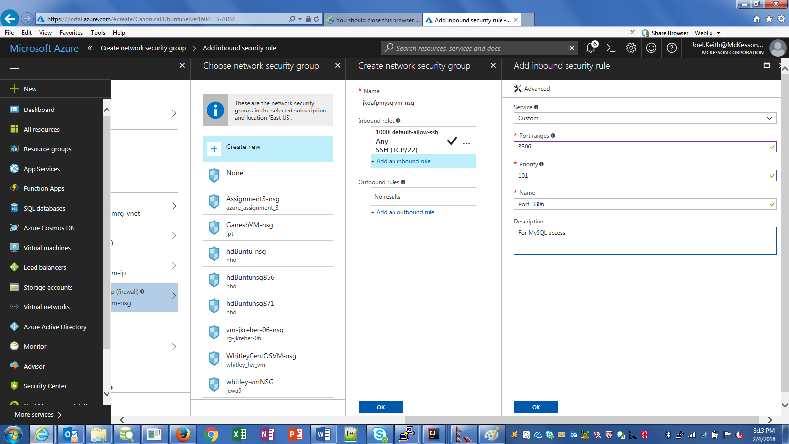

The rest of the options I left as-is, including the creation of a public IP address:

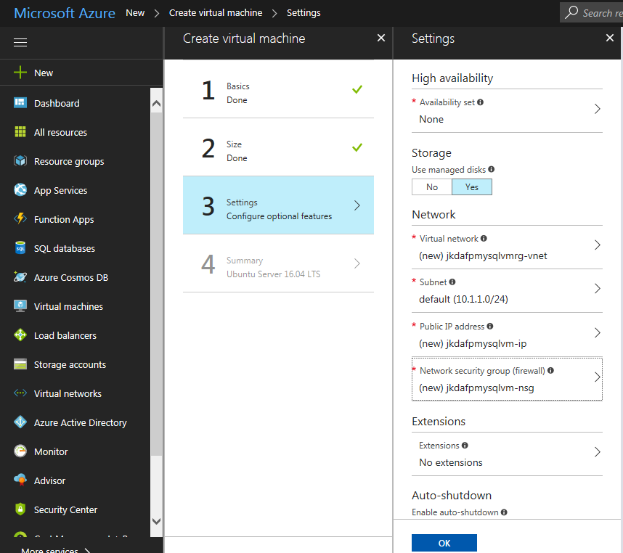

And then created from the Summary screen:

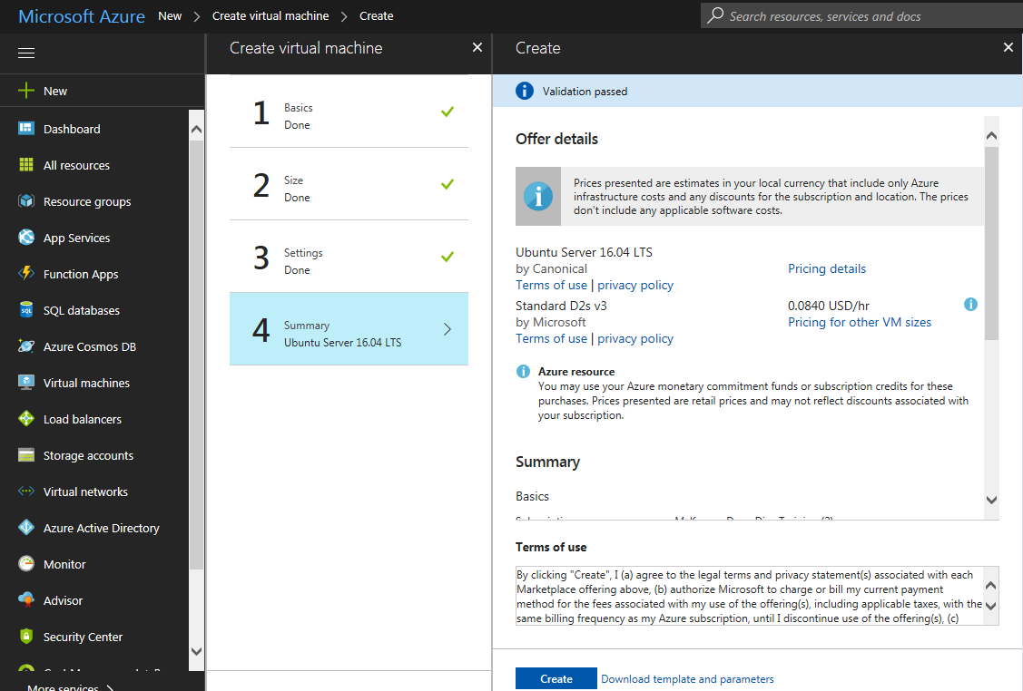

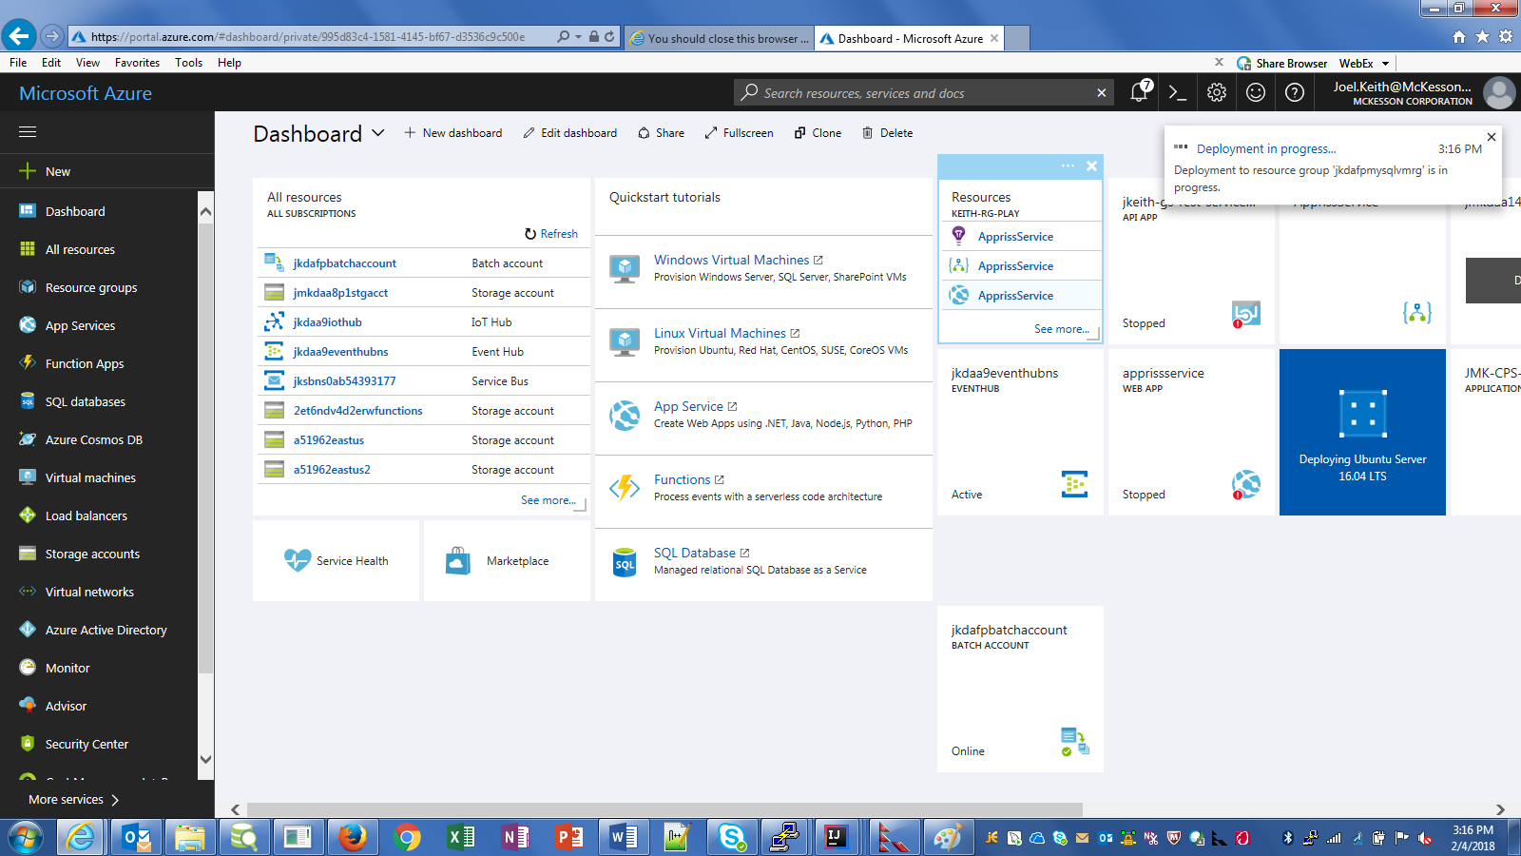

Once the VM is created, make note of the public IP address as that will be used to SSH to the box and perform the MySQL installation:

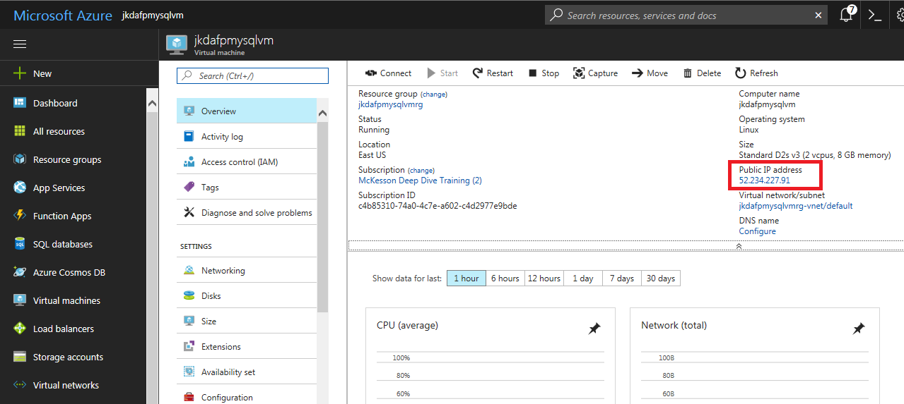

* 1. Confirm SSH access to the VM

Open a shell of some sort (Cygwin, etc) and ssh to the newly created VM using the user id and password created during the VM Installation and the public IP Address:

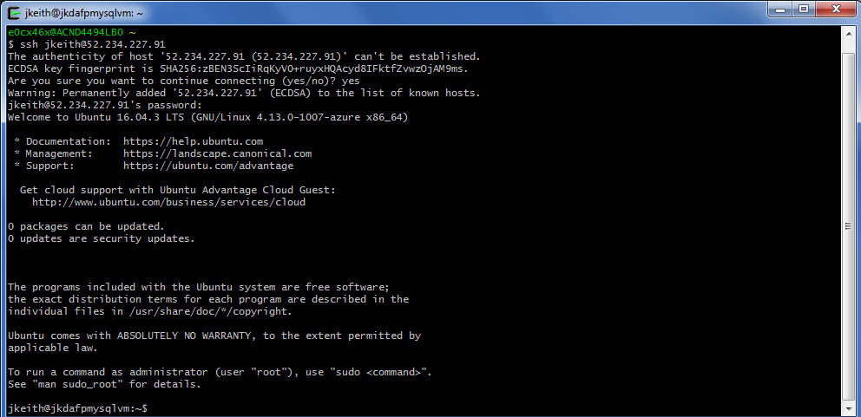

* 1. Install MySQL service

This site provides a good set of instructions for installing MySQL on Ubuntu:

<https://www.digitalocean.com/community/tutorials/how-to-install-mysql-on-ubuntu-16-04>

Following the instruction on the site, execute these commands to install MySQL 5.7:

* sudo apt-get update
* sudo apt-get install mysql-server
* mysql_secure_installation

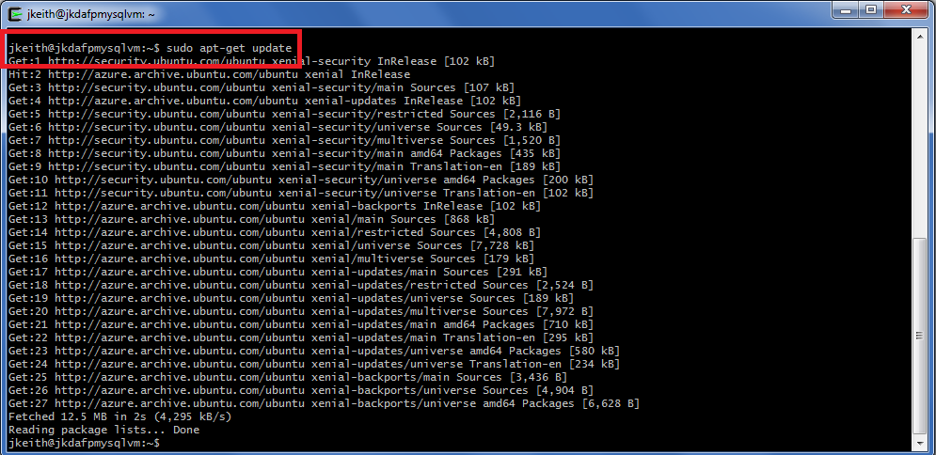

Run the install command and respond with “Yes” when first prompted to authorize installation of multiple MBs of updates:

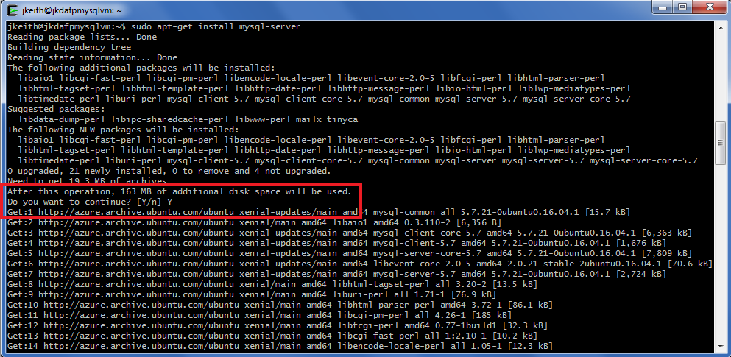

then create a new password for the MySQL root user:

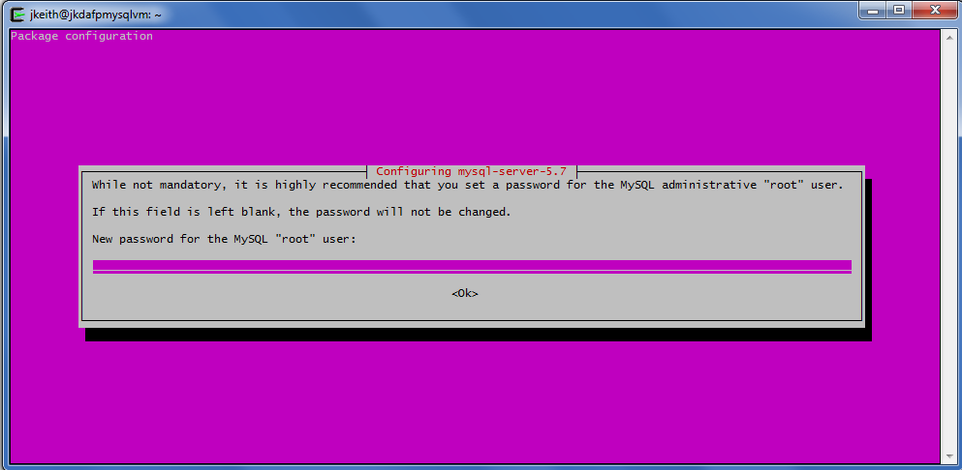

And confirm the password:

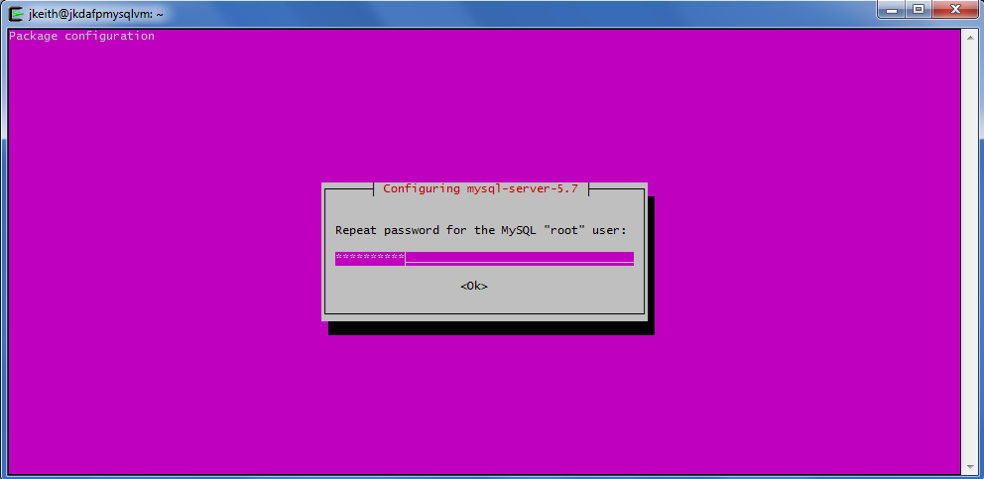

And the installation should complete successfully:

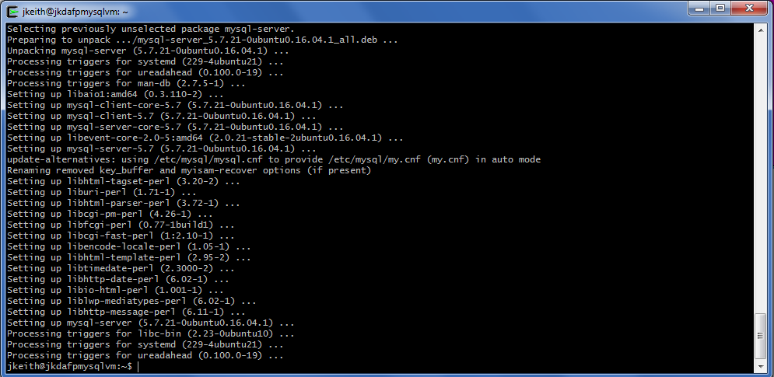

Now install the security update:

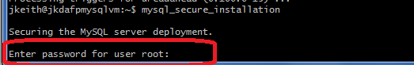

Enter the password for the root user and answer the prompts to set the MySQL installation up as secure as you would like it. I chose a “medium” level password check and did remove anonymous users, but allowed the root user to log in remotely and kept the “test” table:

VALIDATE PASSWORD PLUGIN can be used to test passwords

and improve security. It checks the strength of password

and allows the users to set only those passwords which are

secure enough. Would you like to setup VALIDATE PASSWORD plugin?

Press y|Y for Yes, any other key for No: y

There are three levels of password validation policy:

LOW Length >= 8

MEDIUM Length >= 8, numeric, mixed case, and special characters

STRONG Length >= 8, numeric, mixed case, special characters and dictionary file

Please enter 0 = LOW, 1 = MEDIUM and 2 = STRONG: 1

Using existing password for root.

Estimated strength of the password: 50

Change the password for root ? ((Press y|Y for Yes, any other key for No) : n

... skipping.

By default, a MySQL installation has an anonymous user,

allowing anyone to log into MySQL without having to have

a user account created for them. This is intended only for

testing, and to make the installation go a bit smoother.

You should remove them before moving into a production

environment.

Remove anonymous users? (Press y|Y for Yes, any other key for No) : y

Success.

Normally, root should only be allowed to connect from

'localhost'. This ensures that someone cannot guess at

the root password from the network.

Disallow root login remotely? (Press y|Y for Yes, any other key for No) : n

... skipping.

By default, MySQL comes with a database named 'test' that

anyone can access. This is also intended only for testing,

and should be removed before moving into a production

environment.

Remove test database and access to it? (Press y|Y for Yes, any other key for No) : n

... skipping.

Reloading the privilege tables will ensure that all changes

made so far will take effect immediately.

Reload privilege tables now? (Press y|Y for Yes, any other key for No) : y

Success.

All done!

jkeith@jkdafpmysqlvm:~$

The last step is to test that MySQL is running. Run this command to ensure the service is running:

systemctl status mysql.service

And the service is running:

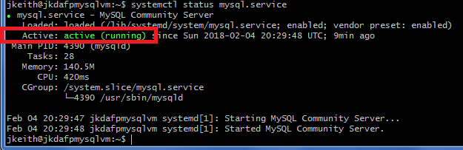

1. Allow remote access to your MySQL service. The Ubuntu installation does not allow access from remote IPs by default
   1. Navigate to the /etc/mysql/mysql.conf.d directory on your VM
   2. Edit the mysqld.cnf file using sudo:
      1. sudo vi mysqld.cnf
   3. Comment out these two lines:
      1. skip-external-locking
      2. bind-address 127.0.0.1

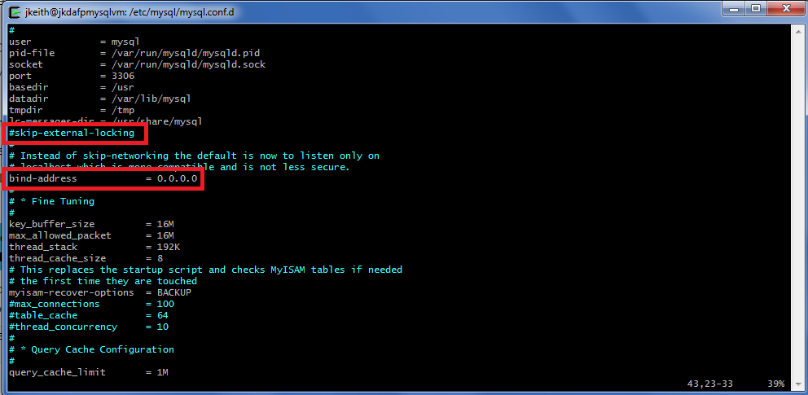

* 1. Save the file and then restart the MySQL service:
     1. systemctl stop mysql.service
     2. systemctl start mysql.service
     3. enter the password for your VM user when asked:

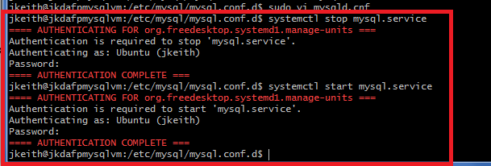

Confirm the service is running again using “systemctl status mysql.service”

* 1. Log into mysql as the root user and grant access to any host:
     1. jkeith@jkdafpmysqlvm:~$ mysql --user=root --password
     2. Enter password:
     3. Welcome to the MySQL monitor. Commands end with ; or \g.
     4. mysql> grant all on *.* to 'root'@'%' identified by '{yourpasswordhere}' with grant option;
     5. Query OK, 0 rows affected, 1 warning (0.00 sec)
     6. mysql> flush privileges;
     7. Query OK, 0 rows affected (0.00 sec)

1. Confirm you can access the MySQL server from a remote environment
   1. This makes loading the seed data scripts simpler and may be required in order to run queries once data is loaded into the “history” table
   2. I installed MySQL Workbench to allow easier access. You could also use your SSH session and run scripts through the MySQL command line but would have to also SFTP the scripts to the VM first.
   3. Here are the steps using MySQL Workbench:

MySQL Workbench installation location:

https://dev.mysql.com/downloads/workbench/

Open up MySQL Workbench, you should see a screen similar to this:

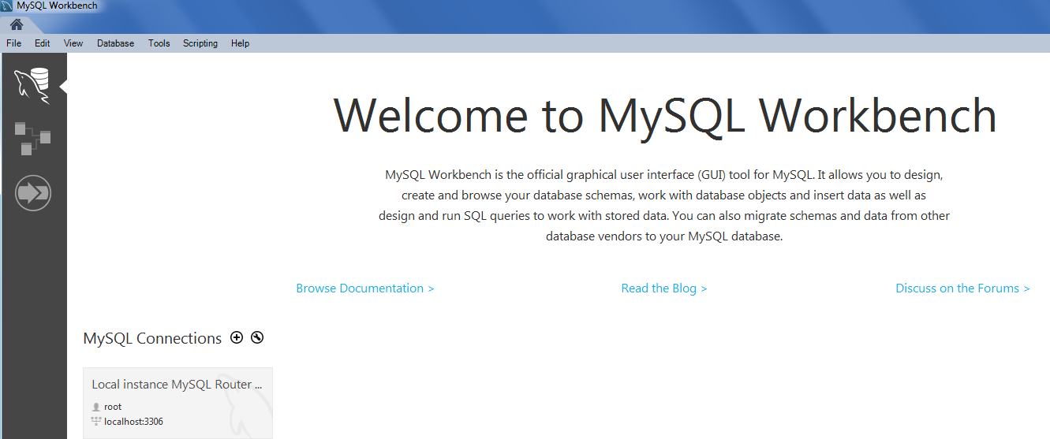

You may or may not have a local MySQL instance available, depending on whether you installed just the workbench or a local MySQL instance as well. I installed a local instance as I used it for testing all scripts and the Azure Batch tasks prior to deployment to Azure.

Add a Connection to the remote MySQL instance running on your VM by clicking the “+” button next to “MySQL Connections”. You can also use the “Database, Manage Connections…” menu to access the Connection dialog as well:

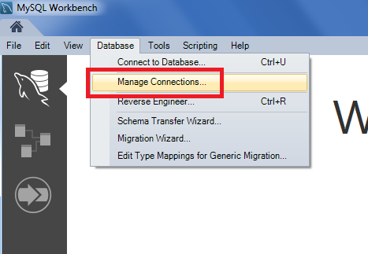

If you use the menu option, select “New” from the resulting screen to start creating a new Connection:

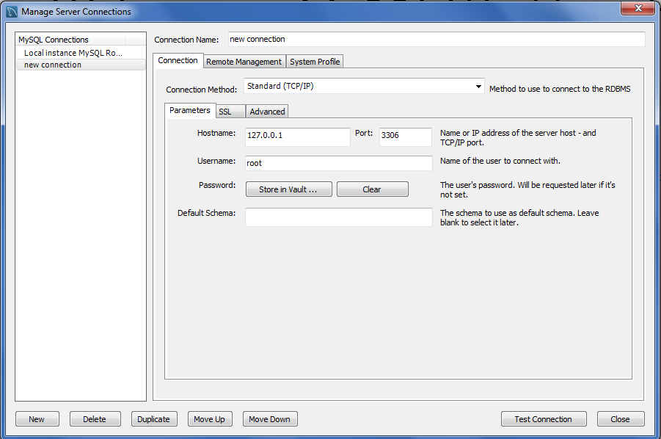

Enter a name for the Connection, and then use the Public IP from your VM as the “HostName”. If you are not all that concerned about security, use the “Store In Vault” option to store the root password. I typically do not and force entry of the password at all times. Leave the Default Schema blank at this time:

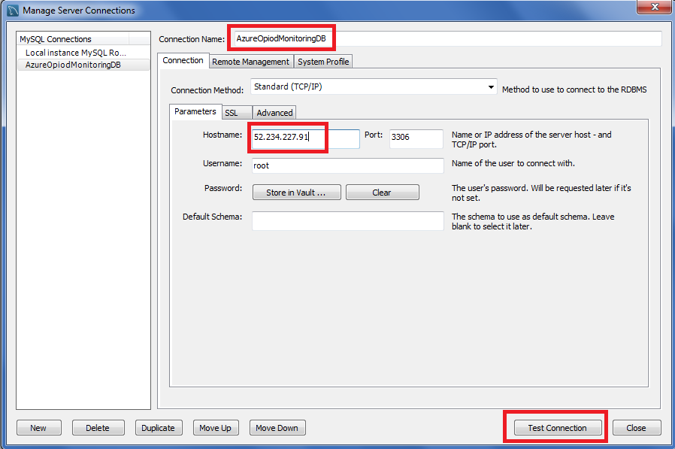

Click Test Connection and you may be prompted for the password for the user:

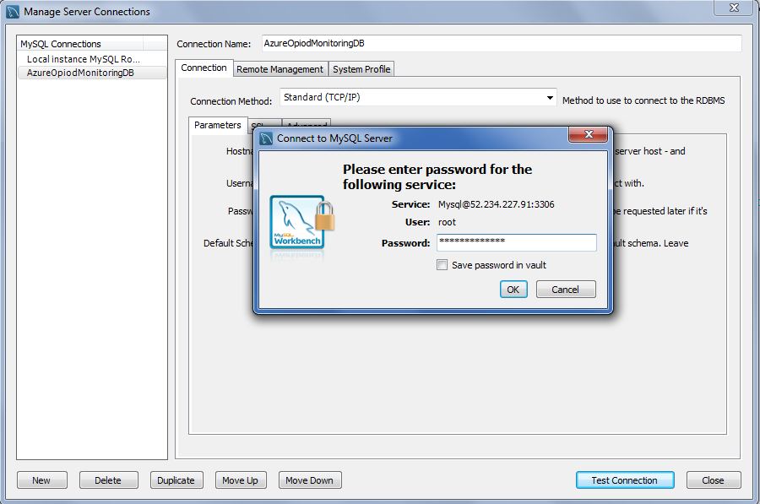

Enter the password and click “OK”. You should see a successful response like the one below:

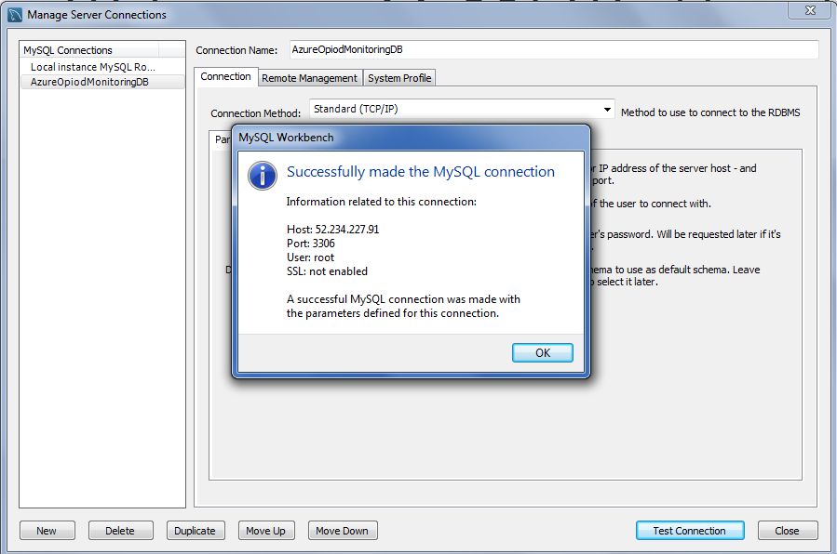

Select OK, then Close, then Database, Connect to Database to log into the server:

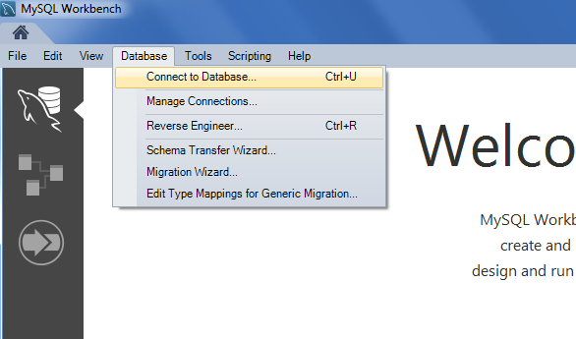

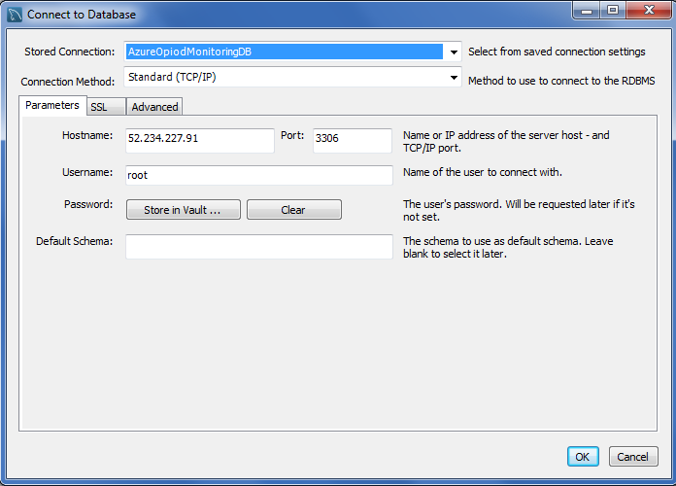

You may or may not be prompted for the password, depending on whether you stored the password in the Vault or not, but if/when your login is successful, you should see a screen similar to this:

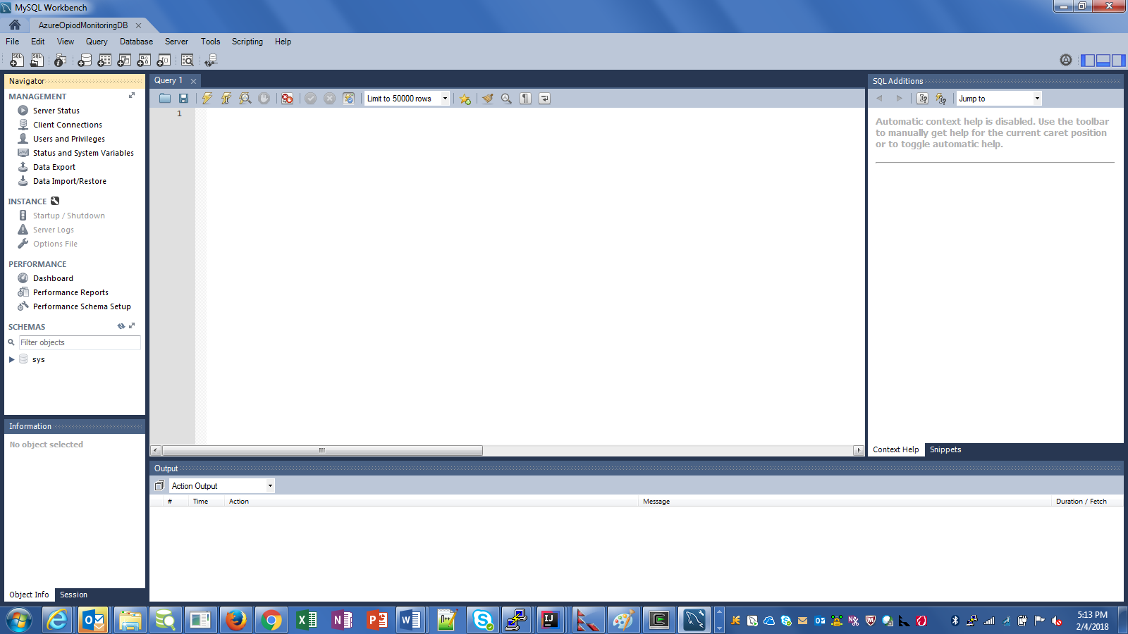

1. Run the SQL script to set up the database and tables
   1. The SQL scripts are located within the downloaded GitHub repository at {root}\DeepAzureFinalProject\OpioidOrderingTracking\db
   2. The database create script is called 1-OpiodOrderingTracking-MySQL-DDL.sql
   3. All tables are defined in one database
   4. Load the file into MySQL Workbench
      1. File, Open SQL Script…

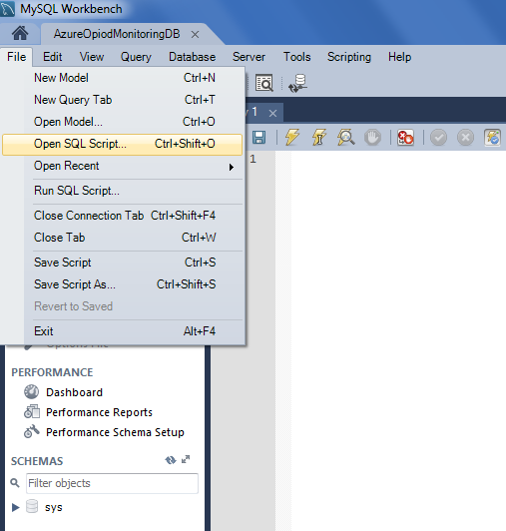

* + 1. Navigate to the directory containing the load scripts and select the 1-OpiodOrderingTracking-MySQL-DDL.sql file

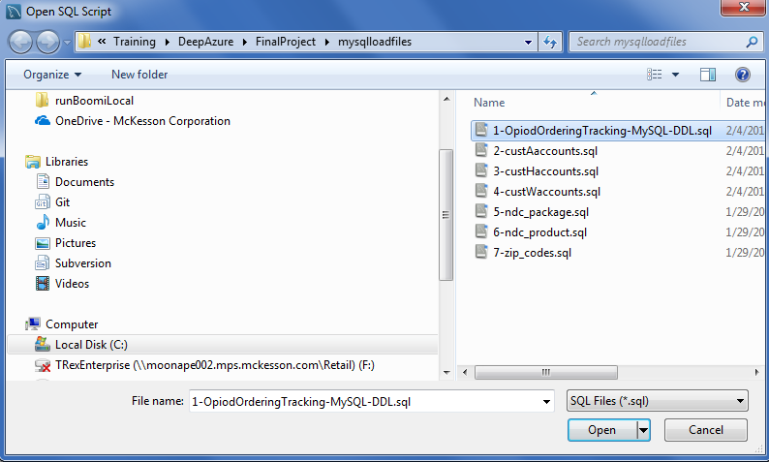

* + 1. Click on the “Lightning bolt” on the tool bar to run the script:

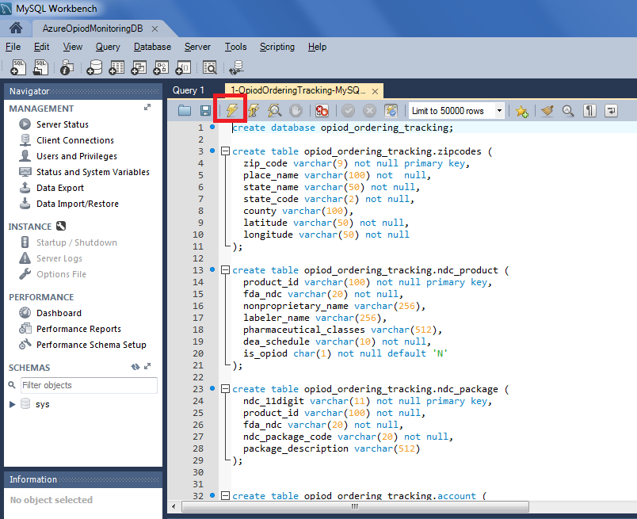

* + 1. Check for any errors. You should not need to “commit” as DDL statements create objects immediately

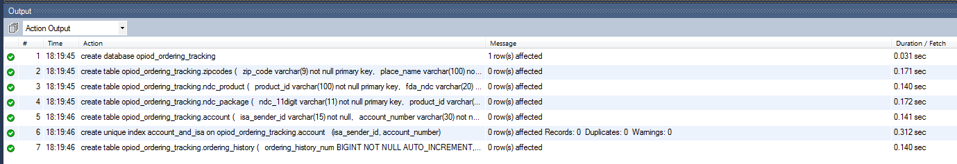

1. Run the other 6 load scripts to insert “seed data” into the tables (except the ordering_history table as that is populate at “run time” only).
   1. The order of the scripts doesn’t really matter but the files are numbered in a reasonable sequence
   2. Some of these scripts may take a long time to run as they contain 1000s of rows
   3. Use the same steps as above to locate each file, select it, and execute it
   4. Be alert for any errors. The default setting for MySQL Workbench is to stop on the first error. Also, “Auto Commit” is turned on by default, so records that processed successfully before any error will remain in the table.
   5. You may need to increase the limit on the number of rows to 50000 or more

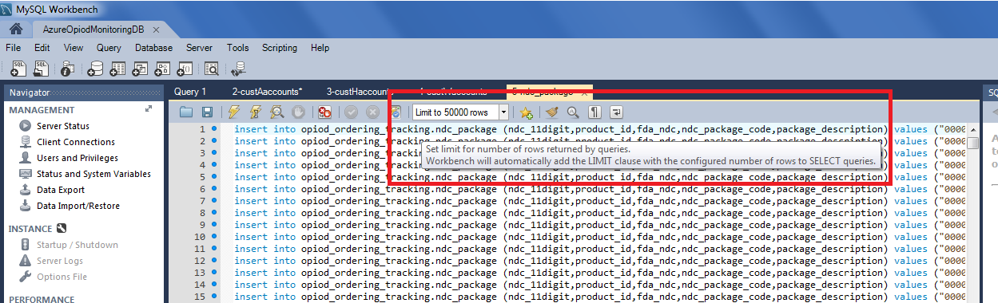

* 1. Start with the “Account” table scripts
     1. 2-custAaccounts.sql (2292 rows)
     2. 3-custHaccounts.sql (785 rows)
     3. 4-custAaccounts.sql (376 rows)
  2. Next run the “NDC” table scripts
     1. 5-ndc_package.sql (13213 rows)
     2. 6-ndc_product.sql (5122 rows)
  3. Finally load the Zip code data
     1. 7-zip_codes.sql (40933 rows)
        1. This file will take the longest to load by far. If connectivity issues interrupt the execution, you can change the option to allow the script to continue execution after an error and then re-run the script. You will see errors for all rows that were able to be inserted but then the successful inserts will continue eventually.

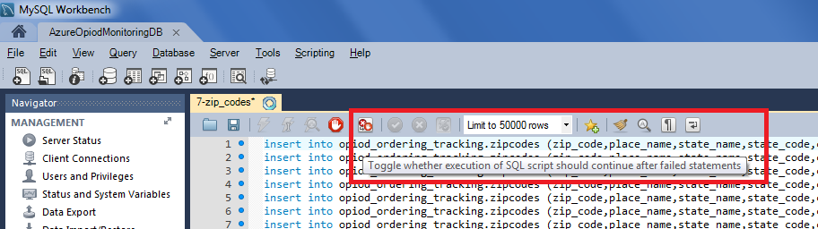

1. Set up a Batch Account in Azure along with a Storage Account
   1. From Azure Portal, select New, then search for Batch Service

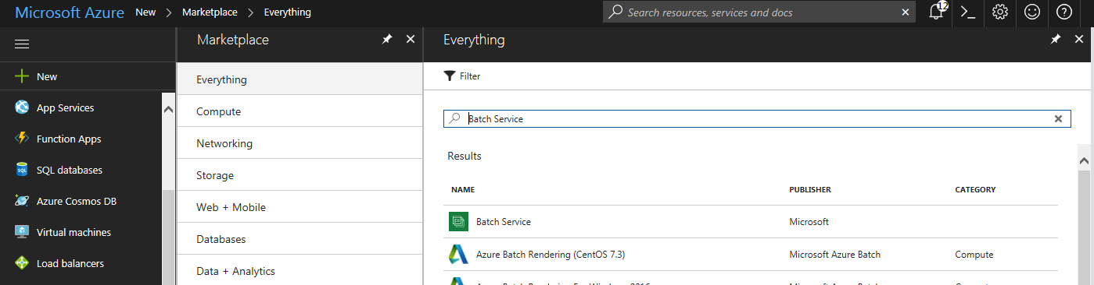

* 1. Select Batch Service

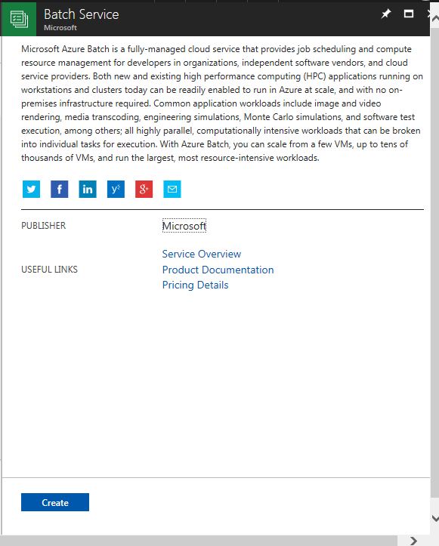

* 1. Then Create
  2. Fill in the initial fields. Make certain to keep Pool Allocation Mode set to “Batch Service”

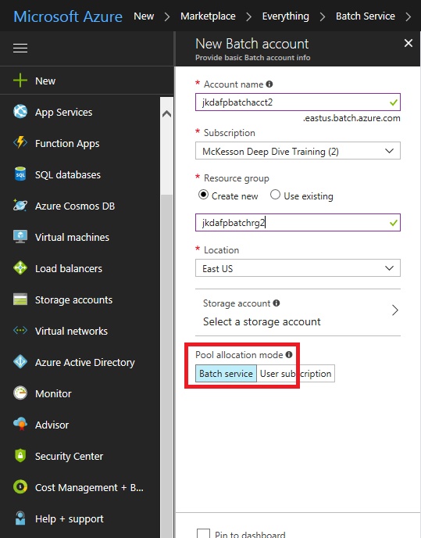

* 1. Select a Storage Account or create a new one for your Batch files and such

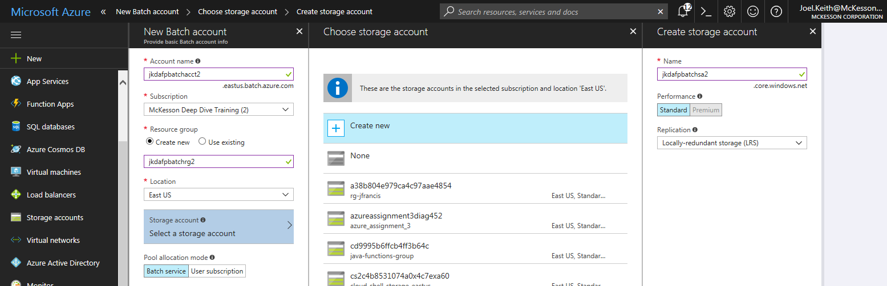

* 1. Click OK to select the Storage Account

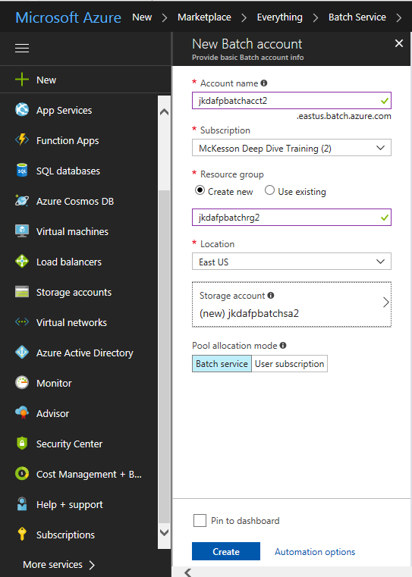

* 1. Click “Create” to create the Batch Account ( you may want to select the “Pin to dashboard” option) and then access the main page for the account

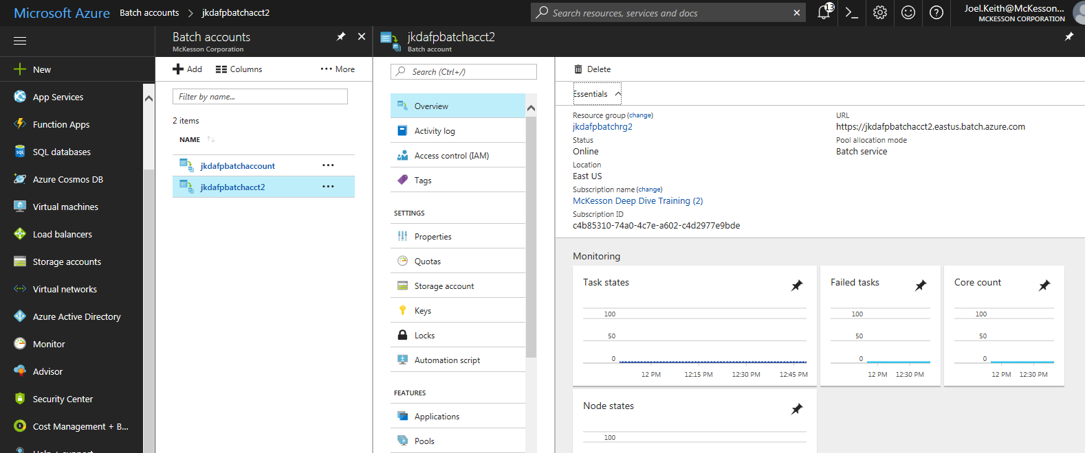

* 1. There are many pieces of data you will need when executing Batch Jobs within the account. Make note of these now or come back to the Batch Account later to obtain the values
     1. Batch URL

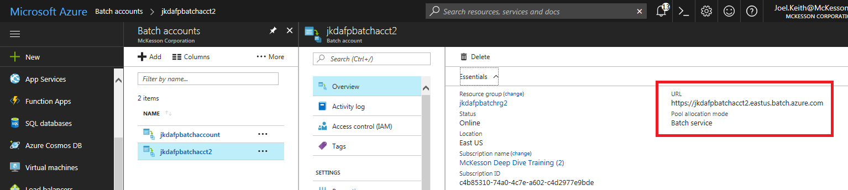

* + 1. Access Keys
       1. Select the Keys link and copy the Primary Access Key value

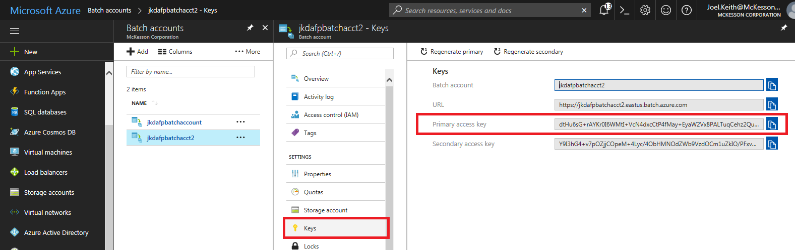

1. Create a Pool and allocate VMs for the Pool
   1. Azure Batch requires a pool of 1 or more VMs exist, as jobs and tasks are scheduled into these VMs (also called Nodes)
   2. Access the Pools setting from the Batch Account

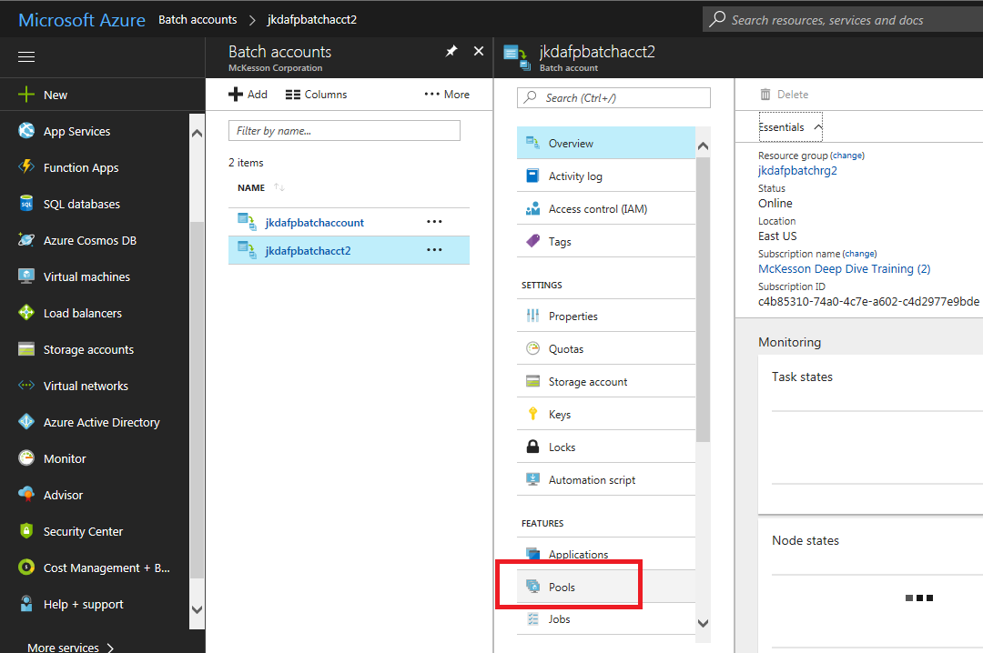

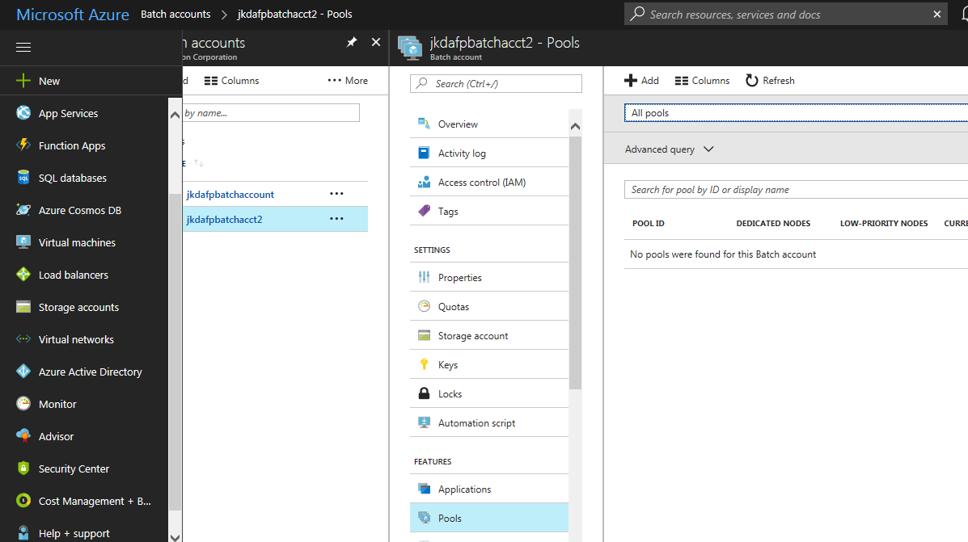

* 1. Click on the Add option to begin the process of adding a Pool
  2. Enter a Pool Id, optional Display Name, and then select the type of VM to use for all nodes in the Pool

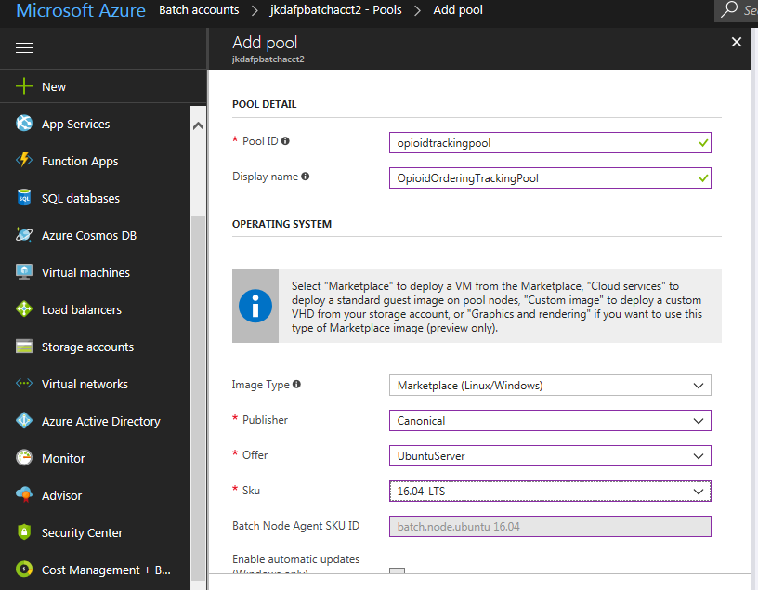

* 1. Scroll the pane to access the next set of options
  2. Enter the size of the data disk you want to use (should not need too large of disk for this example)

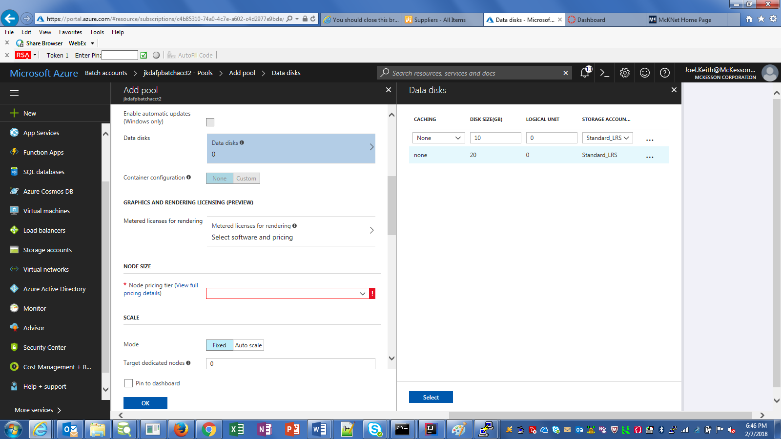

* 1. Click Select to save the disk setting
  2. Select a size for the VMs (again, don’t need to large a configuration for this example)
  3. Enter the number of Nodes you want to have in the pool. I suggest at least 2 for this example, but the more you select the more that will need to be updated with a Java 1.8 installation..

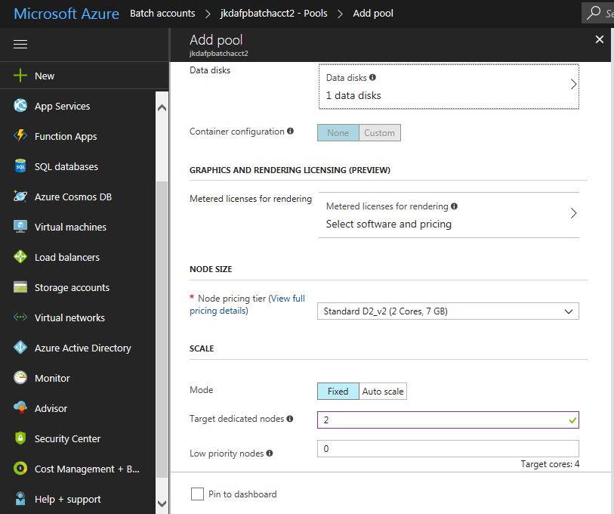

* 1. Scroll down to the next set of options for the Pool

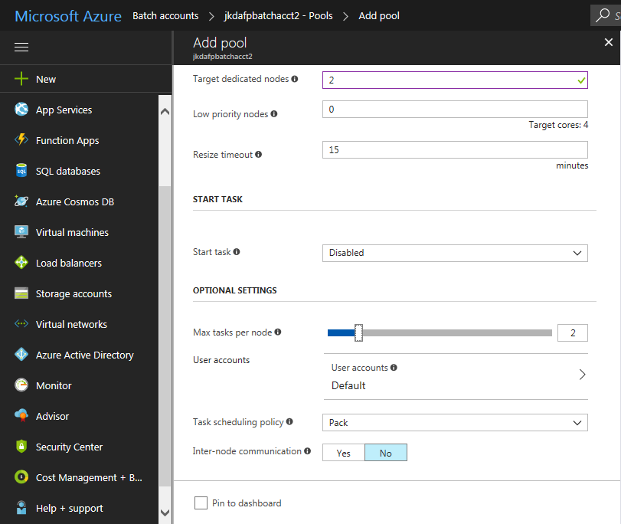

* 1. If you would like to use Low Priority nodes, you can enter the number to use. Low Priority nodes are cheaper but will only accept jobs if they have excess capacity and so can potentially cause jobs to be delayed.
  2. Leave the Resize Timeout at 15 minutes and Start Task as Disabled (we won’t be using a Start Task for this example)
  3. You can adjust the “Max Tasks per node” to allow more tasks to run on each node at the same time. I suggest using more than 2 if you want to load a large amount of test data.
  4. Select the User Accounts option configure access to each of the VMs, so a Java installation can be run

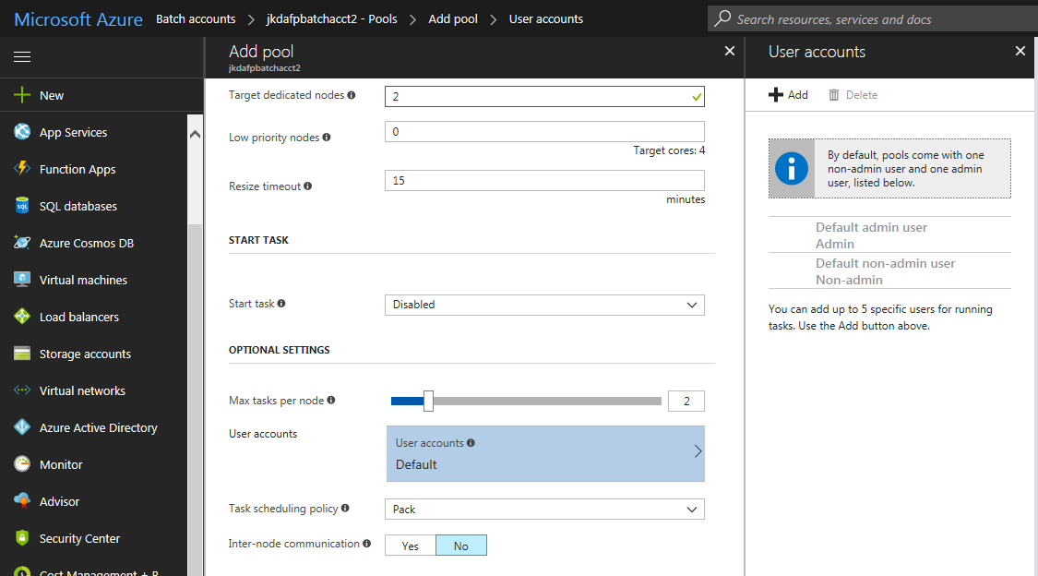

* + 1. We do need an Admin user and it may be simpler to create your own user so you remember the password, etc.
    2. Click the Add option on top to start the User Add process
    3. Enter the user name you would like, and the Password (this has to be a pretty secure password by Azure policy), and then select the Admin User Identity

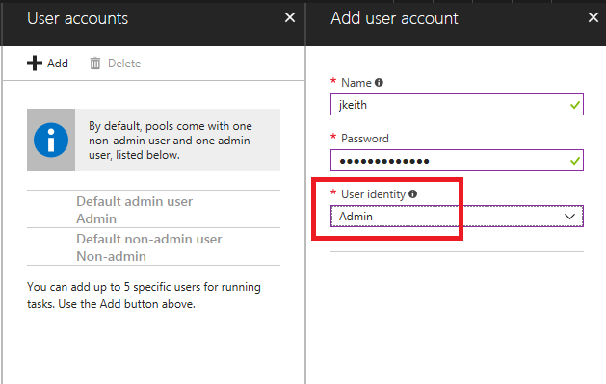

* + 1. Click the Add button to add the Account to the Pool

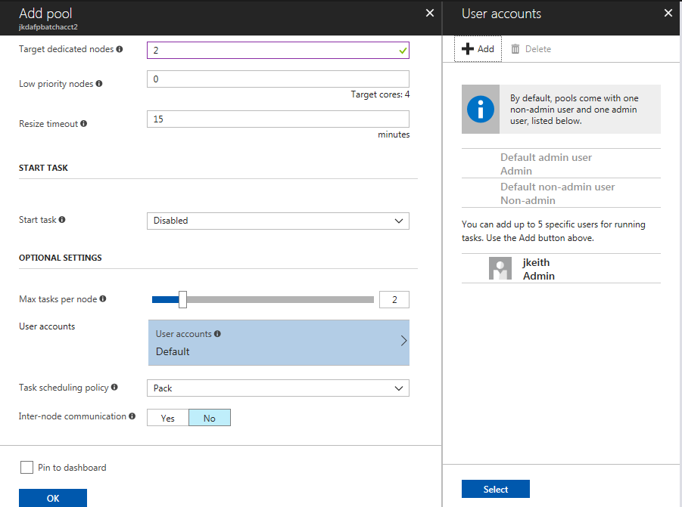

* + 1. Click the Select button to select the new User for the Pool

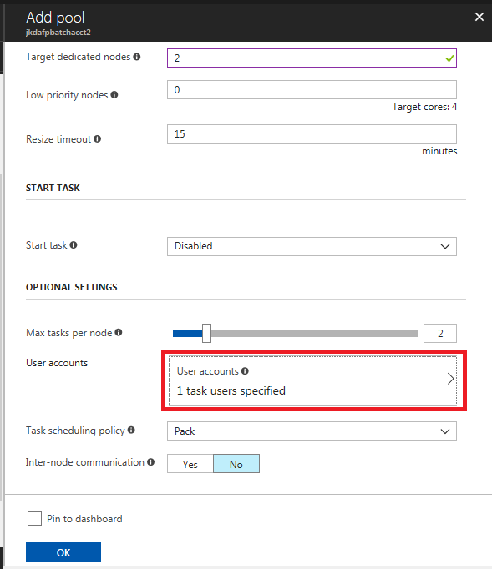

* 1. Leave the Task scheduling policy set to “Pack” at this time.
  2. Leave Inter-node communication set to “No” as we will not be using inter-node communication with this example.
  3. Scroll to the next set of properties to configure

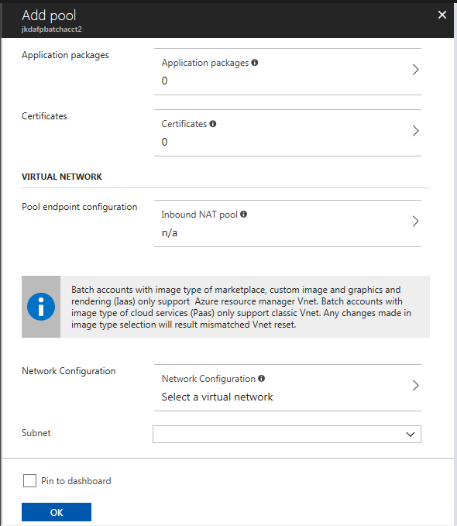

* 1. Leave Application Packages set to 0, and Certificates set to 0.
  2. There is no need for an Inbound NAT pool so leave that unconfigured.
  3. Access the Network Configuration to set up a virtual network

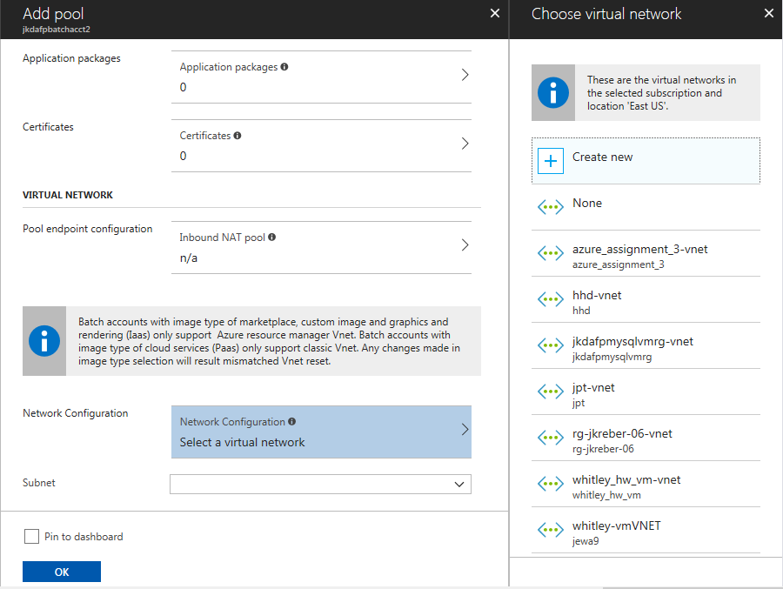

* + 1. If you know of an existing subnet you can use, go ahead and select it, but it is likely you will need to create a new subnet for the Pool so click “Create new” to begin that process
    2. Change the name to something you will recognize, but the other settings are likely to be ok “as is”

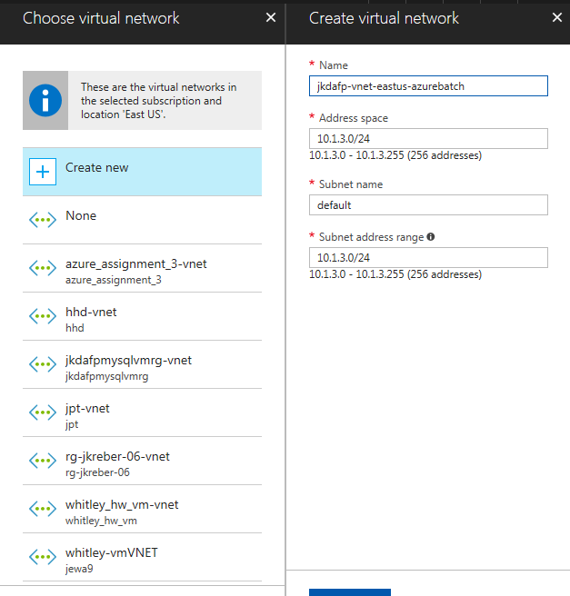

* + 1. Click OK to create the Virtual Network

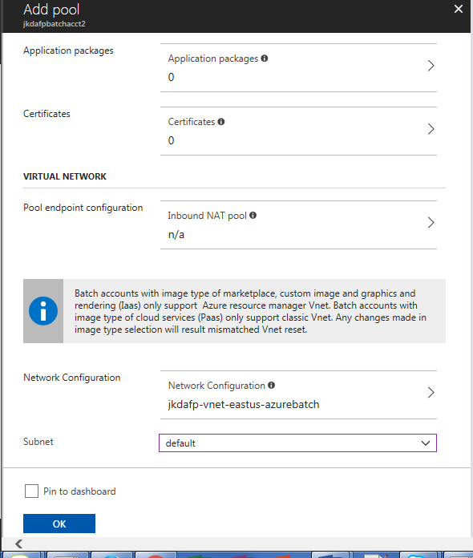

* 1. Click OK to create the Pool and Nodes

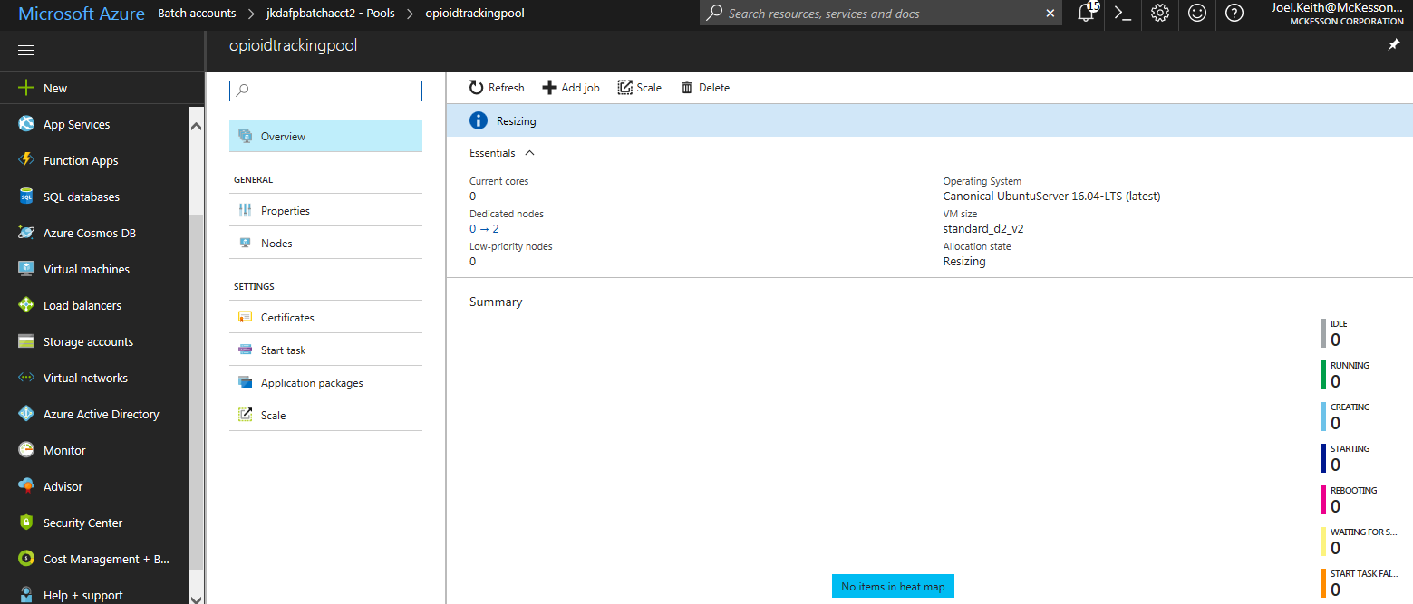

It may take a while for the pool to resize and the nodes to be fully created but eventually the pool should settle into a “Steady” state and you should see the number of nodes and cores updated:

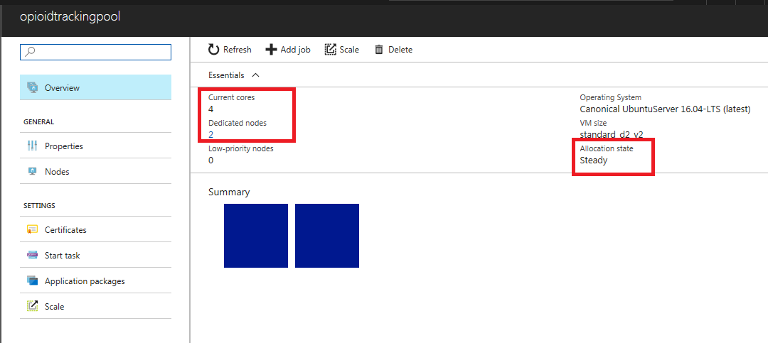

1. Install Java 1.8 on each of the Pool nodes
   1. The nodes in the Pool should now be able to be accessed via SSH using the user name and password entered when the nodes were created.
   2. Access each Node to determine its IP address and/or note the connection string for each node
      1. Click on the Nodes link to view the nodes

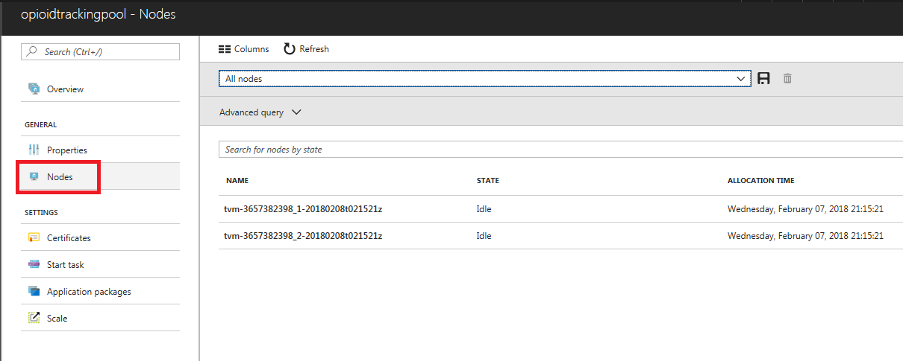

* + 1. Click on each Node Name to access the settings for each Node

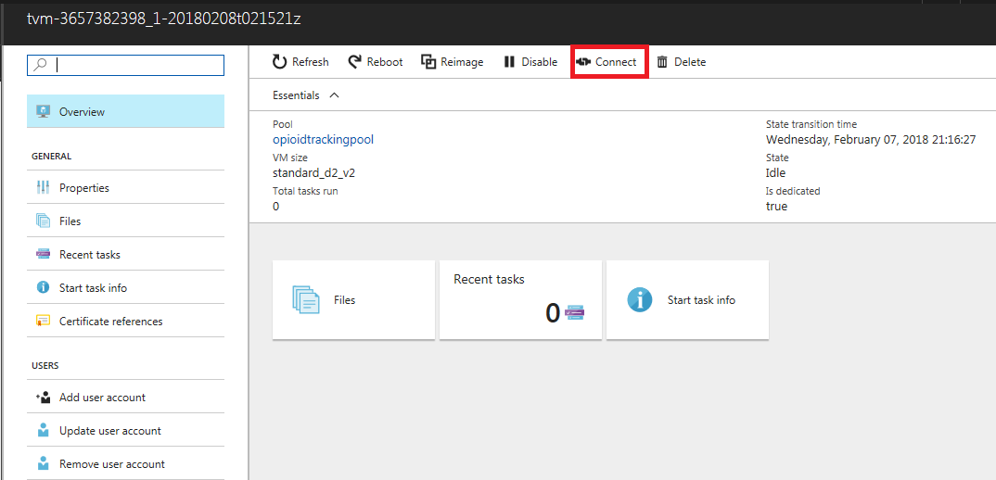

* + 1. Click on the Connect button to view the connection information for the Node

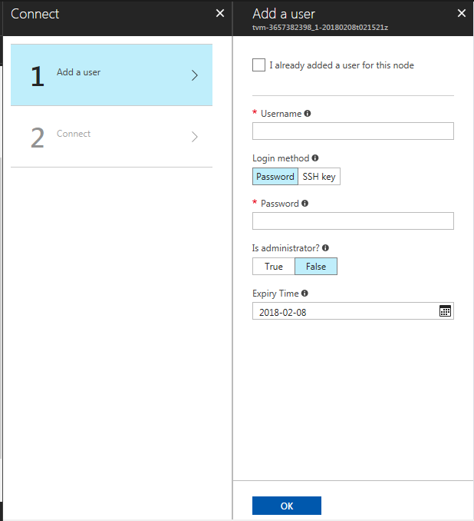

* + 1. Select the “I already added a user for this node” option

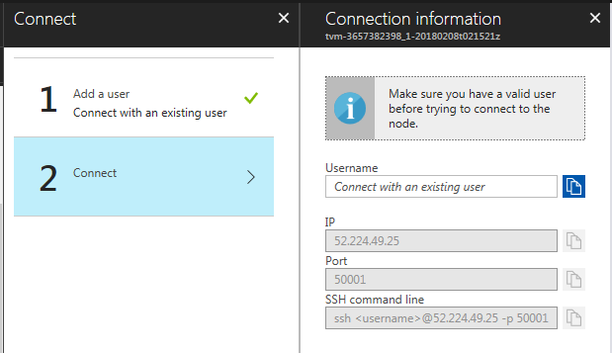

* + 1. Enter the user name you added earlier
    2. Note the SSH command line to use

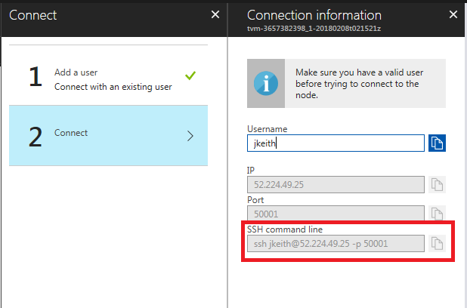

* + 1. Make note of the command line and repeat these steps for all other nodes in the Pool

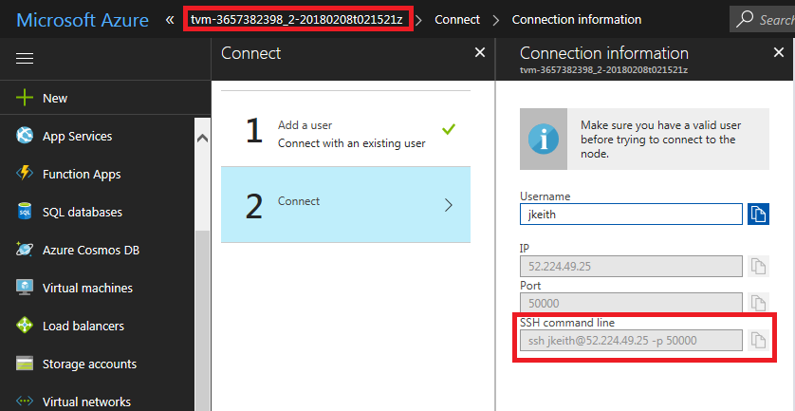

* + 1. For the 2 Nodes I created, the ssh information is:
       1. ssh jkeith@52.224.49.25 -p 50001
       2. ssh jkeith@52.224.49.25 -p 50000
  1. SSH to each node and perform these steps to install Java 1.8
     1. Since I selected Ubuntu as the OS for my nodes, I used these instructions
        1. This is the site I used as a resource: <https://www.digitalocean.com/community/tutorials/how-to-install-java-with-apt-get-on-ubuntu-16-04>

sudo add-apt-repository ppa:webupd8team/java

sudo apt-get update

sudo apt-get install oracle-java8-installer

* + - 1. I used Cygwin to access the nodes and do the install

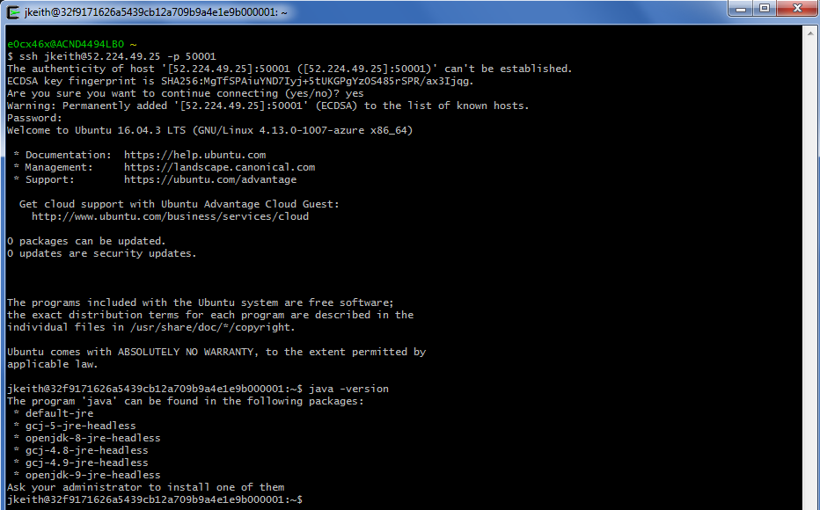

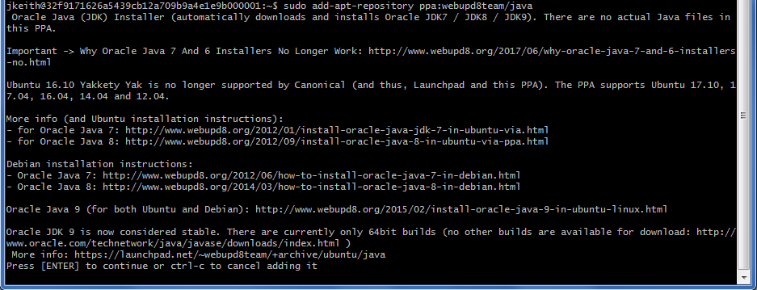

Press Enter to add the Java PPA

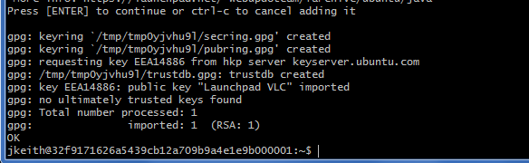

Then run the apt-get update command:

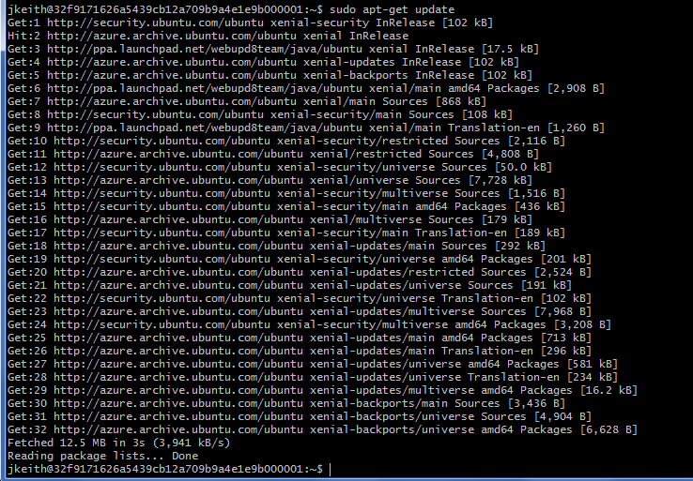

Finally install the 1.8 JDK

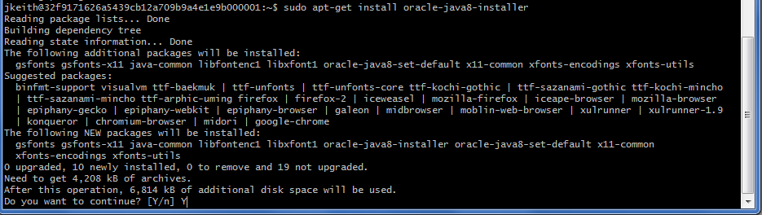

Answer Y to the prompt to continue the installation. You will be presented with a prompt to accept the license terms. Navigate to the OK button and hit the Enter key

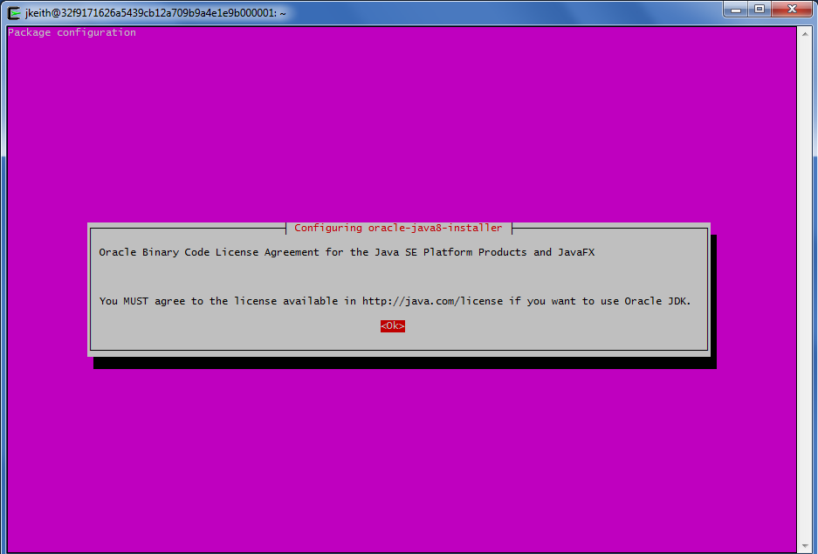

Answer Yes to the following screen:

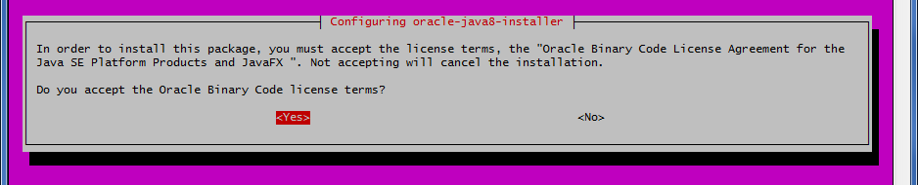

A large number of packages will be installed but eventually the install will complete:

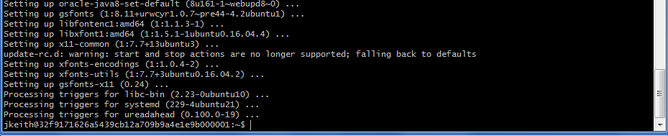

Run the “java -version” command to verify Java is available on the system path:

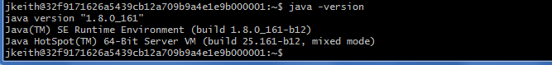

* + - 1. Execute these same steps on the other Node(s) in the pool

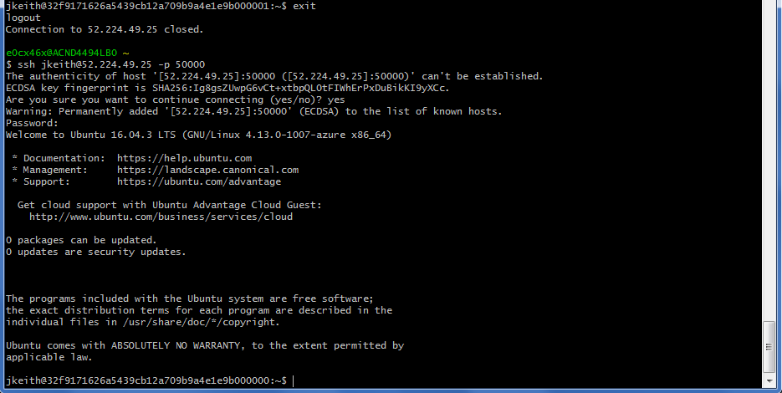

…

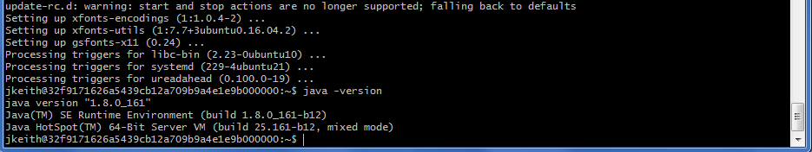

* + 1. If you selected CentOS, these commands work for installing Java 1.8:
       1. wget --no-cookies --no-check-certificate --header "Cookie: gpw_e24=http%3A%2F%2Fwww.oracle.com%2F; oraclelicense=accept-securebackup-cookie" \
       2. "http://download.oracle.com/otn-pub/java/jdk/8u161-b12/2f38c3b165be4555a1fa6e98c45e0808/jdk-8u161-linux-x64.rpm"
       3. sudo yum localinstall jdk-8u161-linux-x64.rpm

1. Configure the Opioid Ordering Tracking batch script
   1. The Windows batch script is located in {root}\DeepAzureFinalProject\OpioidOrderingTracking\bin
   2. The script is called runOpioidOrderingTracking.bat
   3. Update the bat file to set the correct values for Environment Variables used by the Batch Tasks within the Batch Job
      1. JAVA_HOME – if you do not have JAVA_HOME set or it does not point to a 1.8 JDK or JRE, then uncomment this (and the PATH) and set JAVA_HOME to the location of a 1.8 JDK or JRE
      2. STORAGE_ACCOUNT_KEY – the primary key to the storage account linked to your Batch account
      3. STORAGE_ACCOUNT_NAME – the name of the Storage Account

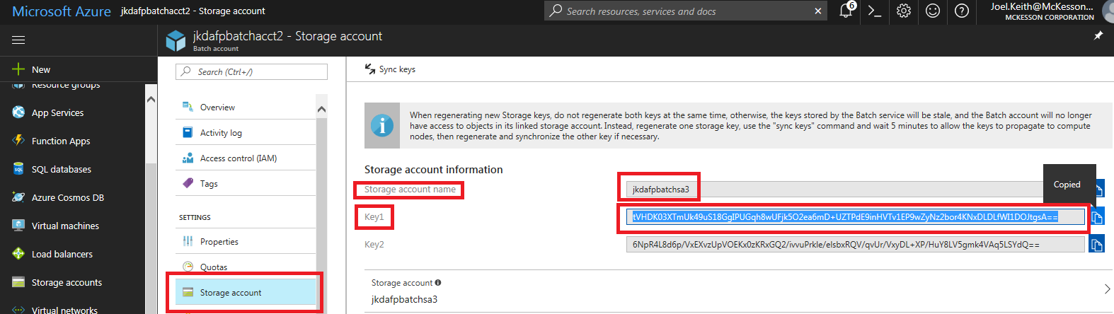

* + 1. AZURE_BATCH_ACCOUNT – the name of your Azure Batch Account
    2. AZURE_BATCH_ACCESS_KEY – the primary Access Key for your Batch Account
    3. AZURE_BATCH_ENDPOINT – the URL for your Batch Account

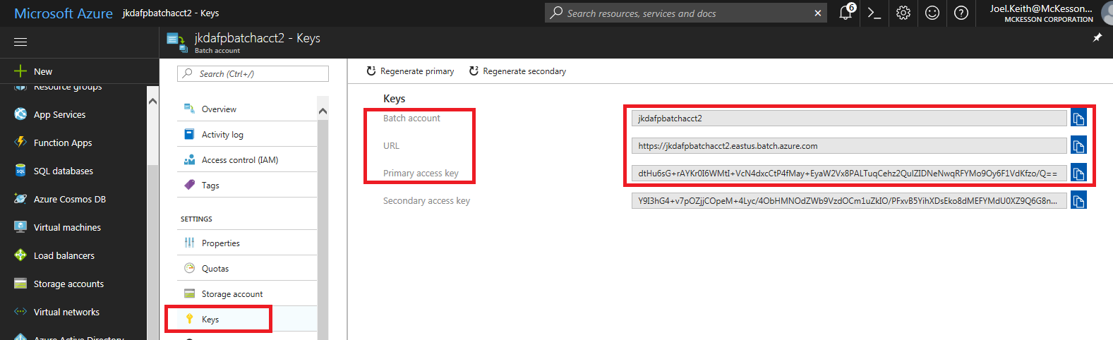

* + 1. BATCH_POOL_ID – the ID for the Pool you created under your Batch Account

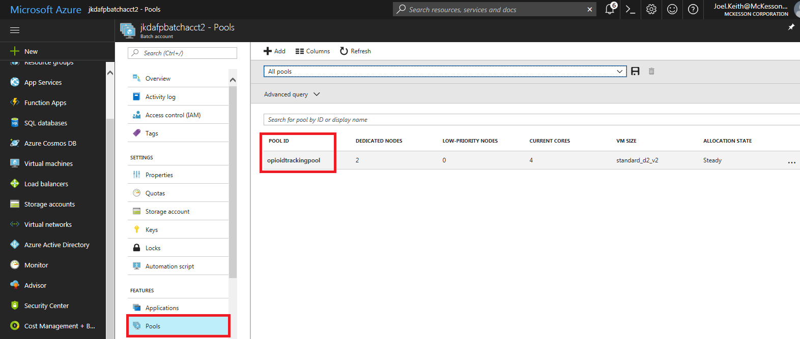

* + 1. JDBC_URL – The default url is:
       1. jdbc:mysql://{IP or DNS of MySQL VM}:3306/opiod_ordering_tracking?user={MySQL User}&password={MySQL User password}&useSSL=false
       2. Replace with the IP for your MySQL VM in Azure
       3. Replace {MySQLUser} with the MySQL user you created (typically this is root)
       4. Replace {MySQLPassword} with the password for the MySQL user
       5. Leave &useSSL=false as-is
       6. Example of a complete URL:
          1. set JDBC_URL="jdbc:mysql://40.71.209.66:3306/opiod_ordering_tracking?user=root&password=yourpasswordhere&useSSL=false"
    2. DELETE_JOBS – if you want to clean up the Jobs, tasks, and all files automatically after each run, then set this to “true” (sans quotes), otherwise set it to “false”. You will be able to view the jobs in Azure Portal or “BatchLabs” but will have to manually delete all Jobs (can be done easily using BatchLabs)

1. Copy files to the Input directory
   1. There are example EDI files contained in the InboundEDI_855_sourcefiles.zip file in the {root}\DeepAzureFinalProject\OpioidOrderingTracking directory
   2. Unzip this file into a different directory (be careful, there are over 6000 files included…) or you can unzip batches of files as you go
   3. Copy a batch of files into the {root}\DeepAzureFinalProject\OpioidOrderingTracking \input directory prior to executing the application. These files WILL be deleted from the input directory as each job processes.
   4. The process should be able to handle loading 1000s of files at a time but you may want to start of small to get the hang of how to execute the process and view
2. Install the BatchLabs tool to aid in viewing your Batch Account and run results
   1. You can view all data in the Azure Portal but BatchLabs provides a better interface in most situations and tends to be quicker at updating
   2. The “BatchLabs” application is located at <https://azure.github.io/BatchLabs/>
      1. This is a beta application but it provides a friendlier environment for viewing your Batch Account
      2. Follow the download instructions for whichever version you feel comfortable with using
   3. When you launch BatchLabs, it prompts you to log into your Azure account:

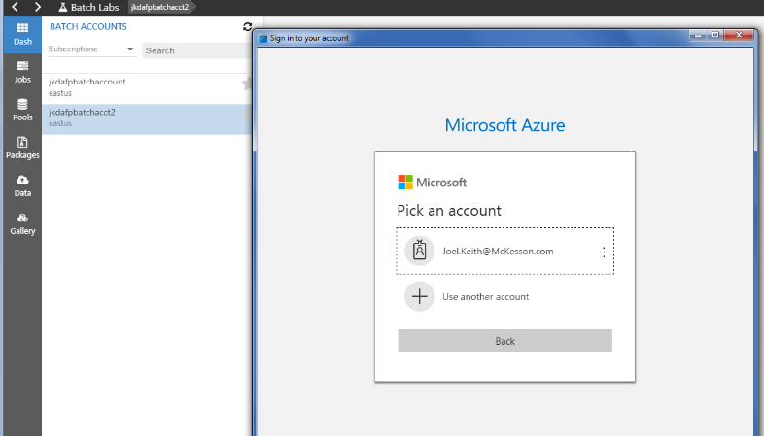

* 1. Enter your account id (the first time in) and click on it to begin the login process. Subsequent times, you will just need to select your account
  2. You will see a message that you are being taken to your login page and then will likely be prompted to enter your password

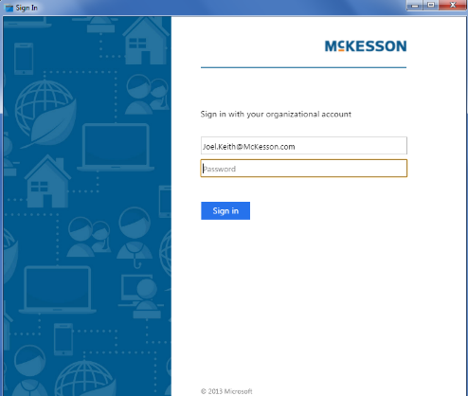

* 1. Enter your password and click the Sign In button.
  2. BatchLabs should show any existing Batch Accounts for your Azure account and any existing job runs, etc

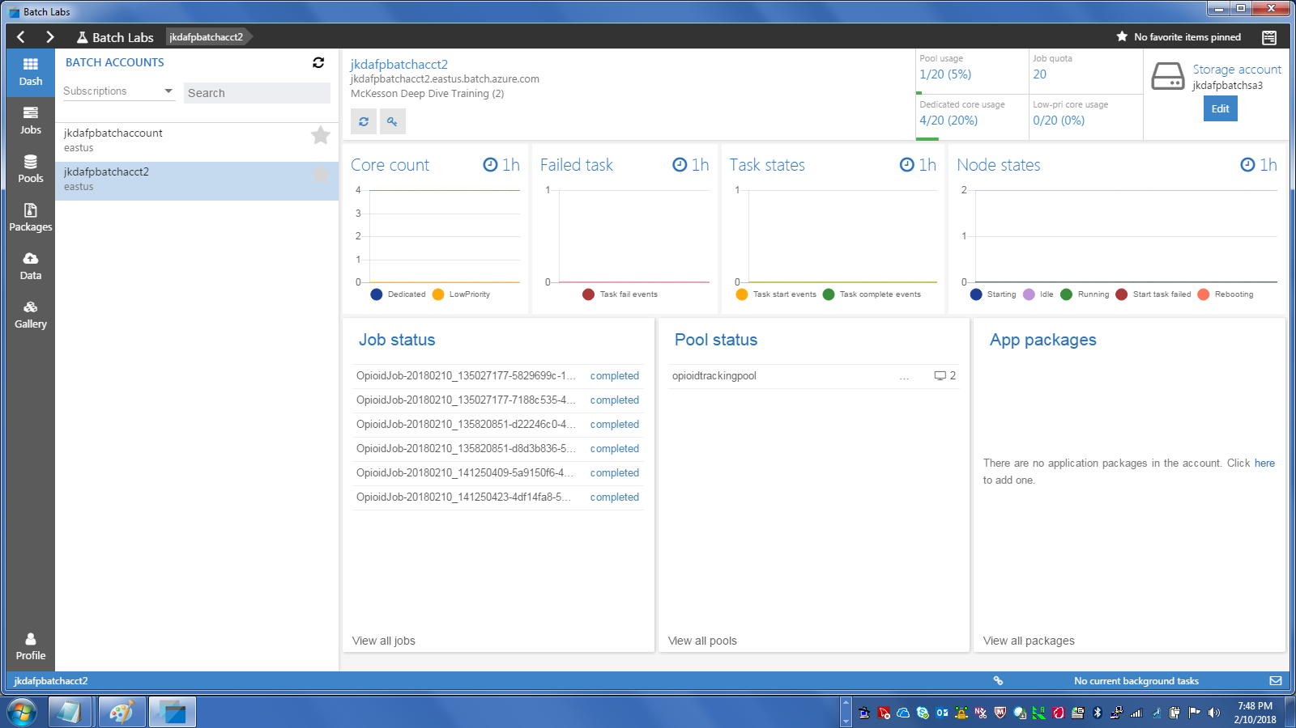

* 1. You can select on Jobs to view job run details, delete jobs, etc

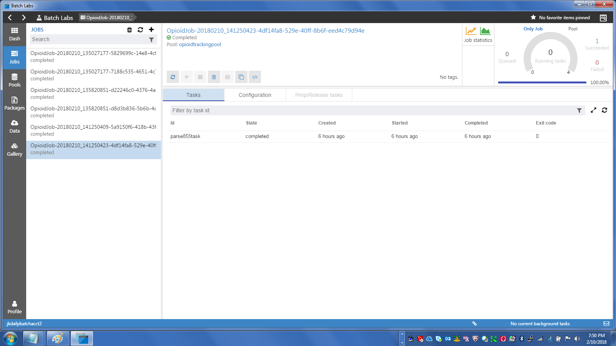

* 1. Click on a task to see the file system for the task and such

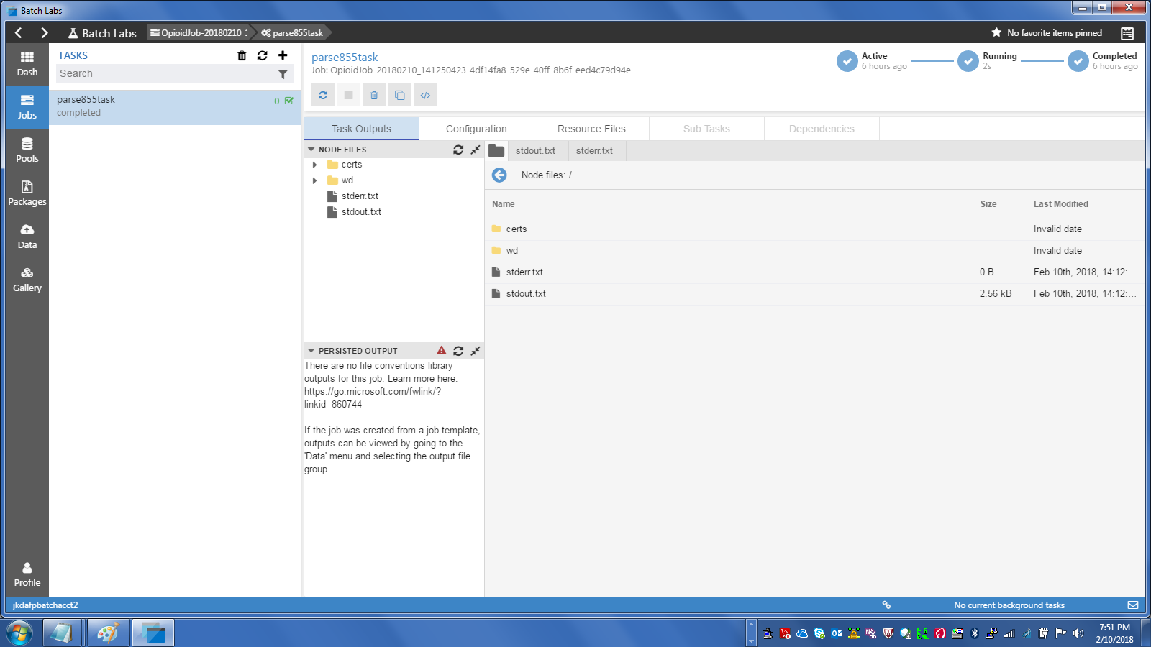

* 1. The “wd” directory is the working directory for the Task. You can open it to see the files the task used

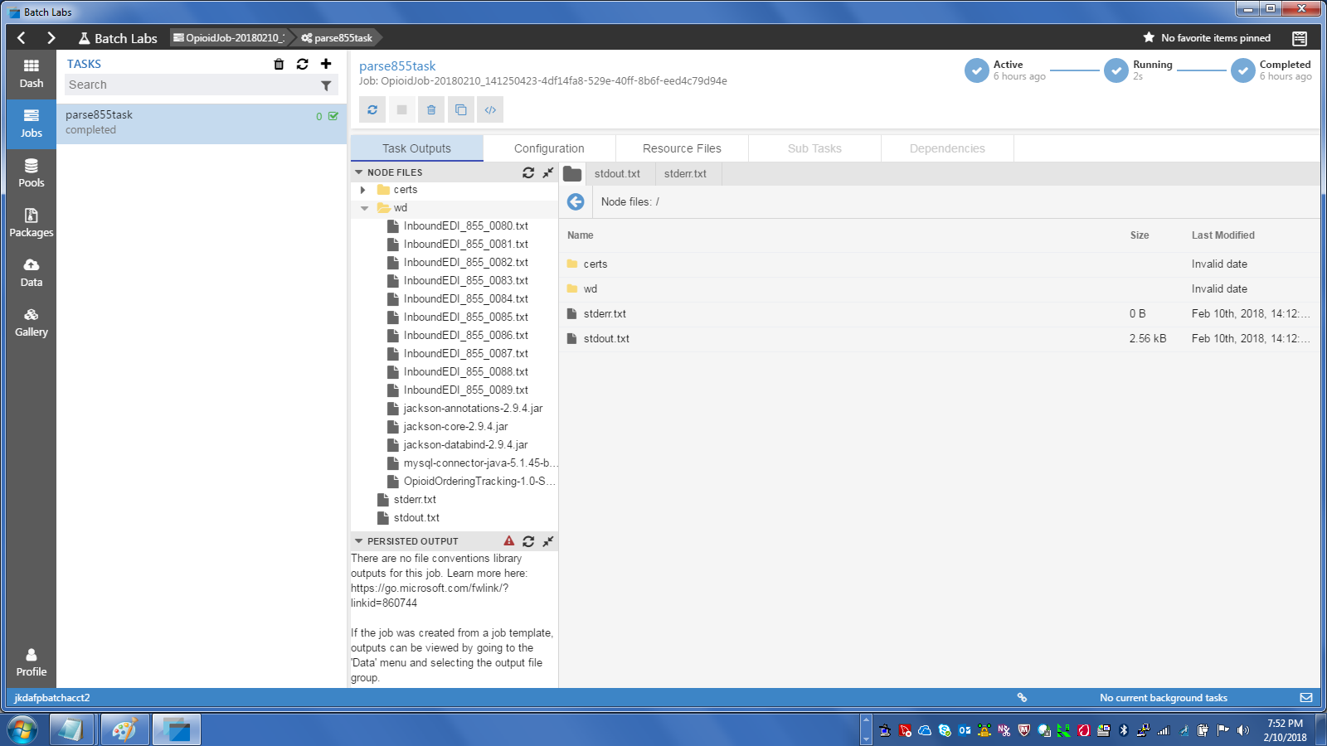

* 1. Of interest are the stderr.txt and stdout.txt files, as they contain the output from the task. This output is also written to the command window but can scroll off screen unless the output is captured

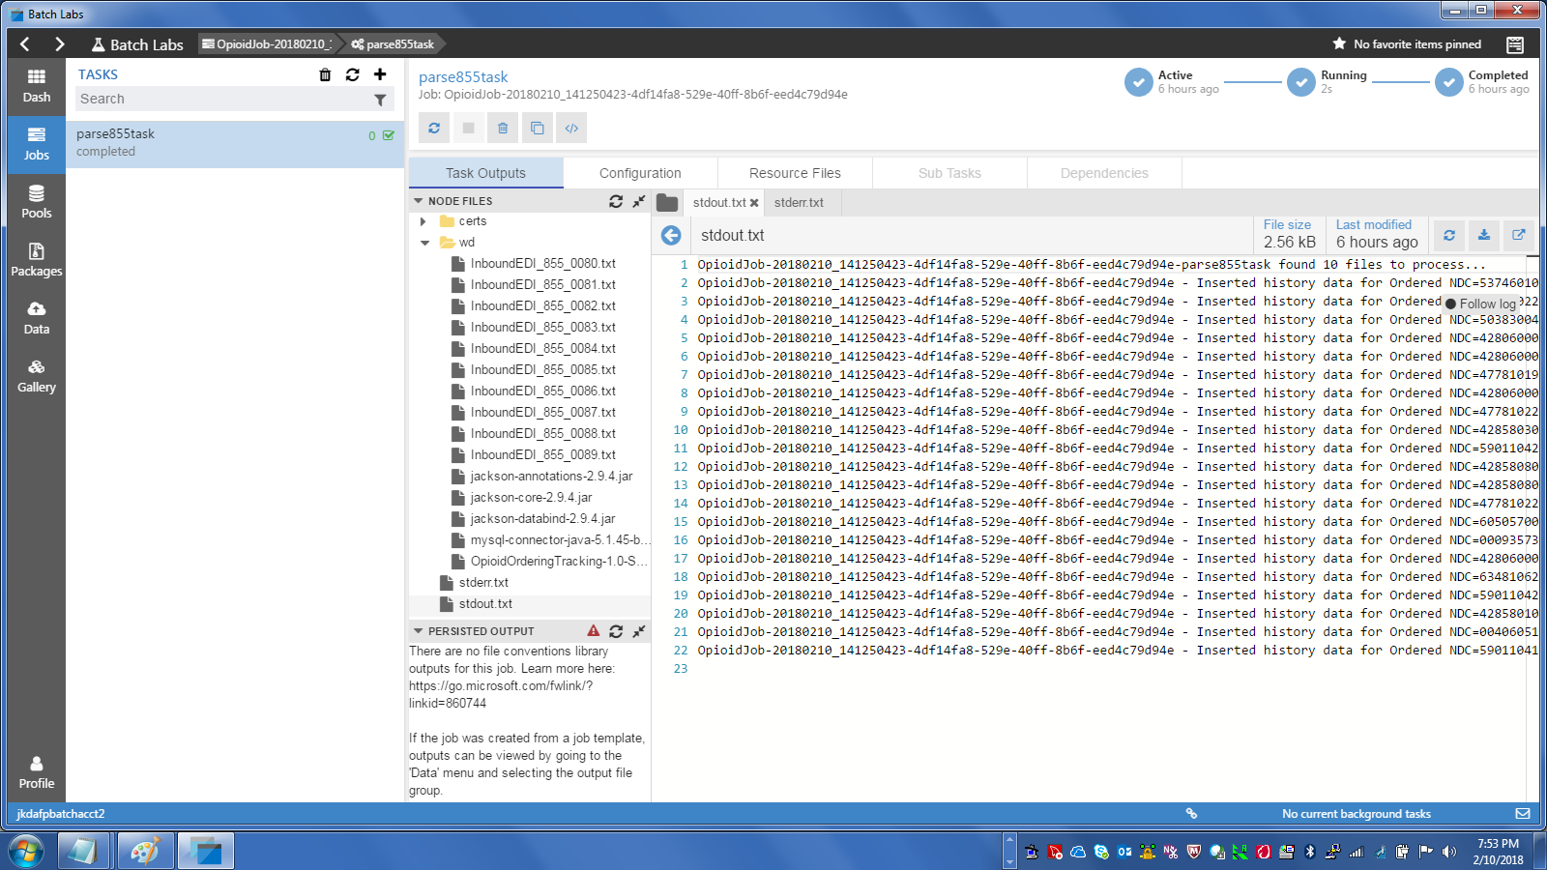

* 1. After the process has run, you should clean up your Jobs. This is easily done from the Job List screen

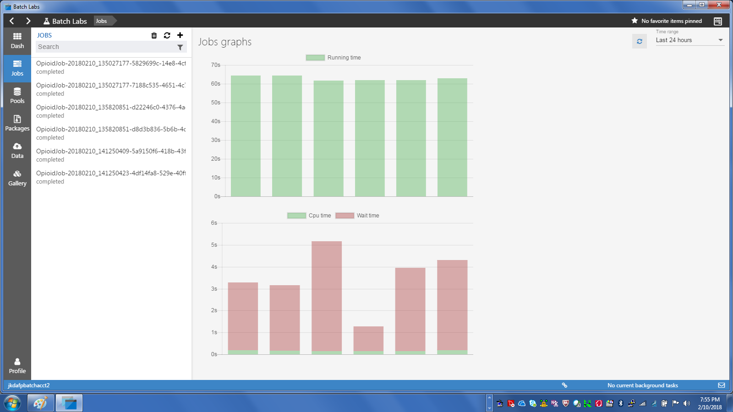

* 1. Simply select one or more Jobs and click on the Garbage Can to delete the Job and all attached files. You will be prompted to confirm:

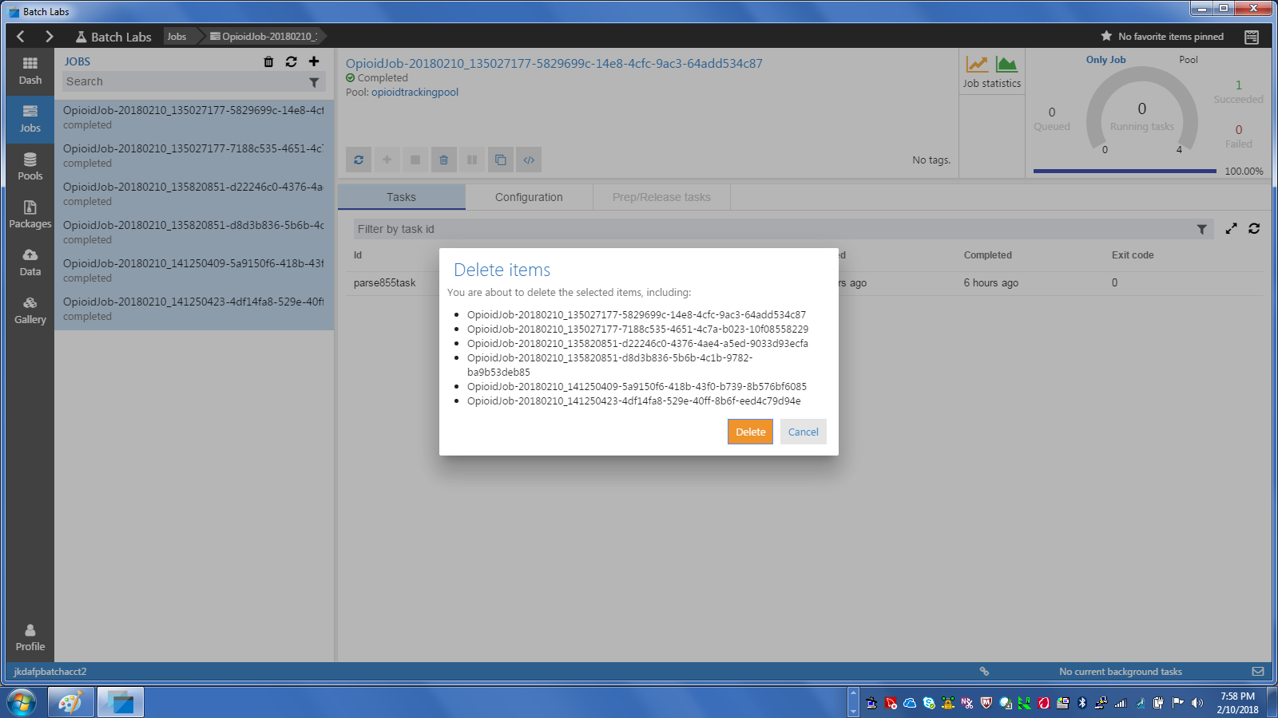

* 1. Selecting Delete will remove the jobs.
  2. Feel free to poke around with the Pools tool as well as it will show more information about the Pools and Nodes

1. Run the Opioid Ordering Tracking script and monitor the results
   1. First, decide on how many files you want to run.
      1. The application will read and process ALL files within the “input” directory.
      2. If you run a larger number of files, you should then configure more files per job and may want to configure a larger number of concurrent jobs running.
   2. Copy files to the input directory
      1. Remove the “removeme.txt” file also

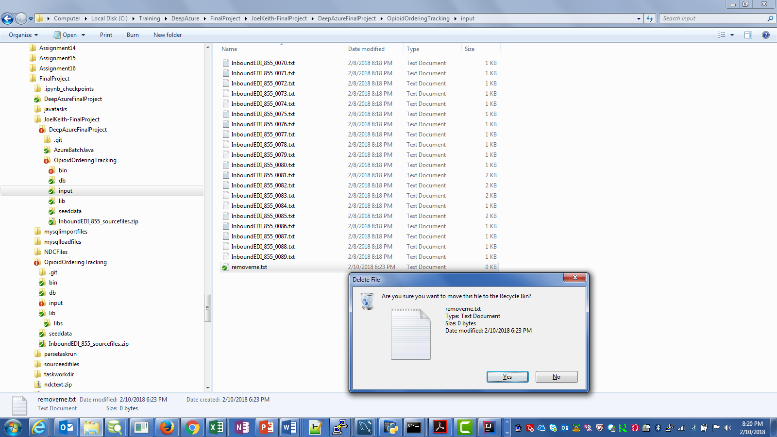

* 1. Open a command window and navigate to the “bin” directory

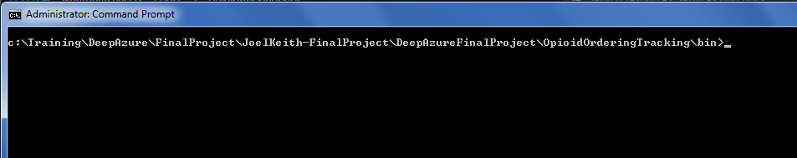

* 1. Enter the command to execute the process and include any overrides to the “Max Files Per Job” and/or “Max Threads” parameters
     1. E.g. – runOpioidOrderingTracking.bat 10 2
     2. This will use 10 files per job with a maximum of 2 concurrent jobs (threads)
  2. Run the job and wait for it to complete
     1. NOTE: You may see errors like these at times:

Storage error writing file OpioidOrderingTracking-1.0-SNAPSHOT.jar to the Storage Account, retrying this file

Storage error writing file mysql-connector-java-5.1.45-bin.jar to the Storage Account, retrying this file

* + 1. I do not yet know what causes these but the jobs will fail miserably if any jar files cannot be uploaded.
    2. If this happens, re-stage the files and continue to try until you get a clean execution

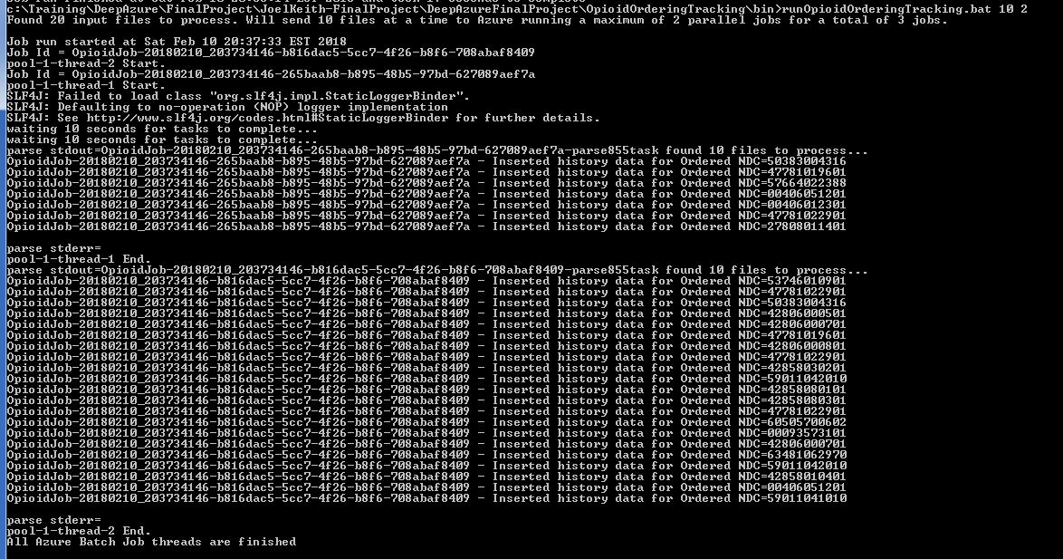

* 1. If you did not delete your jobs as part of the execution, view the job executions in BatchLabs (or in Azure Portal as well)
     1. If you access all jobs, you can filter by Job Name
     2. Job Names start with OpioidJob-YYYYMMDD_HHMMSSSSS
     3. Enter as much of the name as possible to narrow down the list

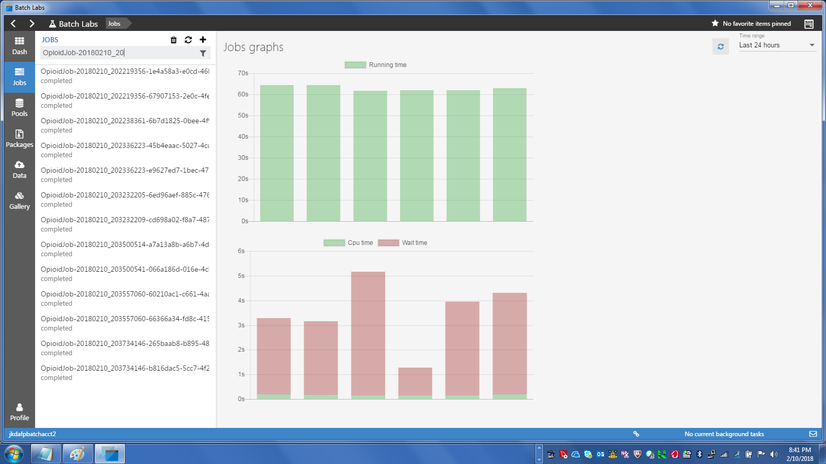

* 1. Clean up your jobs when done to keep space in your Storage Account freed up
  2. Execute the process as much as you like, and with larger data sets. Only a small number of files actually contain Opioid drugs so you will likely need to try to run as many files as possible to build up a good set of history.

1. After building up a good amount of history, extract aggregate data from MySQL and visualize it with plot.ly
   1. You will need to create a plot.ly account to get an API Key (I don’t have the screen shots for that step…)
      1. Go to <https://plot.ly/> to create a plot.ly account
      2. This is a free account and once you sign up you can get your own API key
   2. Open MySQL Workbench or some other SQL tool that has access to your MySQL database out on Azure

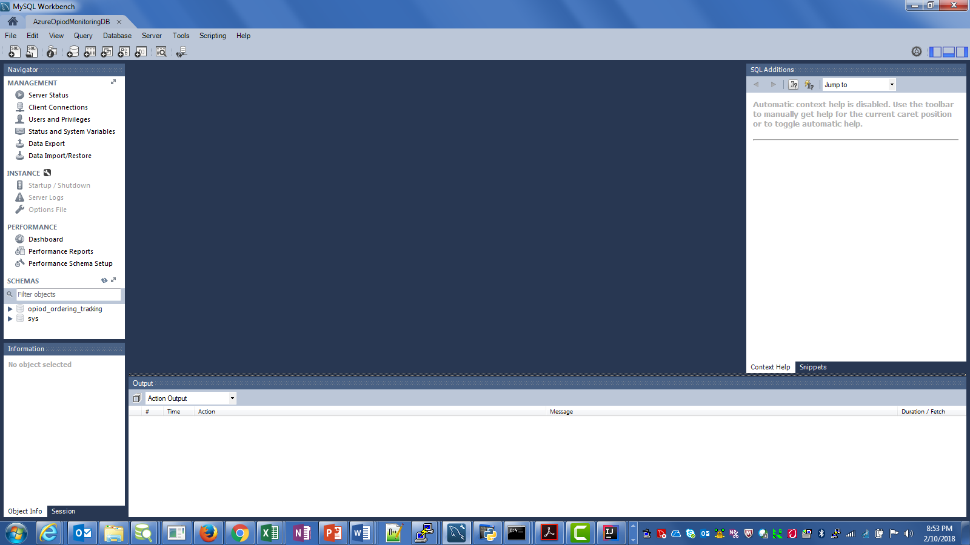

* 1. Open the OrderingHistoryReport.sql SQL script stored at {root}\DeepAzureFinalProject\OpioidOrderingTracking\db

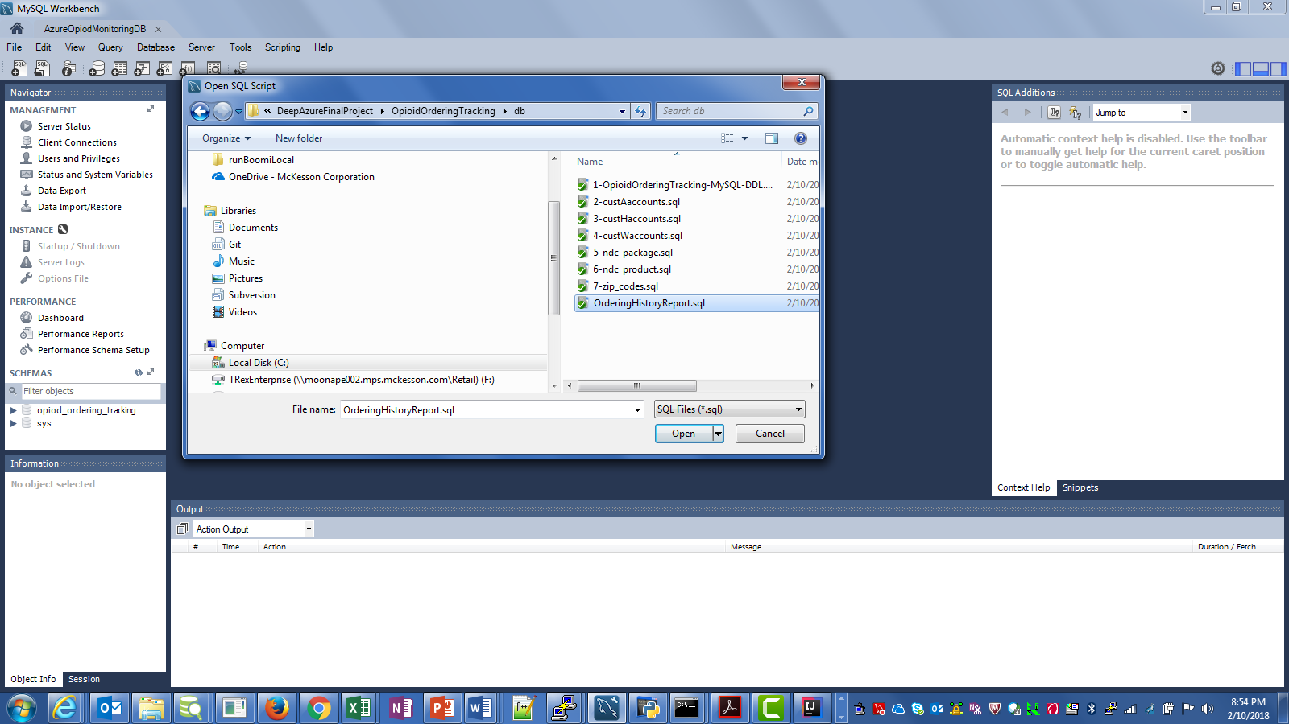

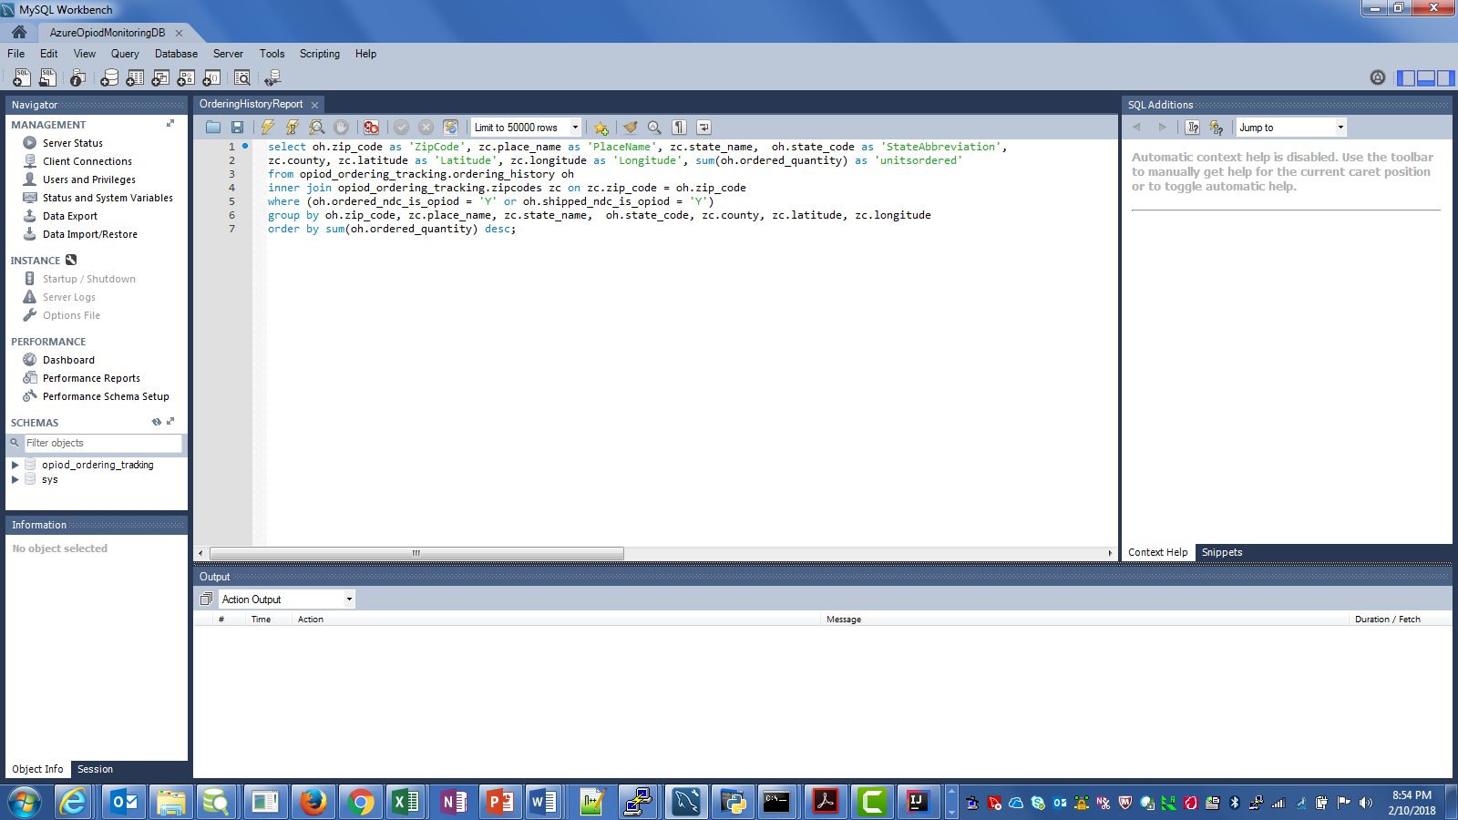

* 1. Execute the query to see Opioid dispensing totals aggregated by Zip Code

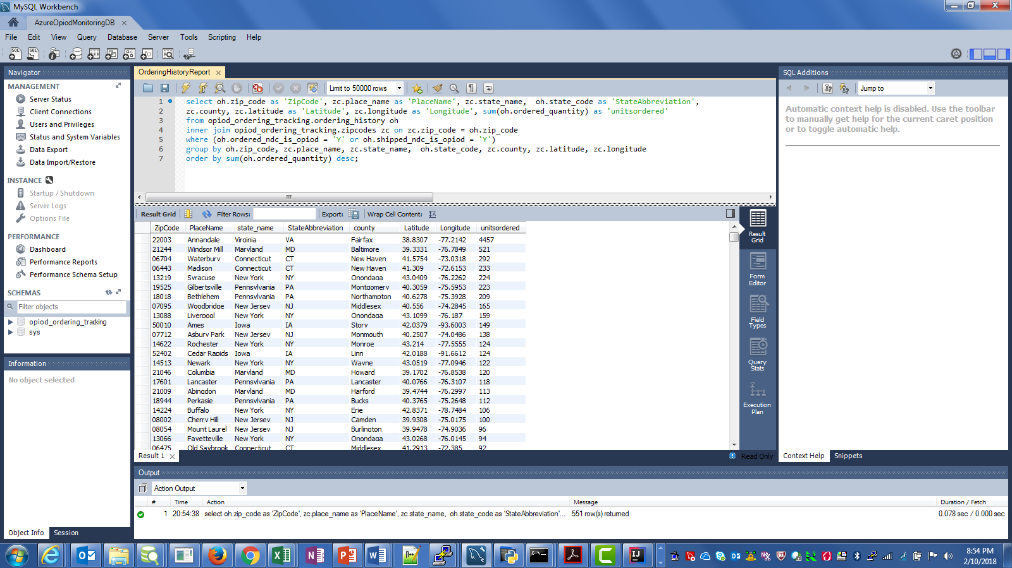

* 1. Export the query results to a comma-separated file (.csv) and DO include the column names
     1. Click on the Export button just above the query results

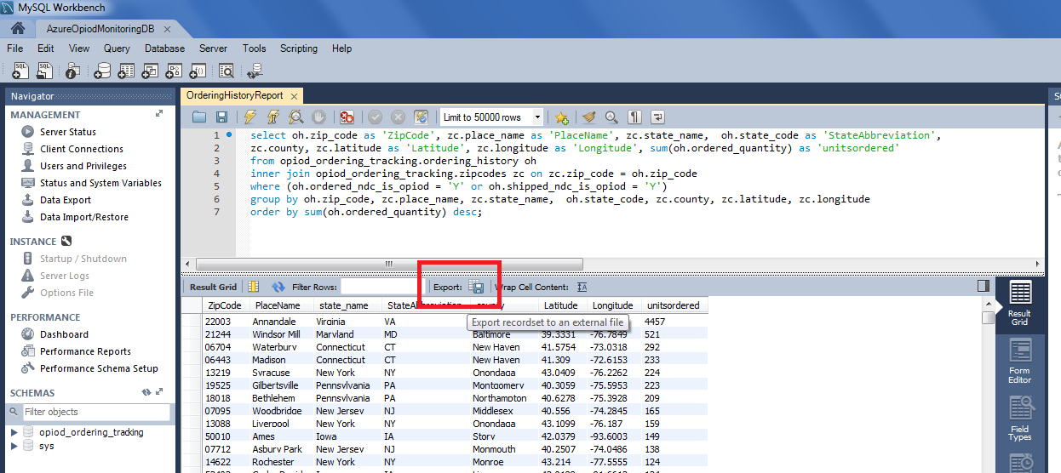

* + 1. Navigate to a location to store the file, enter a file name, and make sure the “CSV (*.csv)” Save as Type option is selected, and click Save

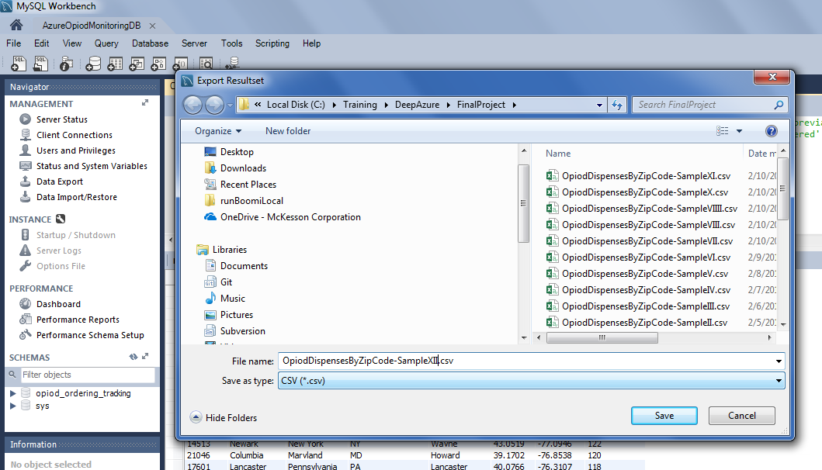

* 1. Open the Jupyter Notebook file called OpiodOrderingBubbleChart.ipynb located at {root}\DeepAzureFinalProject\OpioidOrderingTracking with Jupyter Notebook
     1. This assumes prior installation of Jupyter Notebook.
     2. See <http://jupyter.org/install> to install this tool
     3. Run the Jupyter Notebook server first,

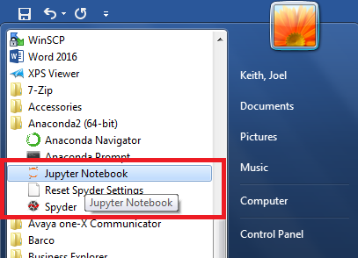

* + 1. When a browser pops up, navigate to the file.

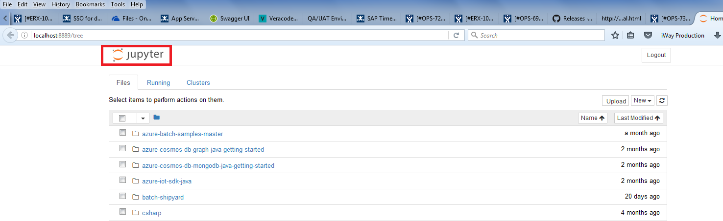

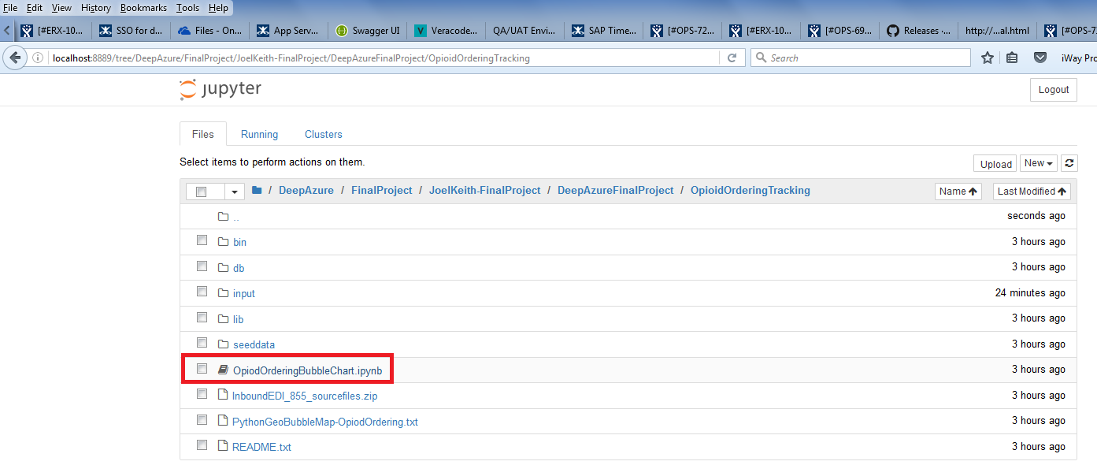

* + 1. Click on the file to open the notebook file up

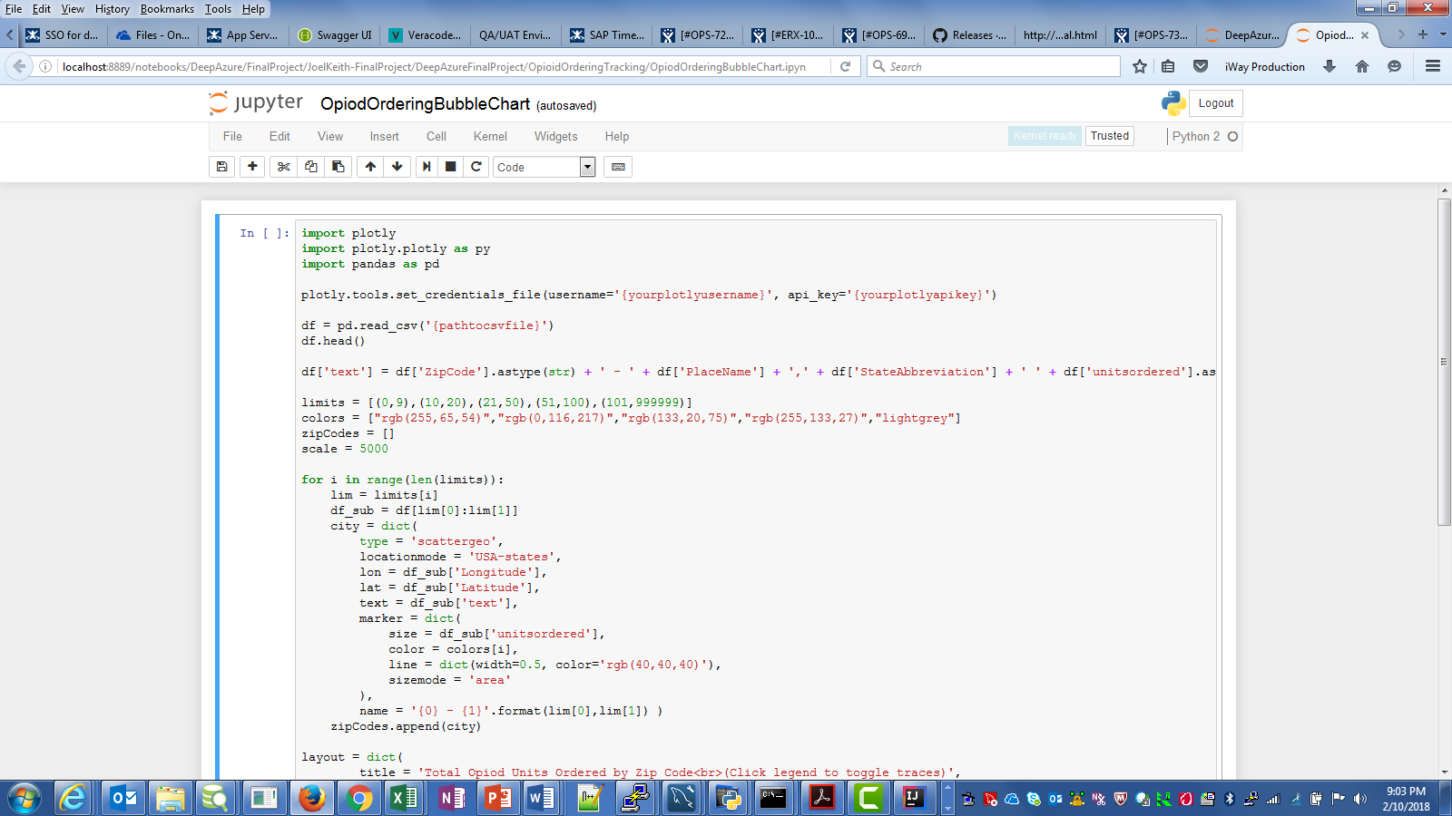

* 1. Edit the first cell to set your Jupyter account and API Key and point to the location of the exported .csv file
     1. You may have to use double slashes ( \\ ) within the path for Windows!

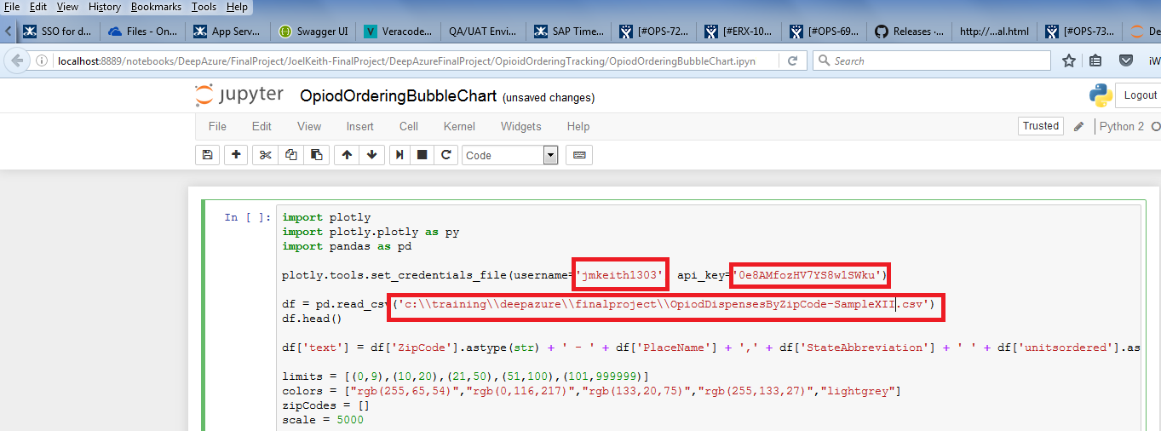

* 1. Run the first cell and wait for the output to be created
     1. Click by the “In [ ]:” area and make certain the cell is Blue
     2. Click the >| icon to run the cell

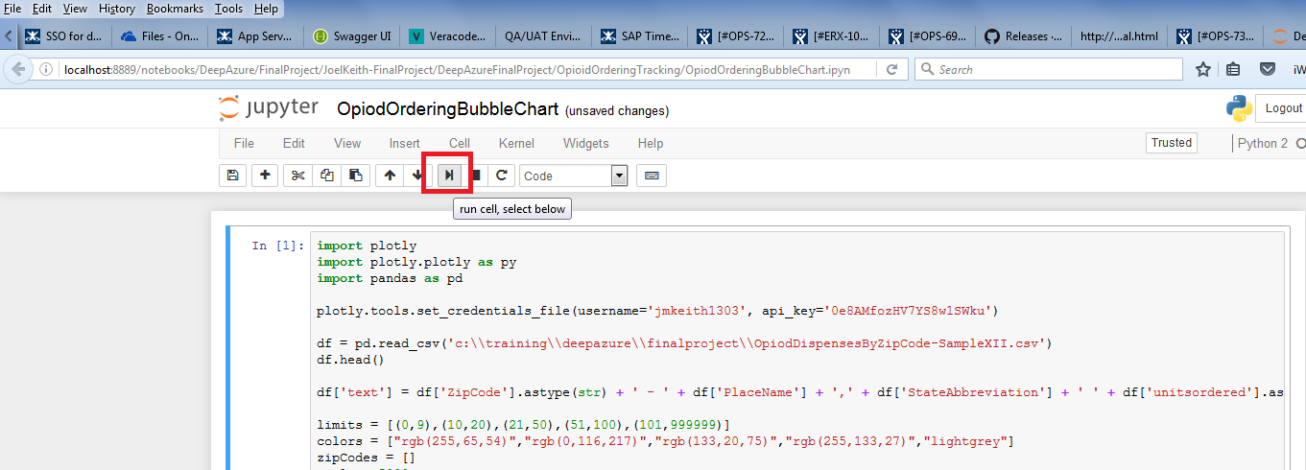

* + 1. The output will show up below the cell

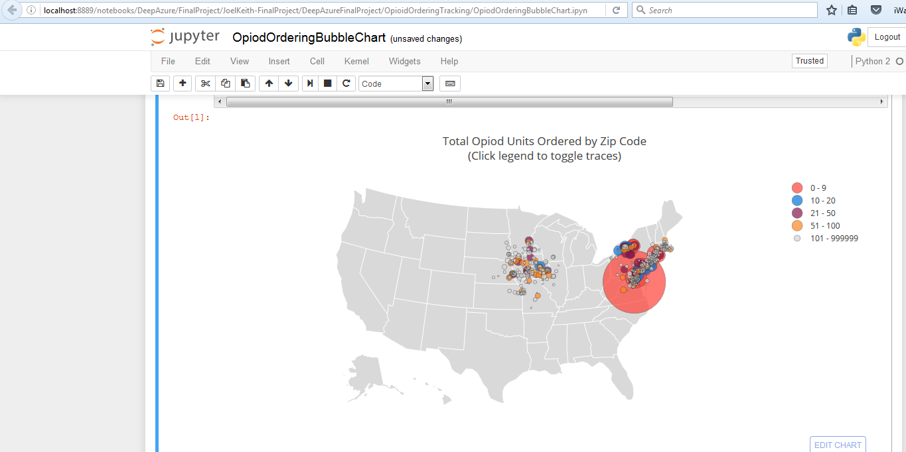

* 1. You can zoom in or out in the map using the wheel in your mouse, the + and – buttons in the window, or on your keyboard.
  2. You can move the map by clicking and dragging with your mouse or through the arrow icon in the window
  3. Hovering over a circle will show the total opioid dispensing for that Zip Code

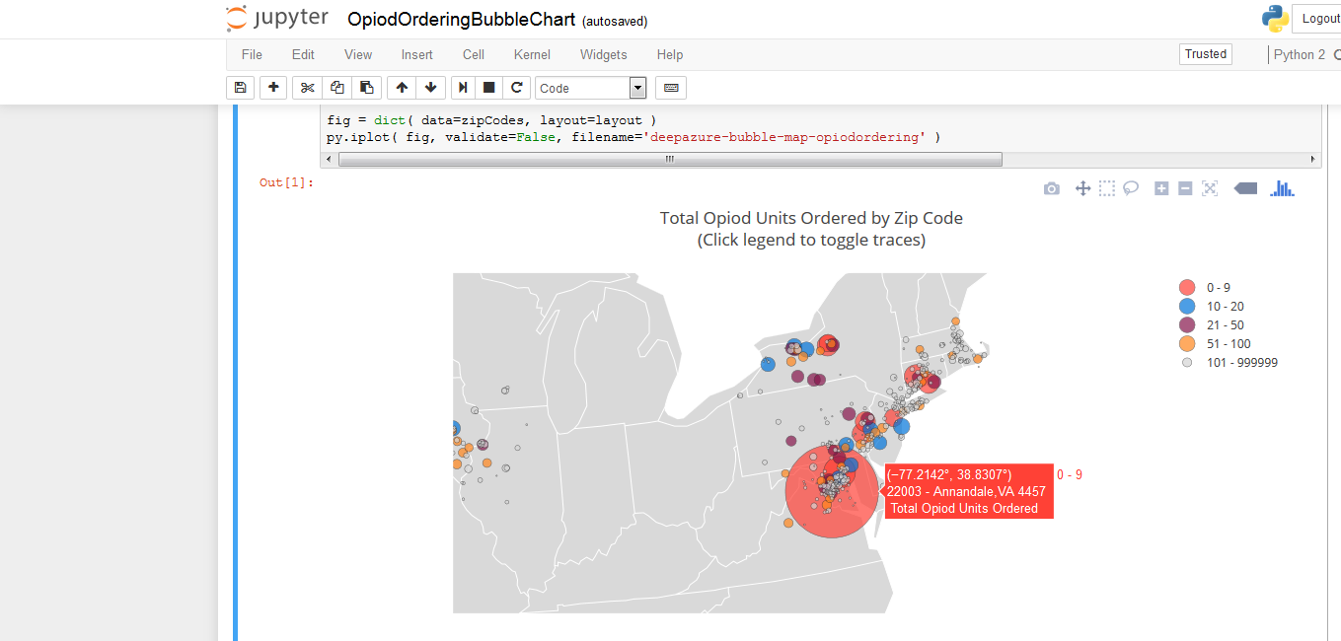

* 1. If you don’t have that good of results, continue to run more files, or try running all 6000+ and eventually you should see some decent output.

# Application code

The OpioidOrderingTracking application is a Java application that makes heavy use of the Azure Batch Java SDK. The sample Java Azure Batch application was used as a starting point, but I adapted the code to a large extent, to add multi-threading capabilities. The classes are not as “clean” as I would ultimately like, but expediency won over architectural purity in many cases. Also, the design and implementation shifted at the near last minute as I discovered problems when running in multiple nodes, so there are vestiges of that older design still in the code.

The primary issue found was that if a job has multiple tasks, Azure Batch has no absolute way of guaranteeing the tasks will all run on the same Node in the Pool. There is an Affinity setting that “hints” at having the tasks all run in the same Node, but even when Task Dependencies are added, the hint does not guarantee that will happen. The older design called for 3 separate Azure Batch Tasks with data exchange via files, but tasks started to fail when running on multiple nodes due to files being missing (they were stored on one node, but the next task ran on another node). Rather than try to come up with a storage scheme that spanned all nodes in the pool (some sort of NAS option), I opted to consolidate the work into one single Azure Batch Task. I did leverage the code fairly easily within the classes for the tasks so the re-write was not horrible, but slowed things down a bit.

The application uses Maven as the build tool and includes the ability to download all of the dependency jar to a “lib” folder. This facilitates execution of the application as a standalone app outside of an IDE. The project up on GitHub does have the dependent jars included for that very purpose.

The code is reasonably well documented so I will not repeat that documentation here, but the general structure of the classes is:

High-level Package: com.mckesson.mpts.azure.batch

Under that package:

**batch**

OpioidOrderingRecorder.java – this is the main application class, the one whose “main” method is called. It is responsible for identifying all files to be processed and allocating them to one or more OpioidOrderingWorker instances for processing. This class uses Java Thread Pooling support built into the JDK to manage starting and scheduling multiple worker threads.

OpioidOrderingWorker.java – This class handles one set of files and contains all of the Azure Batch-specific code to upload files, create jobs and tasks, initiate the jobs, monitor for task completion, and reporting processing results. This class requires many environment variables be set in order to pass appropriate information on to the Azure Batch Job and Task.

**tasks**

**MergeDrugInfoTask**

MergeDrugInfoTask.java – this is the second “step” in the process for recording ordering history. This class accepts a set of OrderedDrug objects that have initial data filled in and augments that data with account demographic information and additional drug data. This data comes from the MySQL database.

**model**

OrderedDrug.java – POJO Java class that has fields for all of the account and drug data for one line in a Purchase Order. This includes information on both the Ordered Drug and the Shipped Drug. At one time, this class was serialized to JSON and subsequently deserialized back to POJO form, using the Jackson JSON library. But the current implementation no longer uses that approach.

OrderedDrugs.java – This class is a simple wrapper around an array of OrderedDrug instances. It had greater purpose back in the JSON time as it provided an overall container for the set of OrderedDrugs within one Purchase Order. It still retains the fact that all contained OrderedDrug instances are from the same PO.

**poackparser**

EDI855ParseTask.java – This is the first step in the ordering tracking process and is the class that is called from Azure during Job processing. This task is responsible for parsing one or more EDI 855 Purchase Order Acknowledgement files and converting them into OrderedDrug instances so they can be augmented and stored for reporting and analysis. The EDI files are obtained from Blob storage.

EDIX12ParseHelper.java – A helper class providing methods to assist in parsing the X12 EDI documents.

EDIX12TransactionData.java – This class has primary responsibility for parsing X12 documents. It uses the Parse Helper and also delegates parsing of the Purchase Order Lines to the EDIX12TransactionLine class

EDIX12TransactionLine.java – This class is responsible for parsing all PO1 and ACK segments in an EDI X12 855 document which represent the Lines on a PO.

**RecordOrderingHistoryTask**

RecordOrderingHistoryTask.java – This is the third step in the ordering tracking process and the class is responsible for taking the augmented OrderedDrug instances and storing them to a MySQL table to be used for historical tracking, analysis, and the like. It filters out all “non-opioid” drugs and only records the ordering history for Opioids. It stores the data in the MySQL database.

TaskInfo.java – This is POJO class that holds the environment variable settings and other configuration settings used by all of the “tasks” within the job. This class is populate by the 855 Parse class and then passed on to the other classes as needed.

## Maven pom.xml

The Maven pom.xml file contains all of the dependencies required for this application. It also contains a Maven plugin that is used by the “package” task to pull down all dependent jar files and place them in a “lib” subfolder of the “target” output folder. The package task also creates the main jar file for the process. The actual pom.xml file is:

*<?***xml version="1.0" encoding="UTF-8"***?>*<**project xmlns="http://maven.apache.org/POM/4.0.0"  
 xmlns:xsi="http://www.w3.org/2001/XMLSchema-instance"  
 xsi:schemaLocation="http://maven.apache.org/POM/4.0.0 http://maven.apache.org/xsd/maven-4.0.0.xsd"**>  
 <**modelVersion**>4.0.0</**modelVersion**>  
  
 <**groupId**>com.mckesson.mpts.azure.tasks</**groupId**>  
 <**artifactId**>OpioidOrderingTracking</**artifactId**>  
 <**version**>1.0-SNAPSHOT</**version**>  
 <**packaging**>jar</**packaging**>  
  
 <**dependencies**>  
 <**dependency**>  
 <**groupId**>com.fasterxml.jackson.core</**groupId**>  
 <**artifactId**>jackson-annotations</**artifactId**>  
 <**version**>2.8.5</**version**>  
 </**dependency**>  
 <**dependency**>  
 <**groupId**>com.fasterxml.jackson.core</**groupId**>  
 <**artifactId**>jackson-databind</**artifactId**>  
 <**version**>2.8.5</**version**>  
 </**dependency**>  
 <**dependency**>  
 <**groupId**>com.microsoft.azure</**groupId**>  
 <**artifactId**>azure-batch</**artifactId**>  
 <**version**>1.0.0</**version**>  
 </**dependency**>  
 <**dependency**>  
 <**groupId**>com.microsoft.rest</**groupId**>  
 <**artifactId**>client-runtime</**artifactId**>  
 <**version**>1.0.1</**version**>  
 </**dependency**>  
 <**dependency**>  
 <**groupId**>com.microsoft.azure</**groupId**>  
 <**artifactId**>azure-client-runtime</**artifactId**>  
 <**version**>1.0.1</**version**>  
 </**dependency**>  
 <**dependency**>  
 <**groupId**>commons-codec</**groupId**>  
 <**artifactId**>commons-codec</**artifactId**>  
 <**version**>1.10</**version**>  
 </**dependency**>  
 <**dependency**>  
 <**groupId**>com.microsoft.azure</**groupId**>  
 <**artifactId**>azure-storage</**artifactId**>  
 <**version**>4.0.0</**version**>  
 </**dependency**>  
 <**dependency**>  
 <**groupId**>mysql</**groupId**>  
 <**artifactId**>mysql-connector-java</**artifactId**>  
 <**version**>5.1.45</**version**>  
 <**scope**>runtime</**scope**>  
 </**dependency**>  
 </**dependencies**>  
  
 <**build**>  
 <**plugins**>  
 <**plugin**>  
 <**groupId**>org.apache.maven.plugins</**groupId**>  
 <**artifactId**>maven-dependency-plugin</**artifactId**>  
 <**executions**>  
 <**execution**>  
 <**id**>copy-dependencies</**id**>  
 <**phase**>prepare-package</**phase**>  
 <**goals**>  
 <**goal**>copy-dependencies</**goal**>  
 </**goals**>  
 <**configuration**>  
 <**outputDirectory**>  
 ${project.build.directory}/libs  
 </**outputDirectory**>  
 </**configuration**>  
 </**execution**>  
 </**executions**>  
 </**plugin**>  
 <**plugin**>  
 <**groupId**>org.apache.maven.plugins</**groupId**>  
 <**artifactId**>maven-jar-plugin</**artifactId**>  
 <**configuration**>  
 <**archive**>  
 <**manifest**>  
 <**addClasspath**>true</**addClasspath**>  
 <**classpathPrefix**>libs/</**classpathPrefix**>  
 <**mainClass**>  
 com.mckesson.mpts.azure.batch.OpiodOrderingRecorder  
 </**mainClass**>  
 </**manifest**>  
 </**archive**>  
 </**configuration**>  
 </**plugin**>  
 </**plugins**>  
 </**build**>  
  
</**project**>

This project should be able to be complied using Maven directly or by creating a Maven project with existing sources within any number of Java IDEs (I use Intellij’s IDEA tool, but Eclipse should work just as well). The application cannot be fully tested outside of Azure, as interacts directly with the Azure Batch framework.

Use the “mvn package” command to compile the project and package the jar, and download all dependent jars.

## Java classes

### com.mckesson.mpts.azure.batch.OpioidOrderingRecorder.java

**package** com.mckesson.mpts.azure.batch;  
  
**import** java.io.*;  
**import** java.util.*;  
**import** java.util.concurrent.ExecutorService;  
**import** java.util.concurrent.Executors;  
  
*/**  
 * This class is the driver application for executing the Opioid Ordering Tracking Azure Batch job and tasks. The  
 * Azure job reads a set of EDI 855 Purchase Order Acknowledgment files, parses them to identify drug information,  
 * matches those drugs up with account demographic information and drug schedule, and the stores the historical  
 * information for reporting purposes. This information includes whether the ordered drug is an Opioid or not.  
 *  
 * This class uses a pool of threads to run OpioidOrderingWorker instances, which initiate the actual Azure Batch job.  
 * This class accepts up to 5 parameters including:  
 *  
 * jarFilePath - the path to the OpioidOrderingTracking jar file containing all Java code for this project  
 * inputDirectory - the path where all EDI input files are stored. Files are allocated in sets to each job based on an  
 * input file limit parameter.  
 * jdbcURL - URL to the MySQL database to use for obtaining drug and demographic data and for storage of ordering  
 * history records  
 * inputFileLimit - optional override to the maximum number of files to allocate to any one Job instance.  
 * maxThreadLimit - optional override to the maximum number of threads (jobs) to run in parallel. In order to set this  
 * override, a value for "inputFileLimit" must be provided as well  
 *  
 * An example of how to implement a thread pool in a Java class was found at:  
 *  
 * https://www.journaldev.com/1069/threadpoolexecutor-java-thread-pool-example-executorservice  
 *  
 *  
 */***public class** OpiodOrderingRecorder {  
  
 **public static final** String ***DEFAULT_INPUT_FILE_LIMIT*** = **"20"**;  
 **public static final** String ***DEFAULT_MAX_THREAD_LIMIT*** = **"10"**;  
  
 **public static void** main(String argv[]) **throws** Exception {  
  
 **if** (argv.**length** < 3) {  
 System.***err***.print(**" Must have at least 3 parameters for jarFilePath inputDirectory jdbcURL."**);  
 System.*exit*(1);  
 }  
  
 String jarFilePath = argv[0];  
 String inputDirectory = argv[1];  
 String jdbcURL = argv[2];  
 String inputFileLimit = argv.**length** >= 4 ? argv[3] : ***DEFAULT_INPUT_FILE_LIMIT***;  
 **int** fileLimit = Integer.*parseInt*(inputFileLimit);  
 String maxThreadLimitStr = argv.**length** >= 5 ? argv[4] : ***DEFAULT_MAX_THREAD_LIMIT***;  
 **int** maxThreadLimit = Integer.*parseInt*(maxThreadLimitStr);  
  
 File inputDirFile = **new** File(inputDirectory);  
  
 *//Only retrieve .txt files from the input directory* FilenameFilter txtFilter = **new** FilenameFilter() {  
 **public boolean** accept(File dir, String name) {  
 String lowercaseName = name.toLowerCase();  
 **if** (lowercaseName.endsWith(**".txt"**)) {  
 **return true**;  
 } **else** {  
 **return false**;  
 }  
 }  
 };  
  
 *//The ExecutorService class provide the controller for thread pooling* ExecutorService executor = **null**;  
 File[] filesToProcess = **null**;  
 Date startTime = **new** Date();  
  
 *//Filter the files in the "input" directory to limit to ".txt" files only* File[] txtFileList = inputDirFile.listFiles(txtFilter);  
 **if** (txtFileList == **null** || txtFileList.**length** == 0) {  
 System.***out***.println(**"No input txt files found in the input directory "** + inputDirectory + **". Exiting..."**);  
 **return**;  
 }  
 **else** {  
 **int** numJobs = (txtFileList.**length** <= fileLimit) ? 1 : ((**int**)(txtFileList.**length** / fileLimit)) + 1;  
 System.***out***.println(**"Found "** + txtFileList.**length** + **" input files to process. Will send "** + fileLimit  
 + **" files at a time to Azure running a maximum of "** + maxThreadLimit + **" parallel jobs for a total of "** + numJobs + **" jobs."**);  
 System.***out***.println(**""**);  
 System.***out***.println(**"Job run started at "** + startTime.toString());  
 }  
 **int** numFilesLeftToProcess = txtFileList.**length**;  
 **int** startingFileIndex = 0;  
  
 *//Set the thread pool up with the max number of concurrent threads (jobs) to run* executor = Executors.*newFixedThreadPool*(maxThreadLimit);  
  
 *//Loop over all of the files found in the input directory. Allocate up to the "max" to each Worker instance* **while** (numFilesLeftToProcess > 0) {  
 *//copy over the set of files to process based on the file limit* **int** lowerFileLimit = (fileLimit < numFilesLeftToProcess ? fileLimit : numFilesLeftToProcess);  
 filesToProcess = **new** File[lowerFileLimit];  
  
 **for** (**int** i=0; i<lowerFileLimit; i++ ) {  
 filesToProcess[i] = txtFileList[startingFileIndex];  
 startingFileIndex++;  
 numFilesLeftToProcess--;  
 }  
  
 *//Create the new worker instance with the set of files to process and other parameters and start the worker  
 // if the thread pool is at it's limit already, the extra threads will wait and then be released as other  
 // threads complete.* Runnable worker = **new** OpiodOrderingWorker(filesToProcess,jarFilePath, jdbcURL);  
 executor.execute(worker);  
 }  
 executor.shutdown();  
  
 *//Wait for all of the threads to be scheduled and complete their processing* **while** (!executor.isTerminated()) {  
 }  
  
 *//All threads have completed, so wrap things up...* System.***out***.println(**"All Azure Batch Job threads are finished"**);  
 System.***out***.println(**""**);  
 Date endTime = **new** Date();  
 **long** elapsedSeconds = endTime.getTime() - startTime.getTime();  
  
 System.***out***.println(**"Job run finished at "** + endTime.toString() + **" and took "** + (elapsedSeconds/1000) + **" seconds to complete"**);  
  
 }  
}

### com.mckesson.mpts.azure.batch.OpioidOrderingWorker.java

**package** com.mckesson.mpts.azure.batch;  
  
**import** com.microsoft.azure.batch.BatchClient;  
**import** com.microsoft.azure.batch.DetailLevel;  
**import** com.microsoft.azure.batch.auth.BatchSharedKeyCredentials;  
**import** com.microsoft.azure.batch.protocol.models.*;  
**import** com.microsoft.azure.storage.CloudStorageAccount;  
**import** com.microsoft.azure.storage.StorageCredentials;  
**import** com.microsoft.azure.storage.StorageCredentialsAccountAndKey;  
**import** com.microsoft.azure.storage.StorageException;  
**import** com.microsoft.azure.storage.blob.*;  
  
**import** java.io.*;  
**import** java.net.URISyntaxException;  
**import** java.security.InvalidKeyException;  
**import** java.text.SimpleDateFormat;  
**import** java.time.Duration;  
**import** java.util.*;  
**import** java.util.concurrent.TimeoutException;  
  
*/**  
 * The purpose of this class is to create one instance of an Azure Batch Job which will parse a provided set of  
 * EDI 855 Purchase Order Acknowledgment documents to obtain drug ordering data. That data will be merged with  
 * demographic data about the ordering Account (Pharmacy) and with drug attributes that can identify whether the  
 * drug is an Opioid or not. Finally the merged data is written to a database table so the ordering event can be  
 * reported on as needed.  
 *  
 * This class accomplishes this task through the use of an Azure Batch Job and 1 Azure Batch Task instance. Each instance  
 * of this class is provided a set of EDI 855 documents to process. These documents are saved to an Azure Storage Account,  
 * along with copies of Java jar files needed by the task and these files are obtained as needed by the Azure task  
 * Output from each task execution is obtained and printed for informational purposes.  
 *  
 * All input files and jar files are initially loaded to an Azure Storage Container as Blob input. Files are read  
 * by the task as-needed.  
 *  
 * The actual task is implemented in three separate Java classes with the main class being executed as a Java Application.  
 * These classes are executed within the Azure Batch framework and each Batch Task includes the command line needed to  
 * initiate each application. This includes references to the jar files on which the task depends.  
 *  
 * This class implements the Runnable interface so it can be integrated into a thread pool or other such mechanism  
 * to allow parallel job execution to take place. All significant processing is started from the "run()" method.  
 *  
 * This class requires 3 pieces of data when an instance is created:  
 *  
 * filesToProcess - an Array of File instances holding the path to each file to process when the instance executes  
 * jarFilePath - path to where jar files needed by the batch task classes are held. These jars are uploaded to Azure  
 * for each Task instance  
 * jdbcURL - the URL to the MySQL database instance housing the demographic and drug information as well as the ordering  
 * history table. This MySQL database must be able to be reached by processes running the Azure Cloud environment so  
 * it is typical that this database be hosted in an Azure VM instance.  
 *  
 *  
 * The basic skeleton code for this class was develop using the sample Java class found on GitHub at this location:  
 *  
 * https://github.com/Azure/azure-batch-samples/tree/master/Java  
 *  
 * This code has been heavily adapted for this specific need but many of the original aspects remain.  
 *  
 * This process requires many environment variables for Azure-related information. These variables must be set  
 * prior to executing instances of this class:  
 *  
 * AZURE_BATCH_ACCOUNT - The name of the Azure Batch Account where the Pool to use is located and where all other  
 * resources will eventually reside. This account must exist prior to running this process!  
 * AZURE_BATCH_ACCESS_KEY - Primary Access Key for the Azure Batch Account  
 * AZURE_BATCH_ENDPOINT - Access URL for the Azure Batch Account  
 * AZ_BATCH_NODE_SHARED_DIR - Directory where output files will be written, so the are accessible across tasks  
 *  
 * STORAGE_ACCOUNT_NAME - Name of the Storage Account to use when uploading files to Azure prior to job execution  
 * STORAGE_ACCOUNT_KEY - Primary Access Key for the Storage Account  
 *  
 * CONTAINER_NAME - The name to use for the Storage Container that will hold the task-related files  
 *  
 * BATCH_POOL_ID - Identifier for a pre-existing Azure Batch Pool containing 1 or more Nodes (VMs) where tha Tasks will  
 * execute.  
 *  
 * DELETE_JOBS - true/false indication whether to delete each Job after it complete (true) or leave the Job and all tasks  
 * out on Azure (false). If a job is deleted, all files uploaded for the Job and all tasks will be removed as well.  
 *  
 * The Azure Jobs are all assigned unique Ids using the following convention:  
 *  
 * OpioidJob-yyyyMMdd_HHmmssSSS-{random generated UUID}  
 *  
 * If this initial Id exceeds 64 characters it is right-truncated to 64. The Id allows jobs that are retained to be able  
 * to be better identified in Azure, while retaining unique names.  
 *  
 */***public class** OpiodOrderingWorker **implements** Runnable{  
  
 **public static final** String ***TASK_JAR*** = **"OpioidOrderingTracking-1.0-SNAPSHOT.jar"**;  
 **public static final** String ***JACKSON_CORE_JAR*** = **"jackson-core-2.9.4.jar"**;  
 **public static final** String ***JACKSON_ANNOTATIONS_JAR*** = **"jackson-annotations-2.9.4.jar"**;  
 **public static final** String ***JACKSON_DATABIND_JAR*** = **"jackson-databind-2.9.4.jar"**;  
 **public static final** String ***MYSQL_JDBC_JAR*** = **"mysql-connector-java-5.1.45-bin.jar"**;  
  
 **public static final** String ***PARSE_855_TASK_NAME*** = **"parse855task"**;  
 **public static final** String ***MERGE_DRUG_INFO_TASK_NAME*** = **"mergedruginfotask"**;  
 **public static final** String ***WRITE_ORDERING_HISTORY_TASK_NAME*** = **"writeorderinghistorytask"**;  
  
 **public static final** String ***STANDARD_CONSOLE_OUTPUT_FILENAME*** = **"stdout.txt"**;  
 **public static final** String ***STANDARD_CONSOLE_ERROR_FILENAME*** = **"stderr.txt"**;  
  
  
 */**  
 * Constructor accepting a set of File instances to send to Azure to be parsed and the path  
 * to where resource jar files are located. The files will be processed within the run() method.  
 *  
 \** ***@param filesToProcess*** *Set of 1 or more File instances, each pointing to an 855 transaction to be parsed to  
 * identify opioid drugs that have been ordered  
 \** ***@param jarFilePath*** *Path to a directory containing jar files needed by the Azure Batch Tasks  
 \** ***@param jdbcURL*** *The URL to use when connecting to the database housing demographic and drug information and when  
 * storing historical ordering information  
 */* **public** OpiodOrderingWorker(File[] filesToProcess, String jarFilePath, String jdbcURL){  
 **this**.**filesToProcess**=filesToProcess;  
 **this**.**jarFilePath** = jarFilePath;  
 **this**.**jdbcURL** = jdbcURL;  
 }  
  
  
 @Override  
 */**  
 * Process the set of File instances, uploading each to an Azure Batch Storage Account. Then start an Azure Batch  
 * job with 1 task that will:  
 * 1) Parse each 855 and capture the account and drug information for each line in the 855  
 * 2) Obtain demographic and additional drug data for each line on each 855  
 * 3) Write each drug that is an opioid to an ordering history table for reporting use  
 *  
 */* **public void** run() {  
 **batchAccount** = System.*getenv*(**"AZURE_BATCH_ACCOUNT"**);  
 **batchKey** = System.*getenv*(**"AZURE_BATCH_ACCESS_KEY"**);  
 **batchUri** = System.*getenv*(**"AZURE_BATCH_ENDPOINT"**);  
 **batchSharedDir** = System.*getenv*(**"AZ_BATCH_NODE_SHARED_DIR"**);  
  
 **storageAccountName** = System.*getenv*(**"STORAGE_ACCOUNT_NAME"**);  
 **storageAccountKey** = System.*getenv*(**"STORAGE_ACCOUNT_KEY"**);  
 **storageContainerName** = System.*getenv*(**"CONTAINER_NAME"**);  
  
 **poolId** = System.*getenv*(**"BATCH_POOL_ID"**);  
  
 String deleteJobOpt = System.*getenv*(**"DELETE_JOBS"**);  
 **if** (deleteJobOpt != **null**) {  
 **deleteJobWhenDone** = Boolean.*parseBoolean*(deleteJobOpt);  
 }  
  
 *//Assign a unique Job Id for this execution. Job Ids are limited to 64 characters and can only use dash or underscore  
 // in conjunction with letters and numbers.  
 //Job Ids starts with a common prefix* String pattern = **"yyyyMMdd_HHmmssSSS"**;  
 SimpleDateFormat format = **new** SimpleDateFormat(pattern);  
  
 String tempJobId = (**"OpioidJob-"** + format.format(**new** Date()) + **"-"** + UUID.*randomUUID*().toString());  
 **jobId** = tempJobId.length() <= 64 ? tempJobId : tempJobId.substring(0,64);  
 System.***out***.println(**"Job Id = "** + **jobId**);  
  
 *//Allow each task 10 minutes for all tasks to complete...* Duration TASK_COMPLETE_TIMEOUT = Duration.*ofMinutes*(10);  
  
 System.***out***.println(Thread.*currentThread*().getName()+**" Start."**);  
 *// Create batch client* **try** {  
 *//Create a BatchClient instance. this will be used throughout the rest of the code when any resource is  
 // required* **this**.**cred** = **new** BatchSharedKeyCredentials(**batchUri**, **batchAccount**, **batchKey**);  
 **this**.**client** = BatchClient.*open*(**cred**);  
  
 *// Create storage container* CloudBlobContainer container = createBlobContainer(**storageAccountName**, **storageAccountKey**);  
  
 *//Create the Pool of Nodes if it does not already exist. The tasks for this job typically require the Pool  
 // be pre-created* CloudPool sharedPool = createPoolIfNotExists(**client**, **poolId**);  
  
 *//Create the Job and the Task and submit them to Azure Batch for processing on a Node within the Pool* submitJobAndAddTask(**client**, container, sharedPool.id(), **jobId**, **jarFilePath**, **batchSharedDir**);  
  
 *//Wait for all tasks in the Job to complete. Once complete, download the stdout.txt and stderr.txt files  
 // The files will be available even if Jobs are deleted when complete as the Job cleanup happens after  
 // downloading any files.* **if** (waitForTasksToComplete(**client**, **jobId**, TASK_COMPLETE_TIMEOUT)) {  
 *// Get the parse task output files* CloudTask task = **client**.taskOperations().getTask(**jobId**, OpiodOrderingWorker.***PARSE_855_TASK_NAME***);  
  
 ByteArrayOutputStream stream = **new** ByteArrayOutputStream();  
 **client**.fileOperations().getFileFromTask(**jobId**, task.id(), ***STANDARD_CONSOLE_OUTPUT_FILENAME***, stream);  
 String stdoutFileContent = stream.toString(**"UTF-8"**);  
 System.***out***.println(**"parse stdout="** + stdoutFileContent);  
  
 stream = **new** ByteArrayOutputStream();  
 **client**.fileOperations().getFileFromTask(**jobId**, task.id(), ***STANDARD_CONSOLE_ERROR_FILENAME***, stream);  
 String stdErrfileContent = stream.toString(**"UTF-8"**);  
 System.***out***.println(**"parse stderr="** + stdErrfileContent);  
  
 */** Removed when re-worked to use 1 task only  
 // Get the drug merge task output files  
 CloudTask drugMergetask = client.taskOperations().getTask(jobId, OpiodOrderingWorker.MERGE_DRUG_INFO_TASK_NAME);  
  
 stream = new ByteArrayOutputStream();  
 client.fileOperations().getFileFromTask(jobId, drugMergetask.id(), STANDARD_CONSOLE_OUTPUT_FILENAME, stream);  
 stdoutFileContent = stream.toString("UTF-8");  
 System.out.println("merge stdout=" + stdoutFileContent);  
  
 stream = new ByteArrayOutputStream();  
 client.fileOperations().getFileFromTask(jobId, drugMergetask.id(), STANDARD_CONSOLE_ERROR_FILENAME, stream);  
 stdErrfileContent = stream.toString("UTF-8");  
 System.out.println("merge stderr=" + stdErrfileContent);  
  
 // Get the hitory write task output files  
 CloudTask historytask = client.taskOperations().getTask(jobId, OpiodOrderingWorker.WRITE_ORDERING_HISTORY_TASK_NAME);  
  
 stream = new ByteArrayOutputStream();  
 client.fileOperations().getFileFromTask(jobId, historytask.id(), STANDARD_CONSOLE_OUTPUT_FILENAME, stream);  
 stdoutFileContent = stream.toString("UTF-8");  
 System.out.println("history stdout=" + stdoutFileContent);  
  
 stream = new ByteArrayOutputStream();  
 client.fileOperations().getFileFromTask(jobId, historytask.id(), STANDARD_CONSOLE_ERROR_FILENAME, stream);  
 stdErrfileContent = stream.toString("UTF-8");  
 System.out.println("history stderr=" + stdErrfileContent);  
 */* }  
 **else** {  
 **throw new** TimeoutException(**"Tasks did not complete within the specified timeout"**);  
 }  
 }  
 **catch** (BatchErrorException err) {  
 printBatchException(err);  
 }  
 **catch** (Exception ex) {  
 ex.printStackTrace();  
 }  
 **finally** {  
 *// Clean up the resource if necessary* **if** (**deleteJobWhenDone**) {  
 **try** {  
 System.***out***.println(**"Deleteing job "** + **jobId**);  
 **client**.jobOperations().deleteJob(**jobId**);  
 } **catch** (BatchErrorException err) {  
 printBatchException(err);  
 } **catch** (IOException ioe) {  
 ioe.printStackTrace();  
 }  
 }  
 }  
 System.***out***.println(Thread.*currentThread*().getName()+**" End."**);  
 }  
  
  
 */**  
 * Create IaaS pool if pool isn't exist. The Pool should be pre-created as the tasks requires Java be installed ahead of time...  
 * The Pool attributes are ones used by the example Azure Batch class and may be changed as needed if not pre-allocating  
 * the pool.  
 \** ***@param client*** *batch client instance  
 \** ***@param poolId*** *the pool id  
 \** ***@return*** *the pool instance  
 \** ***@throws*** *BatchErrorException  
 \** ***@throws*** *IllegalArgumentException  
 \** ***@throws*** *IOException  
 \** ***@throws*** *InterruptedException  
 \** ***@throws*** *TimeoutException  
 */* **private** CloudPool createPoolIfNotExists(BatchClient client, String poolId) **throws** BatchErrorException, IllegalArgumentException, IOException, InterruptedException, TimeoutException {  
 *// Create a pool with 1 A1 VM* String osPublisher = **"OpenLogic"**;  
 String osOffer = **"CentOS"**;  
 String poolVMSize = **"STANDARD_A1"**;  
 *//Canonical UbuntuServer 16.04.0-LTS* **int** poolVMCount = 1;  
 Duration POOL_STEADY_TIMEOUT = Duration.*ofMinutes*(5);  
 Duration VM_READY_TIMEOUT = Duration.*ofMinutes*(20);  
  
 *// Check if pool exists* **if** (!client.poolOperations().existsPool(poolId)) {  
  
 *// See detail of creating IaaS pool at https://blogs.technet.microsoft.com/windowshpc/2016/03/29/introducing-linux-support-on-azure-batch/  
 // Get the sku image reference* List<NodeAgentSku> skus = client.accountOperations().listNodeAgentSkus();  
 String skuId = **null**;  
 ImageReference imageRef = **null**;  
  
 **for** (NodeAgentSku sku : skus) {  
 **if** (sku.osType() == OSType.***LINUX***) {  
 System.***out***.println(**"NodeAgentSku="** + sku.toString());  
 **for** (ImageReference imgRef : sku.verifiedImageReferences()) {  
 System.***out***.println(**"ImageReferece Publisher = "** + imgRef.publisher());  
 System.***out***.println(**"ImageReferece Offer = "** + imgRef.offer());  
 System.***out***.println(**"ImageReferece Version = "** + imgRef.version());  
 System.***out***.println(**"ImageReferece Sku = "** + imgRef.sku());  
 }  
 }  
 }  
  
 **for** (NodeAgentSku sku : skus) {  
 **if** (sku.osType() == OSType.***LINUX***) {  
 **for** (ImageReference imgRef : sku.verifiedImageReferences()) {  
 **if** (imgRef.publisher().equalsIgnoreCase(osPublisher) && imgRef.offer().equalsIgnoreCase(osOffer)) {  
 imageRef = imgRef;  
 skuId = sku.id();  
 **break**;  
 }  
 }  
 }  
 }  
  
 *// Use IaaS VM with Linux* VirtualMachineConfiguration configuration = **new** VirtualMachineConfiguration();  
 configuration.withNodeAgentSKUId(skuId).withImageReference(imageRef);  
  
 client.poolOperations().createPool(poolId, poolVMSize, configuration, poolVMCount);  
 }  
  
 **long** startTime = System.*currentTimeMillis*();  
 **long** elapsedTime = 0L;  
 **boolean** steady = **false**;  
  
 *// Wait for the VM to be allocated* **while** (elapsedTime < POOL_STEADY_TIMEOUT.toMillis()) {  
 CloudPool pool = client.poolOperations().getPool(poolId);  
 **if** (pool.allocationState() == AllocationState.***STEADY***) {  
 steady = **true**;  
 **break**;  
 }  
 System.***out***.println(**"wait 30 seconds for pool steady..."**);  
 Thread.*sleep*(30 * 1000);  
 elapsedTime = (**new** Date()).getTime() - startTime;  
 }  
  
 **if** (!steady) {  
 **throw new** TimeoutException(**"The pool did not reach a steady state in the allotted time"**);  
 }  
  
 *// The VMs in the pool don't need to be in and IDLE state in order to submit a job.  
 // The following code is just an example of how to poll for the VM state* startTime = System.*currentTimeMillis*();  
 elapsedTime = 0L;  
 **boolean** hasIdleVM = **false**;  
  
 *// Wait for at least 1 VM to reach the IDLE state* **while** (elapsedTime < VM_READY_TIMEOUT.toMillis()) {  
 List<ComputeNode> nodeCollection = client.computeNodeOperations().listComputeNodes(poolId, **new** DetailLevel.Builder().withSelectClause(**"id, state"**).withFilterClause(**"state eq 'idle'"**).build());  
 **if** (!nodeCollection.isEmpty()) {  
 hasIdleVM = **true**;  
 **break**;  
 }  
  
 System.***out***.println(**"wait 30 seconds for VM start..."**);  
 Thread.*sleep*(30 * 1000);  
 elapsedTime = (**new** Date()).getTime() - startTime;  
 }  
  
 **if** (!hasIdleVM) {  
 **throw new** TimeoutException(**"The node did not reach an IDLE state in the allotted time"**);  
 }  
  
 **return** client.poolOperations().getPool(poolId);  
 }  
  
 */**  
 * Create blob container in order to upload files  
 \** ***@param storageAccountName*** *storage account name  
 \** ***@param storageAccountKey*** *storage account key  
 \** ***@return*** *CloudBlobContainer instance  
 \** ***@throws*** *URISyntaxException  
 \** ***@throws*** *StorageException  
 */* **private** CloudBlobContainer createBlobContainer(String storageAccountName, String storageAccountKey) **throws** URISyntaxException, StorageException {  
  
 *// Create storage credential from name and key* StorageCredentials credentials = **new** StorageCredentialsAccountAndKey(storageAccountName, storageAccountKey);  
  
 *// Create storage account* CloudStorageAccount storageAccount = **new** CloudStorageAccount(credentials);  
  
 *// Create the blob client* CloudBlobClient blobClient = storageAccount.createCloudBlobClient();  
  
 *// Get a reference to a container.  
 // The container name must be lower case* **return** blobClient.getContainerReference(**storageContainerName**);  
 }  
  
 */**  
 * Upload a file to the blob container and return sas key  
 \** ***@param container*** *blob container  
 \** ***@param fileName*** *the file name of blob  
 \** ***@param filePath*** *the local file path  
 \** ***@return*** *SAS key for the uploaded file  
 \** ***@throws*** *URISyntaxException  
 \** ***@throws*** *IOException  
 \** ***@throws*** *InvalidKeyException  
 \** ***@throws*** *StorageException  
 */* **private** String uploadFileToCloud(CloudBlobContainer container, String fileName, String filePath) **throws** URISyntaxException, IOException, InvalidKeyException, StorageException {  
 *// Create the container if it does not exist.* container.createIfNotExists();  
  
 *// Upload file* CloudBlockBlob blob = container.getBlockBlobReference(fileName);  
 File source = **new** File(filePath);  
 FileInputStream fis = **new** FileInputStream(source);  
 **try** {  
 blob.upload(fis, source.length());  
 }  
 **catch** (IOException ioe) {  
 *//Storage error trying to load a file, retry one time and then skip the file if it continues...* System.***err***.println(**"Storage error writing file "** + fileName + **" to the Storage Account, retrying this file"**);  
 **try** {  
 blob.upload(fis, source.length());  
 }  
 **catch** (Exception e2) {  
 System.***err***.println(**"2nd Storage error writing file "** + fileName + **" to the Storage Account, aborting..."**);  
 System.***err***.println(e2.getMessage());  
 **throw** e2;  
 }  
 }  
 fis.close();  
  
 *// Create policy with 1 day read permission* SharedAccessBlobPolicy policy = **new** SharedAccessBlobPolicy();  
 EnumSet<SharedAccessBlobPermissions> perEnumSet = EnumSet.*of*(SharedAccessBlobPermissions.***READ***);  
 policy.setPermissions(perEnumSet);  
  
 Calendar c = Calendar.*getInstance*();  
 c.setTime(**new** Date());  
 c.add(Calendar.***DATE***, 1);  
 policy.setSharedAccessExpiryTime(c.getTime());  
  
 *// Create SAS key* String sas = blob.generateSharedAccessSignature(policy, **null**);  
 **return** blob.getUri() + **"?"** + sas;  
 }  
  
 */**  
 * Create an Azure Batch job and the 1 task necessary to perform the process. All files and jar resources are uploaded  
 * to the task.  
 \** ***@param client*** *batch client instance  
 \** ***@param container*** *blob container to upload the resource file  
 \** ***@param poolId*** *pool id  
 \** ***@param jobId*** *job id  
 \** ***@throws*** *BatchErrorException  
 \** ***@throws*** *IOException  
 \** ***@throws*** *StorageException  
 \** ***@throws*** *InvalidKeyException  
 \** ***@throws*** *URISyntaxException  
 */* **private void** submitJobAndAddTask(BatchClient client, CloudBlobContainer container, String poolId, String jobId,  
 String jarFilePath, String batchSharedDir) **throws** BatchErrorException, IOException, StorageException, InvalidKeyException, URISyntaxException {  
  
 File nextFile = **null**;  
 String realFileName = **null**;  
  
 *// Create job run at the specified pool* PoolInformation poolInfo = **new** PoolInformation();  
 poolInfo.withPoolId(poolId);  
 JobAddParameter jap =  
 **new** JobAddParameter().withDisplayName(**"OpiodDrugOrderingJob"**).withId(jobId).withUsesTaskDependencies(Boolean.***TRUE***)  
 .withOnAllTasksComplete(OnAllTasksComplete.***TERMINATE_JOB***).withPoolInfo(poolInfo);  
  
*// client.jobOperations().createJob(jobId, poolInfo);* client.jobOperations().createJob(jap);  
  
  
 *// Create task* TaskAddParameter taskToAdd = **new** TaskAddParameter();  
 taskToAdd.withId(***PARSE_855_TASK_NAME***).  
 withCommandLine(  
 String.*format*(**"/usr/bin/java -classpath ./%s:./%s:./%s:./%s:./%s com.mckesson.mpts.azure.tasks.poackparser.EDI855ParseTask %s"**,  
 ***TASK_JAR***,***JACKSON_CORE_JAR***,***JACKSON_DATABIND_JAR***,***JACKSON_ANNOTATIONS_JAR***,***MYSQL_JDBC_JAR***,**jdbcURL**));  
  
 List<ResourceFile> files = **new** ArrayList<ResourceFile>();  
 String x12sas = **null**;  
 ResourceFile file = **null**;  
 **for** (**int** i=0; i<**filesToProcess**.**length**; i++) {  
 nextFile = **filesToProcess**[i];  
 realFileName = nextFile.getName();  
  
 **try** {  
 x12sas = uploadFileToCloud(container, realFileName, nextFile.getPath());  
 }  
 **catch** (Exception se) {  
 System.***err***.println(**"Storage error writing file "** + realFileName + **" to the Storage Account, skipping this file"**);  
 System.***err***.println(se.getMessage());  
 **continue**;  
  
 }  
  
 file = **new** ResourceFile();  
 file.withFilePath(realFileName).withBlobSource(x12sas);  
 files.add(file);  
  
 *//Delete the file so another job execution does not pick it up* nextFile.delete();  
  
  
 }  
 String jarsas = uploadFileToCloud(container, ***TASK_JAR***, jarFilePath+***TASK_JAR***);  
 String jkcsas = uploadFileToCloud(container, ***JACKSON_CORE_JAR***, jarFilePath+***JACKSON_CORE_JAR***);  
 String jkasas = uploadFileToCloud(container, ***JACKSON_ANNOTATIONS_JAR***, jarFilePath+***JACKSON_ANNOTATIONS_JAR***);  
 String jkdsas = uploadFileToCloud(container, ***JACKSON_DATABIND_JAR***, jarFilePath+***JACKSON_DATABIND_JAR***);  
 String mysqlsas = uploadFileToCloud(container, ***MYSQL_JDBC_JAR***, jarFilePath+***MYSQL_JDBC_JAR***);  
  
  
 *// Associate resource file with task* ResourceFile jarFile = **new** ResourceFile();  
 jarFile.withFilePath(***TASK_JAR***).withBlobSource(jarsas);  
  
 ResourceFile jkcFile = **new** ResourceFile();  
 jkcFile.withFilePath(***JACKSON_CORE_JAR***).withBlobSource(jkcsas);  
  
 ResourceFile jkaFile = **new** ResourceFile();  
 jkaFile.withFilePath(***JACKSON_ANNOTATIONS_JAR***).withBlobSource(jkasas);  
  
 ResourceFile jkdFile = **new** ResourceFile();  
 jkdFile.withFilePath(***JACKSON_DATABIND_JAR***).withBlobSource(jkdsas);  
  
 ResourceFile mysqlFile = **new** ResourceFile();  
 mysqlFile.withFilePath(***MYSQL_JDBC_JAR***).withBlobSource(mysqlsas);  
  
 files.add(jarFile);  
 files.add(jkcFile);  
 files.add(jkaFile);  
 files.add(jkdFile);  
 files.add(mysqlFile);  
 taskToAdd.withResourceFiles(files);  
  
 */** Removed when the process was reworked to use 1 task only  
 // Create Merge Drug task with dependency on the Parse Task  
 List<String> mergeTaskDependentTasks = new ArrayList<String>(1);  
 mergeTaskDependentTasks.add(PARSE_855_TASK_NAME);  
 TaskDependencies mergeDependencies = new TaskDependencies().withTaskIds(mergeTaskDependentTasks);  
 TaskAddParameter mergeDrugTask = new TaskAddParameter();  
 mergeDrugTask.withDependsOn(mergeDependencies);  
  
 mergeDrugTask.withId(OpiodOrderingWorker.MERGE_DRUG_INFO_TASK_NAME)  
 .withCommandLine(String.format("/usr/bin/java -classpath ./%s:./%s:./%s:./%s:./%s " +  
 " com.mckesson.mpts.azure.tasks.MergeDrugInfoTask.MergeDrugInfoTask %s",  
 TASK_JAR,JACKSON_CORE_JAR,JACKSON_DATABIND_JAR,JACKSON_ANNOTATIONS_JAR,MYSQL_JDBC_JAR,jdbcURL));  
  
 List<ResourceFile> mergeFiles = new ArrayList<ResourceFile>();  
 mergeFiles.add(jarFile);  
 mergeFiles.add(jkcFile);  
 mergeFiles.add(jkaFile);  
 mergeFiles.add(jkdFile);  
 mergeFiles.add(mysqlFile);  
 mergeDrugTask.withResourceFiles(mergeFiles);  
  
 // Create History Save task with dependency on Merge task  
 List<String> historyTaskDependentTasks = new ArrayList<String>(1);  
 historyTaskDependentTasks.add(MERGE_DRUG_INFO_TASK_NAME);  
 TaskDependencies historyDependencies = new TaskDependencies().withTaskIds(historyTaskDependentTasks);  
 TaskAddParameter historySaveTask = new TaskAddParameter();  
 historySaveTask.withDependsOn(historyDependencies);  
  
 historySaveTask.withId(OpiodOrderingWorker.WRITE_ORDERING_HISTORY_TASK_NAME)  
 .withCommandLine(String.format("/usr/bin/java -classpath ./%s:./%s:./%s:./%s:./%s " +  
 " com.mckesson.mpts.azure.tasks.RecordOrderingHistoryTask.RecordOrderingHistoryTask %s",  
 TASK_JAR,JACKSON_CORE_JAR,JACKSON_DATABIND_JAR,JACKSON_ANNOTATIONS_JAR,MYSQL_JDBC_JAR,jdbcURL));  
  
 List<ResourceFile> historySaveFiles = new ArrayList<ResourceFile>();  
 historySaveFiles.add(jarFile);  
 historySaveFiles.add(jkcFile);  
 historySaveFiles.add(jkaFile);  
 historySaveFiles.add(jkdFile);  
 historySaveFiles.add(mysqlFile);  
 historySaveTask.withResourceFiles(historySaveFiles);  
 */  
 // Add 855 parse task to job* client.taskOperations().createTask(jobId, taskToAdd);  
  
 *// Add Merge Drug task to job  
 //client.taskOperations().createTask(jobId, mergeDrugTask);  
  
 // Add History Save task to job  
 //client.taskOperations().createTask(jobId, historySaveTask);* }  
  
 */**  
 * Wait for all tasks under the specified job to be completed. Return true if all tasks complete within the  
 * timeout period or false if a timeout occurs  
 \** ***@param client*** *batch client instance  
 \** ***@param jobId*** *job id  
 \** ***@param expiryTime*** *the waiting period  
 \** ***@return*** *if task completed in time, return true, otherwise, return false  
 \** ***@throws*** *BatchErrorException  
 \** ***@throws*** *IOException  
 \** ***@throws*** *InterruptedException  
 */* **private boolean** waitForTasksToComplete(BatchClient client, String jobId, Duration expiryTime) **throws** BatchErrorException, IOException, InterruptedException {  
 **long** startTime = System.*currentTimeMillis*();  
 **long** elapsedTime = 0L;  
  
 **while** (elapsedTime < expiryTime.toMillis()) {  
 List<CloudTask> taskCollection = client.taskOperations().listTasks(jobId, **new** DetailLevel.Builder().withSelectClause(**"id, state"**).build());  
  
 **boolean** allComplete = **true**;  
 **for** (CloudTask task : taskCollection) {  
 **if** (task.state() != TaskState.***COMPLETED***) {  
 allComplete = **false**;  
 **break**;  
 }  
 }  
  
 **if** (allComplete) {  
 *// All tasks completed* **return true**;  
 }  
  
 System.***out***.println(**"waiting 10 seconds for tasks to complete..."**);  
  
 *// Check again after 10 seconds* Thread.*sleep*(10 * 1000);  
 elapsedTime = (**new** Date()).getTime() - startTime;  
 }  
  
 *// Timeout, return false* **return false**;  
 }  
  
 */**  
 * print BatchErrorException to console  
 \** ***@param err*** *BatchErrorException instance  
 */* **private void** printBatchException(BatchErrorException err) {  
 System.***out***.println(String.*format*(**"BatchError %s"**, err.toString()));  
 **if** (err.body() != **null**) {  
 System.***out***.println(String.*format*(**"BatchError code = %s, message = %s"**, err.body().code(), err.body().message().value()));  
 **if** (err.body().values() != **null**) {  
 **for** (BatchErrorDetail detail : err.body().values()) {  
 System.***out***.println(String.*format*(**"Detail %s=%s"**, detail.key(), detail.value()));  
 }  
 }  
 }  
 }  
  
 **private** File[] **filesToProcess** = **null**;  
 **private** String **jdbcURL** = **null**;  
  
 **private** String **batchAccount** = **null**;  
 **private** String **batchKey** = **null**;  
 **private** String **batchUri** = **null**;  
 **private** String **batchSharedDir** = **null**;  
  
 **private** String **storageAccountName** = **null**;  
 **private** String **storageAccountKey** = **null**;  
 **private** String **storageContainerName** = **"parsedx12855files"**;  
  
 **private** String **jarFilePath** = **null**;  
  
 **private** BatchSharedKeyCredentials **cred** = **null**;  
 **private** BatchClient **client** = **null**;  
 **private** String **jobId** = **null**;  
 **private** String **poolId** = **null**;  
  
 **private boolean deleteJobWhenDone** = **false**;  
}

### com.mckesson.mpts.azure.tasks.MergeDrugInfoTask.MergeDrugInfoTask.java

**package** com.mckesson.mpts.azure.tasks.MergeDrugInfoTask;  
  
  
**import** com.fasterxml.jackson.databind.ObjectMapper;  
**import** com.mckesson.mpts.azure.tasks.TaskInfo;  
**import** com.mckesson.mpts.azure.tasks.model.OrderedDrug;  
**import** com.mckesson.mpts.azure.tasks.model.OrderedDrugs;  
  
**import** java.io.File;  
**import** java.io.FileReader;  
**import** java.io.FileWriter;  
**import** java.io.FilenameFilter;  
**import** java.sql.*;  
  
*/**  
 * This class represents an Azure Batch Task whose responsibility is to accept a set of OrderedDrug instances produced by the "Parse"  
 * task and augment each OrderedDrug with drug information and demographic data for the "account" (Pharmacy).  
 * Once all objects have been augmented, the set of updated OrderedDrugs is returned  
 *  
 * The augmented data includes:  
 *  
 * Zip Code for the ordering account  
 * State Code for the ordering account  
 * Drug Schedule for the ordered drug  
 * Pharmaceutical classes for the ordered drug (used to determine if a drug is an Opioid)  
 * Drug Schedule for the shipped drug  
 * Pharmaceutical classes for the shipped drug (used to determine if a drug is an Opioid)  
 *  
 * Instances of this class execute within the Azure cloud environment and rely on Environment Variables set by Azure  
 * Batch prior to task execution. These environment variables are:  
 *  
 * AZ_BATCH_TASK_ID - Task identified for this task  
 * AZ_BATCH_JOB_ID - Job Id for the job running this task  
 * AZ_BATCH_TASK_DIR - Task-level directory within the file system. Dependent Jar files are loaded from this location  
 * AZ_BATCH_NODE_SHARED_DIR - Node-level shared directory, accessible to all tasks and jobs. The JSON files are  
 * AZ_BATCH_NODE_ROOT_DIR - The root directory for the Node  
 *  
 * In addition, this class requires two parameters be passed in, those being:  
 * - A TaskInfo instance containing the environment variable needs for the task  
 * - A set of OrderedDrug instances to augment  
 *  
 *  
 * NOTE: The main() method of this class is no longer directly used and instead, the "mergeDrugData()" method is used.  
 */***public class** MergeDrugInfoTask {  
  
 **static** String *batchTaskId* = **null**;  
 **static** String *batchJobId* = **null**;  
 **static** String *batchTaskDir* = **null**;  
 **static** String *batchSharedDir* = **null**;  
 **static** String *batchNodeRootDir* = **null**;  
  
 **static** String *jdbcURL* = **null**;  
  
 **public static final** String ***OPIOD_SEARCH_STR*** = **"opioid"**;  
  
 */**  
 *  
 * NOTE: No longer used, as the class does not operate as a standalone application at this time...  
 *  
 * Read a set of json files containing OrderedDrug instances. For each file, obtain and  
 * populate Account demographic data and NDC-level data for each OrderedDrug  
 * instance. Update each file to include all augmented data.  
 \** ***@param args*** *This process requires the following arguments:  
 * JDBC connection parameters to a database containing the account and drug tables.  
 */* **public static void** main(String[] args) {  
  
 *batchTaskId* = System.*getenv*(**"AZ_BATCH_TASK_ID"**);  
 *batchJobId* = System.*getenv*(**"AZ_BATCH_JOB_ID"**);  
 *batchTaskDir* = System.*getenv*(**"AZ_BATCH_TASK_DIR"**);  
 *batchSharedDir* = System.*getenv*(**"AZ_BATCH_NODE_SHARED_DIR"**);  
 *batchNodeRootDir* = System.*getenv*(**"AZ_BATCH_NODE_ROOT_DIR"**);  
  
 **if** (args.**length** < 1) {  
 System.***err***.println(**"Expected JDBC URL in arg[0]. Please check arguments..."**);  
 System.*exit*(1);  
 }  
 *jdbcURL* = args[0];  
 **if** (*jdbcURL*.length() == 0) {  
 System.***err***.println(**"Empty JDBC URL found in arg[0]. Please provide a valid JDBC URL"**);  
 System.*exit*(1);  
 }  
  
 OrderedDrugs drugSet = **null**;  
 String filePath = **null**;  
 File batchSharedDirFile = **new** File(*batchSharedDir*);  
*// File batchJobDirFile = new File(batchNodeRootDir + "/" + batchJobId );  
// File batchTaskDirFile = new File(batchTaskDir + "/.." );* **try** {  
 *//Get the MySQL driver class* Class.*forName*(**"com.mysql.jdbc.Driver"**).newInstance();  
  
 *//Read only .json files from the shared directory who's name starts with the Job Id  
 // This keeps this task from reading files produced by another task running on the same node* FilenameFilter jsonFilter = **new** FilenameFilter() {  
 **public boolean** accept(File dir, String name) {  
 String lowercaseName = name.toLowerCase();  
 **if** (lowercaseName.startsWith(*batchJobId*.toLowerCase()) &&  
 lowercaseName.endsWith(**".json"**)) {  
 **return true**;  
 } **else** {  
 **return false**;  
 }  
 }  
 };  
 File[] filesToProcess = batchSharedDirFile.listFiles(jsonFilter);  
  
 **if** (filesToProcess == **null** || filesToProcess.**length** == 0) {  
 System.***out***.println(**"Found no JSON files to merge, exiting..."**);  
 System.*exit*(0);  
 }  
 **else** {  
 System.***out***.println(**"Found "** + filesToProcess.**length** + **" JSON files to merge..."**);  
 }  
 File nextFile = **null**;  
  
 *//Process each file found. Deserialize the file data from JSON back to OrderedDrug instances, read additional  
 // data for the account and drugs and set into the object, and then serialize back to JSON for saving to the  
 // file system.* **for**(**int** i=0; i< filesToProcess.**length**; i++) {  
 nextFile = filesToProcess[i];  
 filePath = nextFile.getPath();  
  
 String fileData = *getFileData*(filePath);  
  
 *//ObjectMapper is the Jackson class used to reconstitute Java objects from JSON and serialize them back  
 // to JSON as well...* ObjectMapper om = **new** ObjectMapper();  
 drugSet = om.readValue(fileData, OrderedDrugs.**class**);  
 *//System.out.println("JSON version of OrderedDrugs is:" + drugSet);* **if** (drugSet.getOrderedDrugs() == **null** || drugSet.getOrderedDrugs().**length** == 0) {  
 System.***err***.println(**"No Ordered Drug instances found to process. Skipping this file..."**);  
 **continue**;  
 }  
  
 *//Obtain data from the database for each drug  
 mergeDrugInfo*(drugSet);  
  
 *//System.out.println("Successfully merged drug data into Ordered Drugs.");  
  
 //Serialize the OrderedDrug instances back to JSON* String jsonDrugs = om.writeValueAsString(drugSet);  
 *//System.out.println("JSON version of OrderedDrugs is:");  
 //System.out.println(jsonDrugs);  
  
 //Write the JSON data back to the file system* MergeDrugInfoTask.*writeOutputFile*(filePath, jsonDrugs);  
 }  
 }  
  
 **catch** (Exception e) {  
 System.***err***.println(**"Error encountered merging drug data with Ordered Drugs: "** + e.getMessage());  
 e.printStackTrace();  
 System.*exit*(1);  
 }  
 }  
  
 */**  
 * Given a set of OrderedDrug instances with minimal information, merge in Account Demographic and Drug data and  
 * return the updated set of OrderedDrug instances  
 \** ***@param myTaskInfo*** *TaskInfo instance holding runtime settings required by the task  
 \** ***@param drugsToMerge*** *OrderedDrug instances to merge  
 \** ***@return*** *Updated set of OrderedDrug instances  
 \** ***@throws*** *Exception Thrown if any database access errors occur  
 */* **public static** OrderedDrugs mergeDrugData(TaskInfo myTaskInfo, OrderedDrugs drugsToMerge) **throws** Exception {  
 OrderedDrugs myDrugsToMerge = drugsToMerge;  
  
 *batchTaskId* = myTaskInfo.getBatchTaskId();  
 *batchJobId* = myTaskInfo.getBatchJobId();  
 *batchTaskDir* = myTaskInfo.getBatchTaskDir();  
 *batchSharedDir* = myTaskInfo.getBatchSharedDir();  
 *batchNodeRootDir* = myTaskInfo.getBatchNodeRootDir();  
 *jdbcURL* = myTaskInfo.getJdbcURL();  
  
 *mergeDrugInfo*(myDrugsToMerge);  
 *//Obtain data from the database for each drug* **return** myDrugsToMerge;  
 }  
  
 */**  
 * Read the data for the indicated file from the file system and return in String form. this should be JSON data...  
 \** ***@param filePath*** *\** ***@return*** *\*/* **private static** String getFileData(String filePath) {  
 String fileData = **null**;  
  
 File x12File = **null**;  
 FileReader fileReader = **null**;  
 StringBuffer fileBuff = **new** StringBuffer(1000);  
  
 **if** (filePath != **null**) {  
 **try** {  
 x12File = **new** File(filePath);  
 **if** (x12File.exists()) {  
 fileReader = **new** FileReader(x12File);  
 **int** nextCharacter = fileReader.read();  
 **while** (nextCharacter != -1) {  
 fileBuff.append((**char**)nextCharacter);  
 nextCharacter = fileReader.read();  
 }  
 }  
 }  
 **catch** (Exception e) {  
 e.printStackTrace();  
 }  
 **finally** {  
 **if** (fileReader != **null**) {  
 **try** {  
 fileReader.close();  
 }  
 **catch** (Exception ee) {  
  
 }  
 }  
 }  
 }  
 fileData = fileBuff.toString();  
  
 **return** fileData;  
 }  
  
 */**  
 * Write the "dateToWrite" string back to the file indicated in the filePath parameter.  
 \** ***@param filePath*** *\** ***@param dataToWrite*** *\** ***@throws*** *Exception Thrown if any file exceptions are encountered.  
 */* **private static void** writeOutputFile(String filePath, String dataToWrite) **throws** Exception {  
  
 *//System.out.println("Writing json file to: " + filePath);* File sharedFile = **new** File(filePath);  
 FileWriter fw = **new** FileWriter(sharedFile);  
 fw.write(dataToWrite);  
 fw.flush();  
 fw.close();  
 }  
  
 */**  
 * Augment the OrderedDrug instances with demographic data for the ordering account (pharmacy) and additional  
 * drug data for both the ordered drug and the shipped drug.  
 \** ***@param drugsToProcess*** *set of OrderedDrug instances to process  
 \** ***@throws*** *Exception Thrown if any errors occur.  
 */* **private static void** mergeDrugInfo(OrderedDrugs drugsToProcess) **throws** Exception {  
  
 *mergeAccountInfo*(drugsToProcess);  
 *mergeDrugProductInfo*(drugsToProcess);  
 }  
  
 **private static** String *ACCOUNT_DEMOGRAPHIC_QUERY_1* =  
 **"select state_code, zip_code from opiod_ordering_tracking.account "** +  
 **"where account_number='"**;  
 */** removed use of isa sender id due to de-identificaton issues...  
 "where isa_sender_id = '";  
 private static String ACCOUNT_DEMOGRAPHIC_QUERY_2 =  
 "' and account_number='";  
 */* **private static** String *ACCOUNT_DEMOGRAPHIC_QUERY_3* =  
 **"';"**;  
  
 */**  
 * Read account demographic information and populate into every OrderedDrug instance. All OrderedDrug  
 * instances in this set are from one Purchase Order for one Account so only 1 read is necessary and any found  
 * data is populated to each instance.  
 \** ***@param drugsToProcess*** *Set of OrderedDrug instances to process  
 \** ***@throws*** *Exception Thrown if any JDBC-related errors occur  
 */* **private static void** mergeAccountInfo(OrderedDrugs drugsToProcess) **throws** Exception {  
 OrderedDrug firstDrug = **null**;  
 OrderedDrug[] drugs = drugsToProcess.getOrderedDrugs();  
 firstDrug = drugs[0];  
  
 */**  
 String query = ACCOUNT_DEMOGRAPHIC_QUERY_1 + firstDrug.getIsaSenderId().trim() +  
 ACCOUNT_DEMOGRAPHIC_QUERY_2 + firstDrug.getAccountNumber() +  
 ACCOUNT_DEMOGRAPHIC_QUERY_3;  
 */* String query = *ACCOUNT_DEMOGRAPHIC_QUERY_1* + firstDrug.getAccountNumber() +  
 *ACCOUNT_DEMOGRAPHIC_QUERY_3*;  
  
*// System.out.println("Account Demographic query= " + query);* Connection conn = **null**;  
 Statement stmt = **null**;  
 ResultSet rs = **null**;  
 String stateCode = **null**;  
 String zipCode = **null**;  
  
 **try** {  
 conn = DriverManager.*getConnection*(*jdbcURL*);  
 stmt = conn.createStatement();  
 rs = stmt.executeQuery(query);  
  
 *//If the account is found, get the state code and zip code and add them to each OrderedDrug* **if** (rs.next()) {  
 stateCode = rs.getString(1);  
 zipCode = rs.getString(2);  
  
*// System.out.println("Found State Code " + stateCode + " and zip code " + zipCode +  
// " for ISA Sender Id=" + firstDrug.getIsaSenderId() + " and account number=" + firstDrug.getAccountNumber());* **for** (**int** i=0; i < drugs.**length**; i++) {  
 firstDrug = drugs[i];  
 firstDrug.setAccountStateCode(stateCode);  
 firstDrug.setAccountZipCode(zipCode);  
 }  
 }  
 **else** {  
 System.***out***.println(*batchJobId* + **" - "** + **"No account demographic data found for ISA Sender Id="** + firstDrug.getIsaSenderId() +  
 **" and account number="** + firstDrug.getAccountNumber());  
 }  
  
 } **catch** (SQLException ex) {  
 *// handle any errors* System.***err***.println(*batchJobId* + **" - "** + **"SQLException: "** + ex.getMessage());  
 System.***err***.println(*batchJobId* + **" - "** + **"SQLState: "** + ex.getSQLState());  
 System.***err***.println(*batchJobId* + **" - "** + **"VendorError: "** + ex.getErrorCode());  
 **throw** ex;  
 } **finally** {  
 *// it is a good idea to release  
 // resources in a finally{} block  
 // in reverse-order of their creation  
 // if they are no-longer needed* **if** (rs != **null**) {  
 **try** {  
 rs.close();  
 } **catch** (SQLException sqlEx) {  
 } *// ignore* rs = **null**;  
 }  
  
 **if** (stmt != **null**) {  
 **try** {  
 stmt.close();  
 } **catch** (SQLException sqlEx) {  
 } *// ignore* stmt = **null**;  
 }  
  
 **if** (conn != **null**) {  
 **try** {  
 conn.close();  
 } **catch** (SQLException sqlEx) {  
 } *// ignore* conn = **null**;  
 }  
  
 }  
 }  
  
 **private static** String *NDC_QUERY_1* =**"select npk.ndc_11digit, npd.pharmaceutical_classes, npd.dea_schedule "** +  
 **"from opiod_ordering_tracking.ndc_package npk "** +  
 **"inner join opiod_ordering_tracking.ndc_product npd on npd.product_id = npk.product_id "** +  
 **"where npk.ndc_11digit = '"**;  
 **private static** String *NDC_QUERY_2* = **"';"**;  
 */**  
 * Read drug information for both the ordered drug and the shipped drug (if different from the ordered drug) and  
 * populate the data into the OrderedDrug instance. Do this for each OrderedDrug instance in the set.  
 \** ***@param drugsToProcess*** *The set of OrderedDrug instances to augment  
 \** ***@throws*** *Exception Thrown if any JDBC-related errors occur  
 */* **private static void** mergeDrugProductInfo(OrderedDrugs drugsToProcess) **throws** Exception {  
 OrderedDrug nextDrug = **null**;  
 OrderedDrug[] drugs = drugsToProcess.getOrderedDrugs();  
 String query = **null**;  
  
 Connection conn = **null**;  
 Statement stmt = **null**;  
 ResultSet rs = **null**;  
 String pharmaceuticalClasses = **null**;  
 String deaSchedule = **null**;  
  
 **try** {  
 conn = DriverManager.*getConnection*(*jdbcURL*);  
  
 **for** (**int** i=0; i<drugs.**length**; i++) {  
 nextDrug = drugs[i];  
  
 *//No need to check the drugs if we couldn't find the Account demographic data!* **if** (nextDrug.getAccountStateCode() == **null**) {  
 **break**;  
 }  
  
 **if** (nextDrug.getOrderedNDC() != **null**) {  
 *//Get the data for the Ordered Drug first* query = *NDC_QUERY_1* + nextDrug.getOrderedNDC().trim() +  
 *NDC_QUERY_2*;  
  
 *//System.out.println("Ordered Drug query= " + query);* stmt = conn.createStatement();  
 rs = stmt.executeQuery(query);  
  
 *//If the ordered ndc is found, get the phamaceutical classes and dea schedule and set into the* **if** (rs.next()) {  
 pharmaceuticalClasses = rs.getString(2);  
 deaSchedule = rs.getString(3);  
  
 *//System.out.println("Found pharmaceutical classes " + pharmaceuticalClasses + " and dea schedule " + deaSchedule +  
 // " for Ordered NDC=" + nextDrug.getOrderedNDC());* nextDrug.setOrderedNDCOpiodFlag((pharmaceuticalClasses != **null** && pharmaceuticalClasses.toLowerCase().contains(***OPIOD_SEARCH_STR***)) ? Boolean.***TRUE*** : Boolean.***FALSE***);  
 nextDrug.setOrderedNDCSchedule(deaSchedule);  
  
 } **else** {  
 *//System.out.println("No drug data found for Ordered NDC=" + nextDrug.getOrderedNDC());* }  
 rs.close();  
 stmt.close();  
 }  
  
 **if** (nextDrug.getShippedNDC() != **null**) {  
  
 *//Only read data again if the Shipped NDC is different from the Ordered NDC* **if** (nextDrug.getShippedNDC().equalsIgnoreCase(nextDrug.getOrderedNDC())) {  
 nextDrug.setShippedNDCOpiodFlag(nextDrug.getOrderedNDCOpiodFlag());  
 nextDrug.setShippedNDCSchedule(nextDrug.getOrderedNDCSchedule());  
 }  
 **else** {  
 *//Get the data for the Shipped Drug next* query = *NDC_QUERY_1* + nextDrug.getShippedNDC().trim() +  
 *NDC_QUERY_2*;  
  
 *//System.out.println("Shipped Drug query= " + query);* stmt = conn.createStatement();  
 rs = stmt.executeQuery(query);  
  
 *//If the shipped ndc is found, get the phamaceutical classes and dea schedule and set into the OrderedDrug* **if** (rs.next()) {  
 pharmaceuticalClasses = rs.getString(2);  
 deaSchedule = rs.getString(3);  
  
 *//System.out.println("Found pharmaceutical classes " + pharmaceuticalClasses + " and dea schedule " + deaSchedule +  
 // " for Shipped NDC=" + nextDrug.getShippedNDC());* nextDrug.setShippedNDCOpiodFlag((pharmaceuticalClasses != **null** && pharmaceuticalClasses.toLowerCase().contains(***OPIOD_SEARCH_STR***)) ? Boolean.***TRUE*** : Boolean.***FALSE***);  
 nextDrug.setShippedNDCSchedule(deaSchedule);  
  
 } **else** {  
 *//System.out.println("No drug data found for Shipped NDC=" + nextDrug.getShippedNDC());* }  
 rs.close();  
 stmt.close();  
 }  
  
 }  
 }  
  
 } **catch** (SQLException ex) {  
 *// handle any errors* System.***err***.println(*batchJobId* + **" - "** + **"SQLException: "** + ex.getMessage());  
 System.***err***.println(*batchJobId* + **" - "** + **"SQLState: "** + ex.getSQLState());  
 System.***err***.println(*batchJobId* + **" - "** + **"VendorError: "** + ex.getErrorCode());  
 **throw** ex;  
 } **finally** {  
 *// it is a good idea to release  
 // resources in a finally{} block  
 // in reverse-order of their creation  
 // if they are no-longer needed* **if** (rs != **null**) {  
 **try** {  
 rs.close();  
 } **catch** (SQLException sqlEx) {  
 } *// ignore* rs = **null**;  
 }  
  
 **if** (stmt != **null**) {  
 **try** {  
 stmt.close();  
 } **catch** (SQLException sqlEx) {  
 } *// ignore* stmt = **null**;  
 }  
  
 **if** (conn != **null**) {  
 **try** {  
 conn.close();  
 } **catch** (SQLException sqlEx) {  
 } *// ignore* conn = **null**;  
 }  
  
 }  
 }  
  
  
}

### com.mckesson.mpts.azure.tasks.model.OrderedDrug.java

**package** com.mckesson.mpts.azure.tasks.model;  
  
*/**  
 * POJO class containing all data required for tracking ordering of one drug (along with the shipped drug information)  
 * This class can be serialized to JSON using the Jackson JSON library (and reconstituted as well).  
 */***public class** OrderedDrug {  
  
 **public** OrderedDrug() {  
 }  
  
  
 **public** String getIsaSenderId() {  
 **return isaSenderId**;  
 }  
  
 **public void** setIsaSenderId(String isaSenderId) {  
 **this**.**isaSenderId** = isaSenderId;  
 }  
  
 **public** String getAccountNumber() {  
 **return accountNumber**;  
 }  
  
 **public void** setAccountNumber(String accountNumber) {  
 **this**.**accountNumber** = accountNumber;  
 }  
  
 **public** String getAccountStateCode() {  
 **return accountStateCode**;  
 }  
  
 **public void** setAccountStateCode(String accountStateCode) {  
 **this**.**accountStateCode** = accountStateCode;  
 }  
  
 **public** String getAccountZipCode() {  
 **return accountZipCode**;  
 }  
  
 **public void** setAccountZipCode(String accountZipCode) {  
 **this**.**accountZipCode** = accountZipCode;  
 }  
  
 **public** String getOrderDate() {  
 **return orderDate**;  
 }  
  
 **public void** setOrderDate(String orderDate) {  
 **this**.**orderDate** = orderDate;  
 }  
  
 **public** String getPurchaseOrderNumber() {  
 **return purchaseOrderNumber**;  
 }  
  
 **public void** setPurchaseOrderNumber(String purchaseOrderNumber) {  
 **this**.**purchaseOrderNumber** = purchaseOrderNumber;  
 }  
  
 **public** String getOrderedNDC() {  
 **return orderedNDC**;  
 }  
  
 **public void** setOrderedNDC(String orderedNDC) {  
 **this**.**orderedNDC** = orderedNDC;  
 }  
  
 **public** String getOrderedItem() {  
 **return orderedItem**;  
 }  
  
 **public void** setOrderedItem(String orderedItem) {  
 **this**.**orderedItem** = orderedItem;  
 }  
  
 **public** String getOrderedQuantity() {  
 **return orderedQuantity**;  
 }  
  
 **public void** setOrderedQuantity(String orderedQuantity) {  
 **this**.**orderedQuantity** = orderedQuantity;  
 }  
  
 **public** String getOrderedNDCSchedule() {  
 **return orderedNDCSchedule**;  
 }  
  
 **public void** setOrderedNDCSchedule(String orderedNDCSchedule) {  
 **this**.**orderedNDCSchedule** = orderedNDCSchedule;  
 }  
  
 **public** Boolean getOrderedNDCOpiodFlag() {  
 **return orderedNDCOpiodFlag**;  
 }  
  
 **public void** setOrderedNDCOpiodFlag(Boolean orderedNDCOpiodFlag) {  
 **this**.**orderedNDCOpiodFlag** = orderedNDCOpiodFlag;  
 }  
  
 **public** String getShippedNDC() {  
 **return shippedNDC**;  
 }  
  
 **public void** setShippedNDC(String shippedNDC) {  
 **this**.**shippedNDC** = shippedNDC;  
 }  
  
 **public** String getShippedItem() {  
 **return shippedItem**;  
 }  
  
 **public void** setShippedItem(String shippedItem) {  
 **this**.**shippedItem** = shippedItem;  
 }  
  
 **public** String getShippedQuantity() {  
 **return shippedQuantity**;  
 }  
  
 **public void** setShippedQuantity(String shippedQuantity) {  
 **this**.**shippedQuantity** = shippedQuantity;  
 }  
  
 **public** String getShippedNDCSchedule() {  
 **return shippedNDCSchedule**;  
 }  
  
 **public void** setShippedNDCSchedule(String shippedNDCSchedule) {  
 **this**.**shippedNDCSchedule** = shippedNDCSchedule;  
 }  
  
 **public** Boolean getShippedNDCOpiodFlag() {  
 **return shippedNDCOpiodFlag**;  
 }  
  
 **public void** setShippedNDCOpiodFlag(Boolean shippedNDCOpiodFlag) {  
 **this**.**shippedNDCOpiodFlag** = shippedNDCOpiodFlag;  
 }  
  
 **public** String getAckStatusCode() {  
 **return ackStatusCode**;  
 }  
  
 **public void** setAckStatusCode(String ackStatusCode) {  
 **this**.**ackStatusCode** = ackStatusCode;  
 }  
  
 **private** String **isaSenderId**;  
 **private** String **accountNumber**;  
 **private** String **accountStateCode**;  
 **private** String **accountZipCode**;  
 **private** String **orderDate**;  
 **private** String **purchaseOrderNumber**;  
 **private** String **orderedNDC**;  
 **private** String **orderedItem**;  
 **private** String **orderedQuantity**;  
 **private** String **orderedNDCSchedule**;  
 **private** Boolean **orderedNDCOpiodFlag**;  
 **private** String **shippedNDC**;  
 **private** String **shippedItem**;  
 **private** String **shippedQuantity**;  
 **private** String **shippedNDCSchedule**;  
 **private** Boolean **shippedNDCOpiodFlag**;  
 **private** String **ackStatusCode**;  
  
}

### com.mckesson.mpts.azure.tasks.model.OrderedDrugs.java

**package** com.mckesson.mpts.azure.tasks.model;  
  
*/**  
 * This class represents a set of OrderedDrug objects that all are from the same Purchase Order. This class serves  
 * as a container for use in serializing OrderedDrug objects to JSON and back to Java form.  
 */***public class** OrderedDrugs {  
  
 **public** OrderedDrug[] getOrderedDrugs() {  
 **return this**.**orderedDrugs**;  
 }  
  
 **public void** setOrderedDrugs(OrderedDrug[] orderedDrugs) {  
 **this**.**orderedDrugs** = orderedDrugs;  
 }  
  
 **public** String toString() {  
 StringBuffer buff = **new** StringBuffer(1000);  
 buff.append(**"OrderedDrugs array contains "**);  
  
 **if** (**this**.**orderedDrugs** != **null**) {  
 buff.append(**this**.**orderedDrugs**.**length** + **" item(s)"**);  
 }  
 **else** {  
 buff.append(**"0 item(s)"**);  
 }  
  
 **return** buff.toString();  
 }  
 **private** OrderedDrug[] **orderedDrugs** = **null**;  
  
}

### com.mckesson.mpts.azure.tasks.poackparser.EDI855ParseTask.java

**package** com.mckesson.mpts.azure.tasks.poackparser;  
  
**import** com.fasterxml.jackson.databind.ObjectMapper;  
**import** com.mckesson.mpts.azure.tasks.MergeDrugInfoTask.MergeDrugInfoTask;  
**import** com.mckesson.mpts.azure.tasks.RecordOrderingHistoryTask.RecordOrderingHistoryTask;  
**import** com.mckesson.mpts.azure.tasks.TaskInfo;  
**import** com.mckesson.mpts.azure.tasks.model.OrderedDrug;  
**import** com.mckesson.mpts.azure.tasks.model.OrderedDrugs;  
  
**import** java.io.File;  
**import** java.io.FileReader;  
**import** java.io.FileWriter;  
**import** java.io.FilenameFilter;  
  
*/**  
 * This class operates as an Azure Batch task with the responsibility for parsing one or more EDI X12 855 Purchase  
 * Order Acknowledgment documents to extract out the ordered and shipped drug identifiers. Each ordered/shipped pair is  
 * represented by an OrderedDrug instance. This process also captures the account number of the pharmacy that placed the  
 * order for the purpose of identifying demographic information (state and zip code) only. This eventually allows aggregate  
 * reporting on drug ordering activity.  
 *  
 * After each document is parsed, the resulting data are passed on to the "merge" task where additional drug data is  
 * added to the OrderedDrug as well as account demographic data. After "merging", the "history" task is called to write  
 * any Opioid drugs out to a history table for reporting and analysis purposes.  
 *  
 * EDI X12 Purchase Order Acknowledgment documents hold this information in a couple of EDI Segments, the N1 (for account  
 * number) and PO1/ACK for the ordered (PO1) and shipped (ACK) drug identifiers. The following is an example of such a  
 * document:  
 *  
 * ISA*00* *00* *ZZ*987654321 *ZZ*CUSTABCD *180207*0611*U*00401*000014493*0*P*>~  
 * GS*PR*987654321*CUSTABCD*20180207*0611*14493*X*004010~  
 * ST*855*144930001~  
 * BAK*06*AC*00002720*20180206~  
 * N1*ST**91*0008111575~  
 * N1*SE**91*987654321C~  
 * PO1*1*1*UN*565.61**VN*5197983*N4*00093573201~  
 * ACK*IQ*0*UN****VN*5197983*N4*00093573201~  
 * PO1*2*1*UN*683.8**VN*3300365*N4*54092038301~  
 * ACK*IA*1*UN****VN*3300365*N4*54092038301~  
 *  
 * Account Numbers are held in an N1 segment where N101 (the first field in the segment) contains either "ST" or "BY"  
 * as in:  
 *  
 * N1*ST**91*0008111575~  
 *  
 * The account number is in the 4th fields (N104) and is 0008111575 in this example.  
 *  
 * Drug Identifiers are in the PO1 and ACK segments and follow the "N4" (for the National Drug Code or NDC) or the  
 * "VN" (for the Supplier's Item Number). The PO1 segment contains what was ordered and the ACK segment contains what  
 * was actually shipped. The two drugs are typically the same except in cases where the Supplier substitutes an  
 * equivalent drug due to shortages, better pricing, etc. In this example  
 *  
 * PO1*1*1*UN*565.61**VN*5197983*N4*00093573201~  
 * ACK*IQ*0*UN****VN*5197983*N4*00093573201~  
 *  
 * Both the ordered and shipped drugs are the same, and the NDC is 00093573201 while the Supplier's Item is 5197983,  
 *  
 * These pieces of information are parsed out of each 855 and are stored in an OrderedDrug instance. This class makes  
 * use of helper classes to do the actual parsing of the EDI documents and primarily handles the reading and writing  
 * of file data.  
 *  
 * Instances of this class execute within the Azure cloud environment and rely on Environment Variables set by Azure  
 * Batch prior to task execution. These environment variables are:  
 *  
 * AZ_BATCH_TASK_ID - Task identified for this task  
 * AZ_BATCH_JOB_ID - Job Id for the job running this task  
 * AZ_BATCH_TASK_DIR - Task-level directory within the file system. Dependent Jar files are loaded from this location  
 * AZ_BATCH_NODE_SHARED_DIR - Node-level shared directory, accessible to all tasks and jobs. The JSON files are  
 * AZ_BATCH_NODE_ROOT_DIR - The root directory for the Node  
 *  
 * The set of files to process must be pre-loaded to the Storage Container for the Batch Account, and this class  
 * assumes these files are at the root of the working directory for the class.  
 *  
 */***public class** EDI855ParseTask {  
  
 **public static final** String ***STANDARD_CONSOLE_OUTPUT_FILENAME*** = **"stdout.txt"**;  
 **public static final** String ***STANDARD_CONSOLE_ERROR_FILENAME*** = **"stderr.txt"**;  
  
 */**  
 * Initiate the process of parsing a set of 855 Purchase Order Acknowledgment documents and recording ordering  
 * history for any "opioid" drugs found within the Purchase Order. This class primarily operates within the Azure Batch  
 * framework but can operate as a stand-alone application provided all Environment variables are properly set  
 \** ***@param args*** *Accepts 1 parameter for the JDBC URL for the database used to obtain drug and account and to write  
 * ordering history as well.  
 */* **public static void** main(String[] args) {  
  
 String batchTaskId = System.*getenv*(**"AZ_BATCH_TASK_ID"**);  
 String batchJobId = System.*getenv*(**"AZ_BATCH_JOB_ID"**);  
 String batchTaskDir = System.*getenv*(**"AZ_BATCH_TASK_DIR"**);  
 String batchSharedDir = System.*getenv*(**"AZ_BATCH_NODE_SHARED_DIR"**);  
 String batchNodeRootDir = System.*getenv*(**"AZ_BATCH_NODE_ROOT_DIR"**);  
  
 String jdbcURL = **null**;  
  
 **if** (args.**length** < 1) {  
 System.***err***.println(**"Expected JDBC URL in arg[0]. Please check arguments..."**);  
 System.*exit*(1);  
 }  
 jdbcURL = args[0];  
 **if** (jdbcURL.length() == 0) {  
 System.***err***.println(**"Empty JDBC URL found in arg[0]. Please provide a valid JDBC URL"**);  
 System.*exit*(1);  
 }  
  
 *//Create the task info object for passing to downstream tasks* TaskInfo myInfo = **new** TaskInfo();  
 myInfo.setBatchJobId(batchJobId);  
 myInfo.setBatchNodeRootDir(batchNodeRootDir);  
 myInfo.setBatchSharedDir(batchSharedDir);  
 myInfo.setBatchTaskDir(batchTaskDir);  
 myInfo.setBatchTaskId(batchTaskId);  
 myInfo.setJdbcURL(jdbcURL);  
  
 *//System.out.println("Batch Node Root Dir=" + batchNodeRootDir);  
 //System.out.println("Batch Task Dir=" + batchTaskDir);* String fileData = **null**;  
  
 String fileToProcess = **null**;  
 String outputFileName = **null**;  
  
 **try** {  
 File batchTaskDirFile = **new** File(**"./"**);  
  
 *//Retrieve only .txt files but skip the stderr.txt and stdout.txt files created by executing tasks* FilenameFilter textFilter = **new** FilenameFilter() {  
 **public boolean** accept(File dir, String name) {  
 String lowercaseName = name.toLowerCase();  
 **if** (lowercaseName.endsWith(**".txt"**)) {  
 *//ignore the stderr and stdout files...* **if** (lowercaseName.equalsIgnoreCase(***STANDARD_CONSOLE_OUTPUT_FILENAME***) ||  
 lowercaseName.equalsIgnoreCase(***STANDARD_CONSOLE_ERROR_FILENAME***)) {  
 **return false**;  
 }  
 **else** {  
 **return true**;  
 }  
 } **else** {  
 **return false**;  
 }  
 }  
 };  
  
 *//Retrieve a list of all .txt file in the batch task directory* File[] filesToProcess = batchTaskDirFile.listFiles(textFilter);  
 File nextFile = **null**;  
 EDIX12TransactionData docParser = **null**;  
  
 *//* **if** (filesToProcess != **null** && filesToProcess.**length** > 0) {  
 System.***out***.println(batchJobId + **"-"** + batchTaskId + **" found "** + filesToProcess.**length** + **" files to process..."**);  
 **for** (**int** i=0; i< filesToProcess.**length**; i++) {  
 nextFile = filesToProcess[i];  
 fileToProcess = nextFile.getName();  
 outputFileName = fileToProcess + **".json"**;  
  
 *//System.out.println(batchJobId + " - Now parsing file " + fileToProcess);* **try** {  
 fileData = EDI855ParseTask.*getFileData*(nextFile.getPath());  
  
 *//EDIX12TransactionData encapsulates the X12 parsing logic* docParser = **new** EDIX12TransactionData();  
  
 docParser.setTransactionData(fileData);  
 *//System.out.println("Parsed File data = ");  
 //System.out.println(docParser.toString());  
  
 //EDIX12ParseHelper facilitates geting a file parsed and then stored as OrderedDrug instances* OrderedDrug[] drugs = EDIX12ParseHelper.*getOrderedDrugs*(docParser);  
  
 OrderedDrugs drugSet = **new** OrderedDrugs();  
 drugSet.setOrderedDrugs(drugs);  
  
 *//Removed code to write the files out when this was reworked to directly call downstream tasks  
 //rather than use multiple Azure Batch Tasks  
  
 //Jackson's ObjectMapper class is used to serialized the OrderedDrug set into JSON  
 //ObjectMapper om = new ObjectMapper();  
 //String jsonDrugs = om.writeValueAsString(drugSet);  
 //System.out.println("JSON version of OrderedDrugs is:");  
 //System.out.println(jsonDrugs);  
  
 //Write the JSON file out to a shared directory for pickup by the next task in the job  
 //EDI855ParseTask.writeOutputFile(outputFileName,jsonDrugs,batchSharedDir,batchTaskDir,batchJobId);  
  
 //Directly utilize the downstream Task classes so only 1 Azure Task is needed.* drugSet = MergeDrugInfoTask.*mergeDrugData*(myInfo, drugSet);  
 drugSet = RecordOrderingHistoryTask.*recordDrugData*(myInfo, drugSet);  
  
 *//System.out.println(batchJobId + " - " + fileToProcess + " successfully parsed, merged, and recorded to history");* }  
 **catch** (Exception e1) {  
 System.***err***.println(**"Error encountered processing file "** + fileToProcess + **" skipping this file..."**);  
 System.***err***.println(e1.getMessage());  
 **continue**;  
 }  
  
 }  
 }  
 **else** {  
 System.***out***.println(batchJobId + **" - "** + **"Found no files to parse..."**);  
 }  
  
 }  
 **catch** (Exception e) {  
 e.printStackTrace();  
 }  
  
  
 }  
  
 */**  
 * Read an X12 file from the Blob storage  
 \** ***@param filePath*** *\** ***@return*** *\*/* **private static** String getFileData(String filePath) {  
 String fileData = **null**;  
 File x12File = **null**;  
 FileReader fileReader = **null**;  
 StringBuffer fileBuff = **new** StringBuffer(1000);  
  
 **if** (filePath != **null**) {  
 **try** {  
 x12File = **new** File(filePath);  
 **if** (x12File.exists()) {  
 fileReader = **new** FileReader(x12File);  
 **int** nextCharacter = fileReader.read();  
 **while** (nextCharacter != -1) {  
 fileBuff.append((**char**)nextCharacter);  
 nextCharacter = fileReader.read();  
 }  
 }  
 }  
 **catch** (Exception e) {  
 e.printStackTrace();  
 }  
 **finally** {  
 **if** (fileReader != **null**) {  
 **try** {  
 fileReader.close();  
 }  
 **catch** (Exception ee) {  
  
 }  
 }  
 }  
 }  
 fileData = fileBuff.toString();  
  
 **return** fileData;  
 }  
  
 */**  
 * Write a file out containing the dataToWrite String. This data is written to the Batch Shared Directory with  
 * the Job Id prepended to the File Name. This allows other tasks in this same job to retrieve only these files  
 * from the directory.  
 \** ***@param filePath*** *Full path to the file that was read  
 \** ***@param dataToWrite*** *String containing the file data to write  
 \** ***@param batchSharedDir*** *The Azure Batch shared directory, accessible to all jobs and tasks running in a Node  
 \** ***@param batchTaskDir*** *Obsolete, no longer used...  
 \** ***@param batchJobId*** *The identifier for the current Azure Batch job  
 \** ***@throws*** *Exception If any file-related errors occur  
 */* **private static void** writeOutputFile(String filePath, String dataToWrite, String batchSharedDir, String batchTaskDir, String batchJobId) **throws** Exception {  
 File fileToWrite = **new** File(filePath);  
 String fileName = fileToWrite.getName();  
 String sharedFilePath = batchSharedDir + **"/"** + batchJobId + **"_"** + fileName;  
*// String sharedFilePath = batchTaskDir + "/../" + batchJobId + "_" + fileName;  
  
 //System.out.println("Writing json file to: " + sharedFilePath);* File sharedFile = **new** File(sharedFilePath);  
 FileWriter fw = **new** FileWriter(sharedFile);  
 fw.write(dataToWrite);  
 fw.flush();  
 fw.close();  
 }  
  
}

### com.mckesson.mpts.azure.tasks.poackparser.EDIX12ParseHelper.java

**package** com.mckesson.mpts.azure.tasks.poackparser;  
  
**import** com.mckesson.mpts.azure.tasks.model.OrderedDrug;  
  
**import** java.io.BufferedReader;  
**import** java.io.StringReader;  
**import** java.util.ArrayList;  
**import** java.util.List;  
  
*/**  
 * This class provides helper methods for parsing out X12 data including retrieving all fields within a Segment and  
 * also creating Ordered Drug instances from X12 document data  
 */***public class** EDIX12ParseHelper {  
  
 */**  
 * Remove carriage return/Line feeds from the EDI document to allow for simpler parsing.  
 \** ***@param initialString*** *EDI document to process  
 \** ***@return*** *EDI document as a String with all CR/LF characters removed  
 \** ***@throws*** *Exception Thrown if any errors are encountered reading the String buffer  
 */* **public static** String removeCRLF(String initialString) **throws** Exception {  
 String newString = **null**;  
  
 StringReader sr = **new** StringReader(initialString);  
 BufferedReader br = **new** BufferedReader(sr);  
 StringBuffer buff = **new** StringBuffer(initialString.length());  
 String nextLine = br.readLine();  
  
 **while** (nextLine != **null**) {  
 buff.append(nextLine);  
 nextLine = br.readLine();  
 }  
  
 newString = buff.toString();  
  
 **return** newString;  
 }  
  
 */*  
 * Parse out all fields within the segment currently pointed to by the parseIdx parameter, using the  
 * fieldDelimiter and segmentDelimiter parameters to identify field breaks. Fields are identified by looking for  
 * values between successive field delimiter characters. Fields are numbered from 1 until the Segment Delimiter is  
 * encountered. All fields are returned in a List instance in parsed order (field 1 is located at index 0, field 2 at  
 * index 1, etc).  
 * @param parseIdx Current index within the X12 document from which to start parse activity  
 * @param transactionData The X12 data to parse  
 * @param fieldDelimiter The field delimiter in use within the X12 document  
 * @param segmentDelimiter The segment delimiter in use within the X12 document  
 * @returns List of fields within the current X12 Segment  
 * @throws Exception If any errors are encountered  
 */* **public static** List<String> getFields(**int** parseIdx, String transactionData, String fieldDelimiter, String segmentDelimiter) **throws** Exception {  
 List<String> fields = **new** ArrayList<String>(10);  
 **int** startIdx = parseIdx;  
 **int** endIdx = parseIdx;  
 **int** segEndIdx = -1;  
  
 *//go past segment name then get all fields until segment terminator is reached.* endIdx = transactionData.indexOf(fieldDelimiter, startIdx);  
 segEndIdx = transactionData.indexOf(segmentDelimiter, startIdx);  
  
 startIdx = endIdx+1;  
 String nextField = **null**;  
 **boolean** done = **false**;  
  
 **while** (! done) {  
 *//Need to handle empty field case!* **if** (transactionData.substring(startIdx, startIdx+1) == fieldDelimiter ||  
 transactionData.substring(startIdx, startIdx+1) == segmentDelimiter) {  
 nextField = **new** String(**""**);  
 fields.add(nextField);  
 startIdx++;  
 **if** (startIdx >= segEndIdx) {  
 done = **true**;  
 }  
 }  
 **else** {  
 endIdx = transactionData.indexOf(fieldDelimiter, startIdx);  
 **if** (endIdx == -1 || endIdx > segEndIdx) {  
 *//we are at the last field so get it and mark "done"* endIdx = segEndIdx;  
 done = **true**;  
 }  
 nextField = transactionData.substring(startIdx, endIdx);  
 fields.add(nextField);  
 *//point to start of next field if there is any* startIdx = endIdx + 1;  
 }  
 }  
  
  
 **return** fields;  
 }  
  
 */****  
 * Returns a set of OrderedDrug instances, one for each PO1/ACK line in the 855 transction  
 * All lines share the "header" data  
 \** ***@param x12Transaction*** *EDIX12TransactionData instance created from one 855 transaction  
 \** ***@return*** *List of OrderedDrug instances, one for each PO1/ACK line  
 */* **public static** OrderedDrug[] getOrderedDrugs(EDIX12TransactionData x12Transaction) {  
 List<OrderedDrug> drugs = **new** ArrayList<OrderedDrug>(20);  
 List<EDIX12TransactionLine> lines = **null**;  
 EDIX12TransactionLine nextLine = **null**;  
 OrderedDrug nextDrug = **null**;  
 OrderedDrug[] drugArray = **null**;  
  
  
 **if** (x12Transaction != **null**) {  
 **if** (x12Transaction.getLines() != **null** && x12Transaction.getLines().size() > 0) {  
 lines = x12Transaction.getLines();  
  
 **for** (**int** i=0; i<lines.size();i++) {  
 nextLine = lines.get(i);  
 nextDrug = **new** OrderedDrug();  
 nextDrug.setIsaSenderId(x12Transaction.getIsa06());  
 nextDrug.setAccountNumber(x12Transaction.getBuyingN104() != **null** ? x12Transaction.getBuyingN104() : x12Transaction.getShipToN104());  
 nextDrug.setOrderDate(x12Transaction.getBak04());  
 nextDrug.setPurchaseOrderNumber(x12Transaction.getBak03());  
 nextDrug.setOrderedItem(nextLine.getOrderedItem());  
 nextDrug.setOrderedNDC(nextLine.getOrderedNDC());  
 nextDrug.setOrderedQuantity(nextLine.getOrderedQty());  
 nextDrug.setShippedItem(nextLine.getShippedItem());  
 nextDrug.setShippedNDC(nextLine.getShippedNDC());  
 nextDrug.setShippedQuantity(nextLine.getShippedQty());  
 nextDrug.setAckStatusCode(nextLine.getAckStatus());  
 drugs.add(nextDrug);  
 }  
  
 }  
 }  
  
 drugArray = **new** OrderedDrug[drugs.size()];  
 drugArray = drugs.toArray(drugArray);  
 **return** drugArray;  
 }  
  
  
  
  
}

### com.mckesson.mpts.azure.tasks.poackparser.EDIX12TransactionData.java

**package** com.mckesson.mpts.azure.tasks.poackparser;  
  
**import** java.util.ArrayList;  
**import** java.util.List;  
  
*/**  
 * This class represents one X12 Transaction complete with ISA/GS/GE/IEA information  
 * Several data points about the transaction are exposed as well as the complete  
 * Transaction in String form  
 *   
 \** ***@author*** *Joel Keith  
 *  
 */*@SuppressWarnings(**"PMD.TooManyFields"**)  
**public class** EDIX12TransactionData {  
   
 **public static final** String ***NL*** = System.*getProperty*(**"line.separator"**);  
   
 **public** String getTransactionData() {  
 **return transactionData**;  
 }  
  
 **public void** setTransactionData(String transactionData) **throws** Exception {  
 **this**.**transactionData** = transactionData;  
 parseTransactionData();  
 }  
   
 **public** String getIsa05() {  
 **return isa05**;  
 }  
  
 **public** String getIsa06() {  
 **return isa06**;  
 }  
  
 **public** String getIsa07() {  
 **return isa07**;  
 }  
  
 **public** String getIsa08() {  
 **return isa08**;  
 }  
  
 **public** String getIsa13() {  
 **return isa13**;  
 }  
  
 **public** String getIsa15() {  
 **return isa15**;  
 }  
  
 **public** String getGs01() {  
 **return gs01**;  
 }  
  
 **public** String getGs02() {  
 **return gs02**;  
 }  
  
 **public** String getGs03() {  
 **return gs03**;  
 }  
  
 **public** String getSt01() {  
 **return st01**;  
 }  
  
 **public** String getSt02() {  
 **return st02**;  
 }  
  
 **public** String getRef02() {  
 **return ref02**;  
 }  
  
 **public** String getBak03() {  
 **return bak03**;  
 }  
  
 **public** String getBak04() {  
 **return bak04**;  
 }  
  
 **public** String getBct06() {  
 **return bct06**;  
 }  
  
 **public** String getBct10() {  
 **return bct10**;  
 }  
  
 **public** String getSellingN104() {  
 **return sellingN104**;  
 }  
  
 **public** String getBuyingN104() {  
 **return buyingN104**;  
 }  
  
 **public** String getShipToN104() {  
 **return shipToN104**;  
 }  
  
 **public** String getCtt01() {  
 **return ctt01**;  
 }  
  
 **public** List<EDIX12TransactionLine> getLines() {  
 **return this**.**lines**;  
 }  
  
 **public** String toString() {  
 String myStr = **null**;  
 StringBuffer buff = **new** StringBuffer(1000);  
 buff.append(**"isa05="** + **this**.getIsa05() + **","**);  
 buff.append(**"isa06="** + **this**.getIsa06() + **","**);  
 buff.append(**"isa07="** + **this**.getIsa07() + **","**);  
 buff.append(**"isa08="** + **this**.getIsa08() + **","**);  
 buff.append(**"isa13="** + **this**.getIsa13() + **","**);  
 buff.append(**"isa15="** + **this**.getIsa15() + ***NL***);  
 buff.append(**"gs01="** + **this**.getGs01() + **","**);  
 buff.append(**"gs02="** + **this**.getGs02() + **","**);  
 buff.append(**"gs03="** + **this**.getGs03() + ***NL***);  
 buff.append(**"st01="** + **this**.getSt01() + **","**);  
 buff.append(**"st02="** + **this**.getSt02() + ***NL***);  
 buff.append(**"ref02="** + **this**.getRef02() + ***NL***);  
 buff.append(**"Selling N104="** + **this**.getSellingN104() + **","**);  
 buff.append(**"Buying N104="** + **this**.getBuyingN104() + **","**);  
 buff.append(**"ShipTo N104="** + **this**.getShipToN104() + ***NL***);  
 buff.append(**"bct06="** + **this**.getBct06() + ***NL***);  
 buff.append(**"bct10="** + **this**.getBct10() + ***NL***);  
 buff.append(**"bak03="** + **this**.getBak03() + ***NL***);  
 buff.append(**"bak04="** + **this**.getBak04() + ***NL***);  
  
 **if** (**this**.**lines** != **null**) {  
 **for** (**int** i=0; i< **this**.**lines**.size(); i++) {  
 buff.append(**this**.**lines**.get(i).toString());  
 }  
 }  
  
 buff.append(**"ctt01="** + **this**.getCtt01() + ***NL***);  
*// buff.append("Transaction Data=" + this.getTransactionData());* myStr = buff.toString();  
   
 **return** myStr;  
 }  
  
 */**  
 * Parse through the X12 transaction and pull out the fields exposed as attributes  
 * of this class.  
 \** ***@throws*** *Exception Thrown if any parsing errors are encountered  
 */* **private void** parseTransactionData() **throws** Exception {  
   
 **if** (**transactionData** == **null** || **transactionData**.length() == 0) {  
 **throw new** IllegalStateException(**"No Transaction Data to parse!"**);  
 }  
   
 **transactionData** = EDIX12ParseHelper.*removeCRLF*(**transactionData**);  
   
 **if** (**transactionData** == **null** || **transactionData**.length() == 0) {  
 **throw new** IllegalStateException(**"No Transaction Data to parse after removing CRLF!"**);  
 }  
   
 *//Get the Field and Segment delimiters as those are needed to parse the rest of the data  
 //The ISA segment in an X12 transaction is fixed length so it is trivial to identify the field delimiter  
 // (next character after "ISA") and the Segment Delimiter (located at index 105, column 106).* **fieldDelimiter** = **transactionData**.substring(3, 4);  
 **segmentDelimiter** = **transactionData**.substring(105,106);  
   
 **int** parseIdx = 0;  
 parseIdx = parseISA(parseIdx);  
 parseIdx = parseGS(parseIdx);  
  
 *//GS01 = "PR" indicates this is an 855 Purchase Order Acknowledgment transaction* **if** (**this**.getGs01().equals(**"PR"**)) {  
 parseIdx = parseST(parseIdx);  
 parseIdx = parseBCT(parseIdx);  
 parseIdx = parseBAK(parseIdx);  
 parseIdx = parseREF(parseIdx);  
 parseIdx = parseN1s(parseIdx);  
 parseIdx = parsePO1Acks(parseIdx);  
 parseIdx = parseCTT(parseIdx);  
 }  
  
 }  
  
  
 */**  
 * Parse out the ISA (Interchange Start) segment starting at the parseIdx location returning the next index from which to continue  
 * parsing.  
 \** ***@param parseIdx*** *\** ***@return*** *\** ***@throws*** *Exception  
 */* **private int** parseISA(**int** parseIdx) **throws** Exception {  
 **int** nextIdx = parseIdx;  
 nextIdx = **transactionData**.indexOf(**"ISA"**, parseIdx);  
 **if** (nextIdx == -1) {  
 **throw new** IllegalStateException(**"No ISA segment found!"**);  
 }  
   
 List<String> fields = EDIX12ParseHelper.*getFields*(nextIdx, **transactionData**, **fieldDelimiter**, **segmentDelimiter**);  
   
 **if** (fields == **null** || fields.size() < 14) {  
 **throw new** IllegalStateException(**"Not enough fields were found in the ISA segment! Expected at least 14, found "** + fields.size());  
 }  
   
 **isa05** = fields.get(4);  
 **isa06** = fields.get(5).trim();  
 **isa07** = fields.get(6);  
 **isa08** = fields.get(7).trim();  
 **isa13** = fields.get(12);  
 **isa15** = fields.get(14);  
   
 nextIdx = **transactionData**.indexOf(**segmentDelimiter**);  
 nextIdx++;  
   
 **return** nextIdx;  
 }  
  
 */**  
 * Parse out the GS (Transaction Group Start) segment returning the index of the next character from which to  
 * resume parsing  
 \** ***@param parseIdx*** *\** ***@return*** *\** ***@throws*** *Exception  
 */* **private int** parseGS(**int** parseIdx) **throws** Exception {  
 **int** nextIdx = parseIdx;  
   
 nextIdx = **transactionData**.indexOf(**"GS"**+**fieldDelimiter**, parseIdx);  
 **if** (nextIdx == -1) {  
 **throw new** IllegalStateException(**"No GS segment found!"**);  
 }  
   
 List<String> fields = EDIX12ParseHelper.*getFields*(nextIdx, **transactionData**, **fieldDelimiter**, **segmentDelimiter**);  
   
 **if** (fields == **null** || fields.size() < 3) {  
 **throw new** IllegalStateException(**"Not enough fields were found in the GS segment! Expected at least 3, found "** + fields.size());  
 }  
   
 **gs01** = fields.get(0);  
 **gs02** = fields.get(1);  
 **gs03** = fields.get(2);  
   
 nextIdx = **transactionData**.indexOf(**segmentDelimiter**);  
 *//nextIdx++;* **return** nextIdx;  
 }  
  
 */**  
 * Parse out an ST (Transaction Start) segment, returning the index where parsing should resume  
 \** ***@param parseIdx*** *Starting index for ST parsing  
 \** ***@return*** *\** ***@throws*** *Exception  
 */* **private int** parseST(**int** parseIdx) **throws** Exception {  
 **int** nextIdx = parseIdx;  
   
 nextIdx = **transactionData**.indexOf(**segmentDelimiter** + **"ST"**+**fieldDelimiter**, parseIdx);  
 **if** (nextIdx == -1) {  
 **throw new** IllegalStateException(**"No ST segment found!"**);  
 }  
 nextIdx++;  
   
 List<String> fields = EDIX12ParseHelper.*getFields*(nextIdx, **transactionData**, **fieldDelimiter**, **segmentDelimiter**);  
   
 **if** (fields == **null** || fields.size() < 2) {  
 **throw new** IllegalStateException(**"Not enough fields were found in the ST segment! Expected at least 2, found "** + fields.size());  
 }  
   
 **st01** = fields.get(0);  
 **st02** = fields.get(1);  
   
 nextIdx = **transactionData**.indexOf(**segmentDelimiter**);  
 nextIdx++;  
   
 **return** nextIdx;  
 }  
  
 */**  
 * Parse out all N1 segments within the document. Look for one that contains either "BY" or "ST" in N101 as that  
 * will contain the Account Number for the ordering pharmacy. The "SE" N1 identifies the party sending the drugs.  
 * Return the index of the point where parsing should resume  
 \** ***@param parseIdx*** *Starting point for N1 parsing  
 \** ***@return*** *\** ***@throws*** *Exception  
 */* **private int** parseN1s(**int** parseIdx) **throws** Exception {  
 **int** nextIdx = parseIdx;  
 String n101 = **null**;  
   
 *//May be up to 3 N1s... Look for a "SE" and one of either "BY" or "ST"* nextIdx = **transactionData**.indexOf(**segmentDelimiter** + **"N1"**+**fieldDelimiter**, parseIdx);  
 **while** (nextIdx != -1) {  
 nextIdx++;  
   
 List<String> fields = EDIX12ParseHelper.*getFields*(nextIdx, **transactionData**, **fieldDelimiter**, **segmentDelimiter**);  
   
 **if** (fields != **null** && fields.size() >= 4) {  
 n101 = fields.get(0);  
   
 **if** (n101.equalsIgnoreCase(**"SE"**)) {  
 **sellingN104** = fields.get(3);  
 }  
 **else if** (n101.equalsIgnoreCase(**"BY"**)) {  
 **buyingN104** = fields.get(3);  
 }  
 **else if** (n101.equalsIgnoreCase(**"ST"**)) {  
 **shipToN104** = fields.get(3);  
 }  
   
 nextIdx = **transactionData**.indexOf(**segmentDelimiter** + **"N1"**+**fieldDelimiter**, nextIdx++);  
 }  
 }  
   
 *//Returning original index since we likely ran past the end of the document looking for another N1 segment!* **return** parseIdx;  
 }  
  
 */**  
 * Parse the BCT segment for an X12 Price Catalog.  
 \** ***@param parseIdx*** *\** ***@return*** *\** ***@throws*** *Exception  
 */* **private int** parseBCT(**int** parseIdx) **throws** Exception {  
 **int** nextIdx = parseIdx;  
   
 **if** (**this**.getSt01() != **null** && **this**.getSt01().equals(**"832"**)) {  
 nextIdx = **transactionData**.indexOf(**segmentDelimiter** + **"BCT"**+**fieldDelimiter**, parseIdx);  
 **if** (nextIdx == -1) {  
 **throw new** IllegalStateException(**"No BCT segment found!"**);  
 }  
 nextIdx++;  
   
 List<String> fields = EDIX12ParseHelper.*getFields*(nextIdx, **transactionData**, **fieldDelimiter**, **segmentDelimiter**);  
   
 **if** (fields == **null** || fields.size() < 10) {  
 **throw new** IllegalStateException(**"Not enough fields were found in the BCT segment! Expected at least 10, found "** + fields.size());  
 }  
   
 **bct06** = fields.get(5);  
 **bct10** = fields.get(9);  
   
 nextIdx = **transactionData**.indexOf(**segmentDelimiter**);  
 nextIdx++;  
 }  
   
 **return** nextIdx;  
 }  
  
 */**  
 * Parse out the BAK (Begin Acknowledgment) segment for an 855 Purchase Order transaction. Return the index of the  
 * starting point for further parsing activity.  
 \** ***@param parseIdx*** *\** ***@return*** *\** ***@throws*** *Exception  
 */* **private int** parseBAK(**int** parseIdx) **throws** Exception {  
 **int** nextIdx = parseIdx;  
   
 **if** (**this**.getSt01() != **null** && **this**.getSt01().equals(**"855"**)) {  
 nextIdx = **transactionData**.indexOf(**segmentDelimiter** + **"BAK"**+**fieldDelimiter**, parseIdx);  
 **if** (nextIdx == -1) {  
 **throw new** IllegalStateException(**"No BAK segment found!"**);  
 }  
 nextIdx++;  
   
 List<String> fields = EDIX12ParseHelper.*getFields*(nextIdx, **transactionData**, **fieldDelimiter**, **segmentDelimiter**);  
   
 **if** (fields == **null** || fields.size() < 3) {  
 **throw new** IllegalStateException(**"Not enough fields were found in the BAK segment! Expected at least 3, found "** + fields.size());  
 }  
   
 **bak03** = fields.get(2);  
  
 **if** (fields.size() >= 4) {  
 **bak04** = fields.get(3);  
 }  
   
 nextIdx = **transactionData**.indexOf(**segmentDelimiter**);  
 nextIdx++;  
 }  
   
 **return** nextIdx;  
 }  
  
 */**  
 * Parse out any REF segment returning the index of the starting point for further parsing  
 \** ***@param parseIdx*** *\** ***@return*** *\** ***@throws*** *Exception  
 */* **private int** parseREF(**int** parseIdx) **throws** Exception {  
 **int** nextIdx = parseIdx;  
   
 **if** (**this**.getSt01() != **null** && **this**.getSt01().equals(**"855"**)) {  
 nextIdx = **transactionData**.indexOf(**segmentDelimiter** + **"REF"**+**fieldDelimiter**, parseIdx);  
 **if** (nextIdx != -1) {  
 nextIdx++;  
   
 List<String> fields = EDIX12ParseHelper.*getFields*(nextIdx, **transactionData**, **fieldDelimiter**, **segmentDelimiter**);  
   
 **if** (fields != **null** && fields.size() >= 2) {  
 **ref02** = fields.get(1);  
 }  
   
   
 nextIdx = **transactionData**.indexOf(**segmentDelimiter**);  
 nextIdx++;  
 }  
 }  
   
 **return** nextIdx;  
 }  
  
 */**  
 * Parse out all PO1/ACK lines and store each set in an EDIX12TransactionLine instance. Defer actual parsing  
 * to the EDIX12TransactionLine class. return the index for the point where parsing can resume.  
 \** ***@param parseIdx*** *\** ***@return*** *\** ***@throws*** *Exception  
 */* **private int** parsePO1Acks(**int** parseIdx) **throws** Exception {  
 **int** nextIdx = parseIdx;  
 **int** saveIdx = parseIdx;  
 EDIX12TransactionLine nextLine = **null**;  
 **this**.**lines** = **new** ArrayList<EDIX12TransactionLine>(50);  
  
 nextIdx = **transactionData**.indexOf(**segmentDelimiter** + **"PO1"**+**fieldDelimiter**, parseIdx);  
 **while** (nextIdx != -1) {  
 *//nextIdx++;* nextLine = **new** EDIX12TransactionLine();  
 nextLine.setTransactionData(**transactionData**,nextIdx,**fieldDelimiter**,**segmentDelimiter**);  
 **this**.**lines**.add(nextLine);  
 nextIdx++;  
  
 saveIdx = nextIdx;  
 nextIdx = **transactionData**.indexOf(**segmentDelimiter** + **"PO1"**+**fieldDelimiter**, nextIdx);  
*// nextIdx = transactionData.indexOf(segmentDelimiter);  
// nextIdx++;* }  
 nextIdx = saveIdx;  
  
 **return** nextIdx;  
 }  
  
 */**  
 * Parse out the CTT (Count of Lines) segment returning the index of the starting point for further parsing  
 \** ***@param parseIdx*** *\** ***@return*** *\** ***@throws*** *Exception  
 */* **private int** parseCTT(**int** parseIdx) **throws** Exception {  
 **int** nextIdx = parseIdx;  
   
 *//Check whether we are parsing a 997. If so, set the CTT to 1 as 997s have no CTT* **if** (**st01** != **null** && **st01**.equals(**"997"**)) {  
 *//997s have no CTT segment so set ctt01 to '1' as a default.* **this**.**ctt01** = **"1"**;  
 }  
 **else** {  
 nextIdx = **transactionData**.indexOf(**segmentDelimiter** + **"CTT"**+**fieldDelimiter**, parseIdx);  
 **if** (nextIdx == -1) {  
 String parseContext = **transactionData**.substring(parseIdx, parseIdx+20);  
 **throw new** IllegalStateException(**"No CTT segment found! Parse Index="** + parseIdx + **". ParseContext="** + parseContext);  
 }  
 nextIdx++;  
   
 List<String> fields = EDIX12ParseHelper.*getFields*(nextIdx, **transactionData**, **fieldDelimiter**, **segmentDelimiter**);  
   
 **if** (fields == **null** || fields.size() < 1) {  
 **throw new** IllegalStateException(**"Not enough fields were found in the CTT segment! Expected at least 1, found "** + fields.size());  
 }  
   
 **ctt01** = fields.get(0);  
   
 nextIdx = **transactionData**.indexOf(**segmentDelimiter**);  
 nextIdx++;  
 }  
   
 **return** nextIdx;  
 }  
   
  
  
 **private** String **transactionData** = **null**;  
 **private** String **isa05** = **null**;  
 **private** String **isa06** = **null**;  
 **private** String **isa07** = **null**;  
 **private** String **isa08** = **null**;  
 **private** String **isa13** = **null**;  
 **private** String **isa15** = **null**;  
  
 **private** String **gs01** = **null**;  
 **private** String **gs02** = **null**;  
 **private** String **gs03** = **null**;  
   
 **private** String **st01** = **null**;  
 **private** String **st02** = **null**;  
   
 **private** String **ref02** = **null**;  
  
 **private** String **bak03** = **null**;  
 **private** String **bak04** = **null**;  
  
 **private** String **bct06** = **null**;  
 **private** String **bct10** = **null**;  
   
 **private** String **sellingN104** = **null**;  
 **private** String **buyingN104** = **null**;  
 **private** String **shipToN104** = **null**;  
  
 **private** List<EDIX12TransactionLine> **lines** = **null**;  
 **private** String **ctt01** = **null**;  
   
 **private** String **fieldDelimiter** = **null**;  
 **private** String **segmentDelimiter** = **null**;  
  
  
}

### com.mckesson.mpts.azure.tasks.poackparser.EDIX12TransactionLine.java

**package** com.mckesson.mpts.azure.tasks.poackparser;  
  
**import** java.util.List;  
  
*/**  
 * This class represents one Line in an X12 855 Purchase Order Acknowledgment transaction/  
 * Several data points about the Line and Ack are exposed  
 *   
 \** ***@author*** *Joel Keith  
 *  
 */*@SuppressWarnings(**"PMD.TooManyFields"**)  
**public class** EDIX12TransactionLine {  
   
 **public static final** String ***NL*** = System.*getProperty*(**"line.separator"**);  
   
 **public** String getTransactionData() {  
 **return transactionData**;  
 }  
  
 **public void** setTransactionData(String transactionData, **int** startIdx, String fieldDelimiter, String segmentDelimiter) **throws** Exception {  
 **this**.**transactionData** = transactionData;  
 parseTransactionData(startIdx, fieldDelimiter, segmentDelimiter);  
 }  
   
 **public** String getPO101() {  
 **return po101**;  
 }  
  
 **public void** setPO101(String po101) {  
 **this**.**po101** = po101;  
 }  
  
 **public** String getOrderedQty() {  
 **return orderedQty**;  
 }  
  
 **public void** setOrderedQty(String orderedQty) {  
 **this**.**orderedQty** = orderedQty;  
 }  
  
 **public** String getOrderedNDC() {  
 **return orderedNDC**;  
 }  
  
 **public void** setOrderedNDC(String orderedNDC) {  
 **this**.**orderedNDC** = orderedNDC;  
 }  
  
 **public** String getOrderedItem() {  
 **return orderedItem**;  
 }  
  
 **public void** setOrderedItem(String orderedItem) {  
 **this**.**orderedItem** = orderedItem;  
 }  
  
 **public** String getAckStatus() {  
 **return ackStatus**;  
 }  
  
 **public void** setAckStatus(String ackStatus) {  
 **this**.**ackStatus** = ackStatus;  
 }  
  
 **public** String getShippedQty() {  
 **return shippedQty**;  
 }  
  
 **public void** setShippedQty(String shippedQty) {  
 **this**.**shippedQty** = shippedQty;  
 }  
  
 **public** String getShippedNDC() {  
 **return shippedNDC**;  
 }  
  
 **public void** setShippedNDC(String shippedNDC) {  
 **this**.**shippedNDC** = shippedNDC;  
 }  
  
 **public** String getShippedItem() {  
 **return shippedItem**;  
 }  
  
 **public void** setShippedItem(String shippedItem) {  
 **this**.**shippedItem** = shippedItem;  
 }  
  
 **public** String toString() {  
 String myStr = **null**;  
 StringBuffer buff = **new** StringBuffer(1000);  
 buff.append(**"po101="** + **this**.getPO101() + **","**);  
 buff.append(**"orderedItem="** + **this**.getOrderedItem() + **","**);  
 buff.append(**"orderedNDC="** + **this**.getOrderedNDC() + **","**);  
 buff.append(**"orderedQuantity="** + **this**.getOrderedQty() + **","**);  
 buff.append(**"ackStatus="** + **this**.getAckStatus() + **","**);  
 buff.append(**"shippedItem="** + **this**.getShippedItem() + **","**);  
 buff.append(**"shippedNDC="** + **this**.getShippedNDC() + **","**);  
 buff.append(**"shippedQuantity="** + **this**.getShippedQty() + ***NL***);  
  
 myStr = buff.toString();  
   
 **return** myStr;  
 }  
  
 */**  
 * Parse through the X12 transaction and pull out the fields exposed as attributes  
 * of this class.  
 \** ***@throws*** *Exception Thrown if any parsing errors are encountered  
 */* **private void** parseTransactionData(**int** startIdx, String fieldDelimiter, String segmentDelimiter) **throws** Exception {  
   
 **if** (**transactionData** == **null** || **transactionData**.length() == 0) {  
 **throw new** IllegalStateException(**"No Transaction Data to parse!"**);  
 }  
   
 **transactionData** = EDIX12ParseHelper.*removeCRLF*(**transactionData**);  
   
 **if** (**transactionData** == **null** || **transactionData**.length() == 0) {  
 **throw new** IllegalStateException(**"No Transaction Data to parse after removing CRLF!"**);  
 }  
   
  
 **int** parseIdx = startIdx;  
 parseIdx = parsePO1Acks(parseIdx, fieldDelimiter, segmentDelimiter);  
  
 }  
   
   
 **private int** parsePO1Acks(**int** parseIdx, String fieldDelimiter, String segmentDelimiter) **throws** Exception {  
 **int** nextIdx = parseIdx;  
 String temp = **null**;  
 List<String> fields = **null**;  
  
 nextIdx = **transactionData**.indexOf(segmentDelimiter +**"PO1"**+fieldDelimiter, parseIdx);  
 **if** (nextIdx != -1) {  
 nextIdx++;  
*// PO1|1|4|UN|328.27||VN|2018646|N4|50458014030~* fields = EDIX12ParseHelper.*getFields*(nextIdx, **transactionData**, fieldDelimiter, segmentDelimiter);  
  
 **if** (fields != **null** && fields.size() >= 1) {  
 **po101** = fields.get(0);  
 **if** (fields.size() >= 2) {  
 **orderedQty** = fields.get(1);  
 }  
 *//Get the item and ndc* **if** (fields.size() >= 6) {  
 temp = fields.get(5);  
 **if** (temp.equals(**"VN"**)) {  
 **orderedItem** = fields.get(6);  
 }  
 **else if** (temp.equals(**"N4"**)) {  
 **orderedNDC** = fields.get(6);  
 }  
 }  
 **if** (fields.size() >= 8) {  
 temp = fields.get(7);  
 **if** (temp.equals(**"VN"**)) {  
 **orderedItem** = fields.get(8);  
 }  
 **else if** (temp.equals(**"N4"**)) {  
 **orderedNDC** = fields.get(8);  
 }  
 }  
 **if** (fields.size() >= 10) {  
 temp = fields.get(9);  
 **if** (temp.equals(**"VN"**)) {  
 **orderedItem** = fields.get(10);  
 }  
 **else if** (temp.equals(**"N4"**)) {  
 **orderedNDC** = fields.get(10);  
 }  
 }  
 }  
  
  
 nextIdx = **transactionData**.indexOf(segmentDelimiter);  
 nextIdx++;  
 }  
  
  
*// ACK|IA|4|UN||||VN|2018646|N4|50458014030~* nextIdx = **transactionData**.indexOf(segmentDelimiter + **"ACK"**+fieldDelimiter, parseIdx);  
 **if** (nextIdx != -1) {  
 nextIdx++;  
  
 fields = EDIX12ParseHelper.*getFields*(nextIdx, **transactionData**, fieldDelimiter, segmentDelimiter);  
  
 **if** (fields != **null** && fields.size() >= 2) {  
 **ackStatus** = fields.get(0);  
 **shippedQty** = fields.get(1);  
 *//Get the item and ndc if they are present* **if** (fields.size() >= 8) {  
 temp = fields.get(6);  
 **if** (temp.equals(**"VN"**)) {  
 **shippedItem** = fields.get(7);  
 }  
 **else if** (temp.equals(**"N4"**)) {  
 **shippedNDC** = fields.get(7);  
 }  
 }  
 **if** (fields.size() >= 10) {  
 temp = fields.get(8);  
 **if** (temp.equals(**"VN"**)) {  
 **shippedItem** = fields.get(9);  
 }  
 **else if** (temp.equals(**"N4"**)) {  
 **shippedNDC** = fields.get(9);  
 }  
 }  
 **if** (fields.size() >= 12) {  
 temp = fields.get(10);  
 **if** (temp.equals(**"VN"**)) {  
 **shippedItem** = fields.get(11);  
 }  
 **else if** (temp.equals(**"N4"**)) {  
 **shippedNDC** = fields.get(11);  
 }  
 }  
 }  
  
 *//Set Shipped fields to "Ordered" if shipped not found* **shippedItem** = (**shippedItem** == **null** ? **orderedItem** : **shippedItem**);  
 **shippedNDC** = (**shippedNDC** == **null** ? **orderedNDC** : **shippedNDC**);  
 **shippedQty** = (**shippedQty** == **null** ? **orderedQty** : **shippedQty**);  
  
 nextIdx = **transactionData**.indexOf(segmentDelimiter);  
 nextIdx++;  
 }  
  
 **return** nextIdx;  
 }  
   
  
  
 **private** String **transactionData** = **null**;  
 **private** String **po101** = **null**; *//line number* **private** String **orderedQty** = **null**; *//lin02* **private** String **orderedNDC** = **null**; *//lin006/08/10=N4* **private** String **orderedItem** = **null**; *//lin06/08/10=VN* **private** String **ackStatus** = **null**; *//ack01* **private** String **shippedQty** = **null**; *//ack02* **private** String **shippedNDC** = **null**; *//ack07/09/11=N4* **private** String **shippedItem** = **null**; *//ack07/09/11=VN*}

### com.mckesson.mpts.azure.tasks.RecordOrderingHistoryTask.RecordOrderingHistoryTask.java

**package** com.mckesson.mpts.azure.tasks.RecordOrderingHistoryTask;  
  
  
**import** com.fasterxml.jackson.databind.ObjectMapper;  
**import** com.mckesson.mpts.azure.tasks.TaskInfo;  
**import** com.mckesson.mpts.azure.tasks.model.OrderedDrug;  
**import** com.mckesson.mpts.azure.tasks.model.OrderedDrugs;  
  
**import** java.io.File;  
**import** java.io.FileReader;  
**import** java.io.FileWriter;  
**import** java.io.FilenameFilter;  
**import** java.sql.*;  
  
*/**  
 * This class operates as an Azuer Batch Task and processes files containing OrderedDrug instances.  
 * The drugs contained in these objects are stored to a history table along with demographic information (State and Zip Code)  
 * to allow aggregation of ordering data.  
 * The set of OrderedDrug objects to process are passed to the class by a preceding task, along with context information.  
 *  
 * Instances of this class execute within the Azure cloud environment and rely on Environment Variables set by Azure  
 * Batch prior to task execution. These environment variables are:  
 *  
 * AZ_BATCH_TASK_ID - Task identified for this task  
 * AZ_BATCH_JOB_ID - Job Id for the job running this task  
 * AZ_BATCH_TASK_DIR - Task-level directory within the file system. Dependent Jar files are loaded from this location  
 * AZ_BATCH_NODE_SHARED_DIR - Node-level shared directory, accessible to all tasks and jobs. The JSON files are  
 * AZ_BATCH_NODE_ROOT_DIR - The root directory for the Node  
 *  
 * In addition, this class requires two parameters be passed in, those being:  
 * - A TaskInfo instance containing the environment variable needs for the task  
 * - A set of OrderedDrug instances to augment  
 *  
 *  
 * NOTE: The main() method of this class is no longer directly used and instead, the "recordDrugData()" method is used.  
 *  
 */***public class** RecordOrderingHistoryTask {  
  
 **static** String *batchTaskId* = **null**;  
 **static** String *batchJobId* = **null**;  
 **static** String *batchTaskDir* = **null**;  
 **static** String *batchSharedDir* = **null**;  
 **static** String *batchNodeRootDir* = **null**;  
  
 **static** String *jdbcURL* = **null**;  
  
  
 */**  
 * Accept a path to json file of OrderedDrug instances and a JDBC URL. Read the file and  
 * write information to history for row where drug information was found.  
 \** ***@param args*** *This process requires the following arguments:  
 * File name to retrieve from the batch node shared directory  
 * JDBC URL to the database containing the history table  
 *  
 * The process also requires JDBC connection parameters to a database containing  
 * the account and drug tables.  
 */* **public static void** main(String[] args) {  
  
 *batchTaskId* = System.*getenv*(**"AZ_BATCH_TASK_ID"**);  
 *batchJobId* = System.*getenv*(**"AZ_BATCH_JOB_ID"**);  
 *batchTaskDir* = System.*getenv*(**"AZ_BATCH_TASK_DIR"**);  
 *batchSharedDir* = System.*getenv*(**"AZ_BATCH_NODE_SHARED_DIR"**);  
 *batchNodeRootDir* = System.*getenv*(**"AZ_BATCH_NODE_ROOT_DIR"**);  
  
 **if** (args.**length** < 1) {  
 System.***err***.println(**"Expected JDBC URL in arg[0]. Please check arguments..."**);  
 System.*exit*(1);  
 }  
 *jdbcURL* = args[0];  
  
 **if** (*jdbcURL*.length() == 0) {  
 System.***err***.println(**"Empty JDBC URL found in arg[0]. Please provide a valid JDBC URL"**);  
 System.*exit*(1);  
 }  
  
 String fileToProcess = **null**;  
 OrderedDrug[] drugs = **null**;  
 OrderedDrugs drugSet = **null**;  
 String filePath = **null**;  
 File batchSharedDirFile = **new** File(*batchSharedDir*);  
*// File batchJobRootDirFile = new File(batchNodeRootDir + "/" +batchJobId);  
// File batchTaskDirFile = new File(batchTaskDir + "/..");* **try** {  
 Class.*forName*(**"com.mysql.jdbc.Driver"**).newInstance();  
  
 *//Return only .json files whose name starts with the Job Id value* FilenameFilter jsonFilter = **new** FilenameFilter() {  
 **public boolean** accept(File dir, String name) {  
 String lowercaseName = name.toLowerCase();  
 **if** (lowercaseName.startsWith(*batchJobId*.toLowerCase()) &&  
 lowercaseName.endsWith(**".json"**)) {  
 **return true**;  
 } **else** {  
 **return false**;  
 }  
 }  
 };  
 File[] filesToProcess = batchSharedDirFile.listFiles(jsonFilter);  
*// File[] filesToProcess = batchTaskDirFile.listFiles(jsonFilter);* **if** (filesToProcess == **null** || filesToProcess.**length** == 0) {  
 System.***out***.println(**"Found no JSON files to record for history, exiting..."**);  
 System.*exit*(0);  
 }  
 **else** {  
 System.***out***.println(**"Found "** + filesToProcess.**length** + **" JSON files to record for history..."**);  
 }  
 File nextFile = **null**;  
  
 *//Process all files found, writing relevant drug ordering information to a history table* **for**(**int** i=0; i< filesToProcess.**length**; i++) {  
 nextFile = filesToProcess[i];  
 filePath = nextFile.getPath();  
  
 String fileData = *getFileData*(filePath );  
  
 *//The Jackson ObjectMapper class is used to reconstitute OrderedDrug instances from JSON format* ObjectMapper om = **new** ObjectMapper();  
 drugSet = om.readValue(fileData, OrderedDrugs.**class**);  
 *//System.out.println("JSON version of OrderedDrugs is:" + drugSet);* **if** (drugSet.getOrderedDrugs() == **null** || drugSet.getOrderedDrugs().**length** == 0) {  
 System.***out***.println(**"No Ordered Drug instances found to process. Halting the job..."**);  
 System.*exit*(0);  
 }  
  
 *//Write the OrderedDrug intances to history  
 writeDrugInfoToHisory*(drugSet);  
  
 *//String jsonDrugs = om.writeValueAsString(drugSet);  
 //System.out.println("JSON version of OrderedDrugs is:");  
 //System.out.println(jsonDrugs);  
  
 //RecordOrderingHistoryTask.writeOutputFile(filePath,jsonDrugs);* }  
 System.***out***.println(**"Successfully processed all JSON files."**);  
  
 }  
  
 **catch** (Exception e) {  
 System.***err***.println(**"Error encountered writing drug data to history: "** + e.getMessage());  
 e.printStackTrace();  
 System.*exit*(1);  
 }  
  
  
 }  
  
 */**  
 * Given a set of OrderedDrug instances with minimal information, merge in Account Demographic and Drug data and  
 * return the updated set of OrderedDrug instances  
 \** ***@param myTaskInfo*** *TaskInfo instance holding runtime settings required by the task  
 \** ***@param drugsToMerge*** *OrderedDrug instances to merge  
 \** ***@return*** *Updated set of OrderedDrug instances  
 \** ***@throws*** *Exception Thrown if any database access errors occur  
 */* **public static** OrderedDrugs recordDrugData(TaskInfo myTaskInfo, OrderedDrugs drugsToMerge) **throws** Exception {  
 OrderedDrugs myDrugsToMerge = drugsToMerge;  
  
 *batchTaskId* = myTaskInfo.getBatchTaskId();  
 *batchJobId* = myTaskInfo.getBatchJobId();  
 *batchTaskDir* = myTaskInfo.getBatchTaskDir();  
 *batchSharedDir* = myTaskInfo.getBatchSharedDir();  
 *batchNodeRootDir* = myTaskInfo.getBatchNodeRootDir();  
 *jdbcURL* = myTaskInfo.getJdbcURL();  
  
 *//Write each drug to history as needed  
 writeDrugInfoToHisory*(myDrugsToMerge);  
  
  
  
 **return** myDrugsToMerge;  
 }  
  
 */**  
 * retrieve the file data stored at the indicated file path and return the data in String form  
 \** ***@param filePath*** *\** ***@return*** *\*/* **private static** String getFileData(String filePath) {  
 String fileData = **null**;  
  
 File x12File = **null**;  
 FileReader fileReader = **null**;  
 StringBuffer fileBuff = **new** StringBuffer(1000);  
  
 **if** (filePath != **null**) {  
 **try** {  
 x12File = **new** File(filePath);  
 **if** (x12File.exists()) {  
 fileReader = **new** FileReader(x12File);  
 **int** nextCharacter = fileReader.read();  
 **while** (nextCharacter != -1) {  
 fileBuff.append((**char**)nextCharacter);  
 nextCharacter = fileReader.read();  
 }  
 }  
 }  
 **catch** (Exception e) {  
 e.printStackTrace();  
 }  
 **finally** {  
 **if** (fileReader != **null**) {  
 **try** {  
 fileReader.close();  
 }  
 **catch** (Exception ee) {  
  
 }  
 }  
 }  
 }  
 fileData = fileBuff.toString();  
  
 **return** fileData;  
 }  
  
 */**  
 * Obsolete - no longer needed  
 \** ***@param filePath*** *\** ***@param dataToWrite*** *\** ***@throws*** *Exception  
 */* **private static void** writeOutputFile(String filePath, String dataToWrite) **throws** Exception {  
  
 *//System.out.println("Writing json file to: " + filePath);* File sharedFile = **new** File(filePath);  
 FileWriter fw = **new** FileWriter(sharedFile);  
 fw.write(dataToWrite);  
 fw.flush();  
 fw.close();  
 }  
  
 **private static** String *DRUG_ORDERING_HISTORY_INSERT_1* =  
 **"insert into opiod_ordering_tracking.ordering_history (order_date, isa_sender_id, account_number,"** +  
 **" state_code, zip_code, purchase_order_number, ordered_ndc,ordered_ndc_dea_schedule,"** +  
 **" ordered_ndc_is_opiod, ordered_item_number, ordered_quantity, shipped_ndc, shipped_ndc_dea_schedule,"** +  
 **" shipped_ndc_is_opiod,shipped_item_number, shipped_quantity, date_added) VALUES ("**;  
 **private static** String *DRUG_ORDERING_HISTORY_INSERT_2* =  
 **");"**;  
  
 */**  
 * Write drug data to the history table if an OrderedDrug has Account demographic data and either the ordered or shipped  
 * drug information exists.  
 \** ***@param drugsToProcess*** *\** ***@throws*** *Exception Thrown if any JDBC-related errors occur  
 */* **private static void** writeDrugInfoToHisory(OrderedDrugs drugsToProcess) **throws** Exception {  
 OrderedDrug nextDrug = **null**;  
 OrderedDrug[] drugs = drugsToProcess.getOrderedDrugs();  
 String insertString = **null**;  
 **int** insertCount = 0;  
  
 Connection conn = **null**;  
 Statement stmt = **null**;  
  
 **try** {  
 conn = DriverManager.*getConnection*(*jdbcURL*);  
 conn.setAutoCommit(**false**);  
  
 **for** (**int** i=0; i<drugs.**length**; i++) {  
 nextDrug = drugs[i];  
  
 *//No need to check the drugs if we couldn't find the Account demographic data or any NDC information* **if** (nextDrug.getAccountStateCode() == **null** ||  
 (nextDrug.getOrderedNDCSchedule() == **null** &&  
 nextDrug.getShippedNDCSchedule() == **null**)) {  
 *//System.out.println("Either no Account or no NDC information found for an Ordered Drug. Skipping OrderedDrug = " + nextDrug.toString());* **continue**;  
 }  
 **else** {  
 *//Only write out history records for those drugs are are Opioids* **if** ((nextDrug.getOrderedNDCOpiodFlag() == **null** || nextDrug.getOrderedNDCOpiodFlag().booleanValue() == **false**) &&  
 (nextDrug.getShippedNDCOpiodFlag() == **null** || nextDrug.getShippedNDCOpiodFlag().booleanValue() == **false**)) {  
 *//System.out.println("Neither the Ordered NDC nor the Shipped NDC is an Opioid. Skipping OrderedDrug = " + nextDrug.toString());* **continue**;  
 }  
 }  
  
 *//Get the data for the Ordered Drug first* insertString = *DRUG_ORDERING_HISTORY_INSERT_1* +  
 **"str_to_date('"** + nextDrug.getOrderDate() + **"','%Y%m%d')"** + **", "** +  
 **"'"** + nextDrug.getIsaSenderId() + **"'"** + **", "** +  
 **"'"** + nextDrug.getAccountNumber() + **"'"** + **", "** +  
 **"'"** + nextDrug.getAccountStateCode() + **"'"** + **", "** +  
 **"'"** + nextDrug.getAccountZipCode() + **"'"** + **", "** +  
 **"'"** + nextDrug.getPurchaseOrderNumber() + **"'"** + **", "** +  
 **"'"** + nextDrug.getOrderedNDC() + **"'"** + **", "** +  
 **"'"** + nextDrug.getOrderedNDCSchedule() + **"'"** + **", "** +  
 **"'"** + ((nextDrug.getOrderedNDCOpiodFlag() != **null** && nextDrug.getOrderedNDCOpiodFlag() == Boolean.***TRUE***) ? **"Y"** : **"N"**) + **"'"** + **", "** +  
 **"'"** + nextDrug.getOrderedItem() + **"'"** + **", "** +  
 **"'"** + nextDrug.getOrderedQuantity() + **"'"** + **", "** +  
 **"'"** + nextDrug.getShippedNDC() + **"'"** + **", "** +  
 **"'"** + nextDrug.getShippedNDCSchedule() + **"'"** + **", "** +  
 **"'"** + ((nextDrug.getShippedNDCOpiodFlag() != **null** && nextDrug.getShippedNDCOpiodFlag() == Boolean.***TRUE***) ? **"Y"** : **"N"**) + **"'"** + **", "** +  
 **"'"** + nextDrug.getShippedItem() + **"'"** + **", "** +  
 **"'"** + nextDrug.getShippedQuantity() + **"'"** + **", "** +  
 **"CURDATE()"** +  
 *DRUG_ORDERING_HISTORY_INSERT_2*;  
  
 *//System.out.println("Drug History Insert= " + insertString);* stmt = conn.createStatement();  
 **int** rowsInserted = stmt.executeUpdate(insertString);  
  
 *//If the ordered ndc is found, get the phamaceutical classes and dea schedule and set into the* **if** (rowsInserted == 1) {  
 insertCount++;  
 System.***out***.println(*batchJobId* + **" - "** + **"Inserted history data for Ordered NDC="** + nextDrug.getOrderedNDC());  
  
 } **else** {  
 System.***err***.println(*batchJobId* + **" - "** + **"No row inserted as expected for Ordered NDC="** + nextDrug.getOrderedNDC());  
 }  
 stmt.close();  
 }  
 **if** (insertCount > 0) {  
 *//System.out.println("Inserted " + insertCount + " row(s) into the ordering history table.");* }  
 conn.commit();  
  
  
 } **catch** (Exception ex) {  
 *// handle any errors* System.***err***.println(*batchJobId* + **" - "** + **"Exception: "** + ex.getMessage());  
 **if** (ex **instanceof** SQLException) {  
 SQLException sqe = (SQLException)ex;  
 System.***err***.println(*batchJobId* + **" - "** + **"SQLState: "** + sqe.getSQLState());  
 System.***err***.println(*batchJobId* + **" - "** + **"VendorError: "** + sqe.getErrorCode());  
 }  
 conn.rollback();  
 **throw** ex;  
 } **finally** {  
 *// it is a good idea to release  
 // resources in a finally{} block  
 // in reverse-order of their creation  
 // if they are no-longer needed* **if** (stmt != **null**) {  
 **try** {  
 stmt.close();  
 } **catch** (SQLException sqlEx) {  
 } *// ignore* stmt = **null**;  
 }  
  
 **if** (conn != **null**) {  
 **try** {  
 conn.close();  
 } **catch** (SQLException sqlEx) {  
 } *// ignore* conn = **null**;  
 }  
  
 }  
 }  
  
  
}

### com.mckesson.mpts.azure.tasks.TaskInfo.java

**package** com.mckesson.mpts.azure.tasks;  
  
*/**  
 * This class is a simple data storage class for common parameters required by al tasks within  
 * the job. It is designed to be passed on to share common info and can be added to as needed  
 */***public class** TaskInfo {  
  
  
  
 **public** String getBatchTaskId() {  
 **return batchTaskId**;  
 }  
  
 **public void** setBatchTaskId(String batchTaskId) {  
 **this**.**batchTaskId** = batchTaskId;  
 }  
  
 **public** String getBatchJobId() {  
 **return batchJobId**;  
 }  
  
 **public void** setBatchJobId(String batchJobId) {  
 **this**.**batchJobId** = batchJobId;  
 }  
  
 **public** String getBatchTaskDir() {  
 **return batchTaskDir**;  
 }  
  
 **public void** setBatchTaskDir(String batchTaskDir) {  
 **this**.**batchTaskDir** = batchTaskDir;  
 }  
  
 **public** String getBatchSharedDir() {  
 **return batchSharedDir**;  
 }  
  
 **public void** setBatchSharedDir(String batchSharedDir) {  
 **this**.**batchSharedDir** = batchSharedDir;  
 }  
  
 **public** String getBatchNodeRootDir() {  
 **return batchNodeRootDir**;  
 }  
  
 **public void** setBatchNodeRootDir(String batchNodeRootDir) {  
 **this**.**batchNodeRootDir** = batchNodeRootDir;  
 }  
  
 **public** String getJdbcURL() {  
 **return jdbcURL**;  
 }  
  
 **public void** setJdbcURL(String jdbcURL) {  
 **this**.**jdbcURL** = jdbcURL;  
 }  
 **private** String **batchTaskId** = **null**;  
 **private** String **batchJobId** = **null**;  
 **private** String **batchTaskDir** = **null**;  
 **private** String **batchSharedDir** = **null**;  
 **private** String **batchNodeRootDir** = **null**;  
  
 **private** String **jdbcURL** = **null**;  
  
  
}

# Summary

In general, Azure Batch is a sophisticated offering and has a great deal of features and functions that make it an attractive solution. In fact, there are so many features and nuances, that it was difficult to be able to focus on what was “necessary” in order to get some sort of functioning demonstration of the technology. I believe the technology has a lot of promise and I did not find any overt “bugs” within the Java SDK (surprisingly) or through run-time execution. The documentation was fairly extensive and seemed to be fairly complete, if not somewhat focused on the .NET platform for more involved examples.

I did find that I would have like to see more examples of how to upload Applications ahead of time and then make use of an Application from a Task. It was not clear to me how this could be done with an application that requires something more than just running a command. Also, when dealing with Tasks, I went down a rabbit hole trying to demonstrate using multiple tasks within a job, where there was data dependency between the tasks, only to find out that each task within a Job can be scheduled into a different Node (VM). That broke my application and would have required a lot more infrastructure work to accomplish effectively (shared NAS for example, or greater use of Storage Accounts). More explicit documentation on how tasks operate would have helped (or perhaps I just didn’t delve deep enough into all of the doco).

From a personal stand-point, I found I spent too much time on data manipulation and other “non-Azure” tasks, and so perhaps chose a solution that was more dependent on outside work that I originally anticipated. I would have like to have been able to investigate more of the advanced features of Azure Batch, like the ability to run Docker containers within Batch Nodes but did not end up having the time to do that. But all in all, it was a great learning experience and exercised my “architect” skills in a way I have not had in a few years.

From the solution standpoint, I did run into an issue with uploading files to an Azure Storage Container that did not surface until (of course) when I went to start creating the YouTube demonstrations of the solution. This was extremely frustrating of course, and could have been related to network issues rather than any Azure-related issue. But due to the lateness at which I was doing all of this within the project (Saturday morning), I could not delve into finding a solution. But this would then be something I would need to pursue if we were to try to use this approach in a “production” environment.

Next Steps:

* Delve into how to run Docker Containers within Nodes in Azure Batch. I think this would be the best way to achieve the promise of dynamic scalability, as it would allow pre-deployment of all application code and allow new Nodes to be added without any manual intervention (I had to manually install Java on each Node for my exercise). Microsoft provides a “batch-shipyard” tool that helps with setting up Docker containers for use in Batch Pool Nodes, but I did not have time to delve into that product.
* This solution purposefully kept data at an aggregate level, due to the sensitive nature of the application. It would require work to get it into a form where it could be used by a customer to help identify potential fraud and abuse, and so from that perspective, it was not as “satisfying” a solution. I would like to take this to the next level and get it much closer to a truly functioning solution, to see if it really would be able to provide sufficient use to perhaps market as a service to our EnterpriseRx customer base. I believe the capabilities of Azure Batch would help greatly as it would require significantly less infrastructure investment to get such a solution ready for market.

# References

MySQL Installation on Ubuntu 16.4 - <https://www.digitalocean.com/community/tutorials/how-to-install-mysql-on-ubuntu-16-04>

MySQL Workbench install - <https://dev.mysql.com/downloads/workbench/>

Site with instructions for allowing remote connections to a MySQL database: <https://www.techrepublic.com/article/how-to-set-up-mysql-for-remote-access-on-ubuntu-server-16-04/>

plot.ly Python library - <https://plot.ly/python/bubble-maps/>

NOTE: You will have to create a free account with plot.ly and get an API Key in order to use the plot.ly library within a Jupyter Notebook.

Batch Labs – Batch account viewing tool (Extremely useful!) : <https://azure.github.io/BatchLabs/>

Batch Shipyard – Docker container tool: <https://github.com/Azure/batch-shipyard/>

Jupyter Notebook - <http://jupyter.org/install>

Main Azure Batch site: <https://docs.microsoft.com/en-us/azure/batch/batch-api-basics>

Azure Batch REST API: <https://docs.microsoft.com/en-us/rest/api/batchservice/>